NCDA Speaker’s Bureau
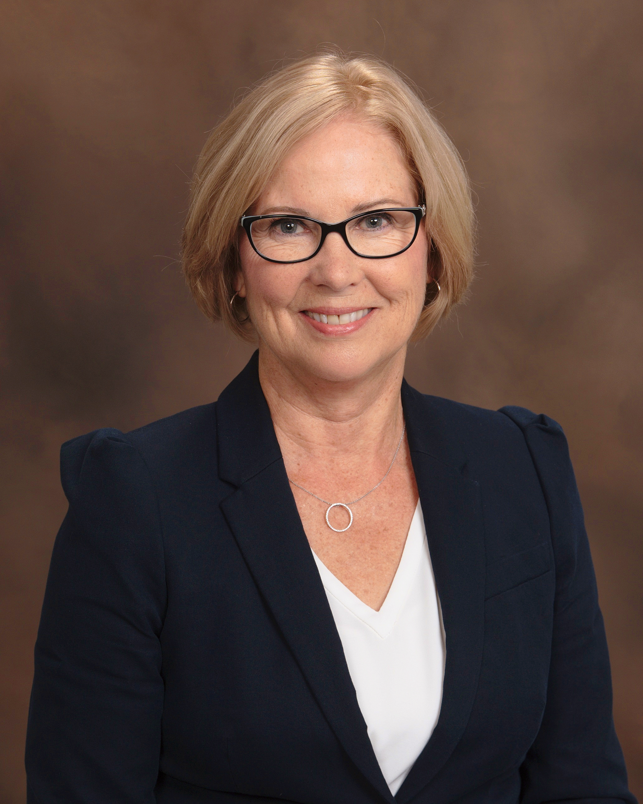
Mary Rose Tichar, LPC
17927 Canterbury Road
Cleveland, OH 44119
Phone #: 216-409-7875
Email: mrtichar@gmail.com
Website: www.insideoutcareer.com

Brief Bio
Mary Rose Tichar is President of InsideOut Career Direction, LLC She is a Master Career Counselor with 15 years experience helping individuals navigate their career journey. Whether a client is seeking their first full time job or in transition from one season of life and career to a new season, her approach is to help individuals connect their innermost self with their life at work.

In addition to InsideOut Career Direction, she is a career professional at Case Western Reserve University in Cleveland OH. Mary Rose has an extensive network with engineering industry and business professionals. Her knowledge and understanding of industry expectations for students (co-op and interns) and for full time hires, makes her an expert in the field. She has a niche with female engineers who need to find their “voice at the table”.

Certifications
- Licensed Professional Counselor (LPC)
- Executive Coach
- MBTI
- Strong Interest Inventory
- Emotional Intelligence assessments: Emotions and Behaviors at Work (EBW) and Emotional and Social Competency Instrument (ESCI)

Presentation Titles
- What a Difference Type Makes: An Exploration of the Myers Briggs Type Indicator
- Communication Styles and Empathic Relationships (at home and at work)
- The Global Engineer and The I-Beam Engineer: models of success for engineering leadership

Fee: $1500-$3000 plus travel, accommodations and cost of materials/handouts.

Format : Lecture, discussion, and group activities focused on the topic’s expected learning outcomes.

Length of Session: 1-3 hours - depends on the topic and the interest level of the attendees.

Availability: Year round. Need a one-month advanced notice.

Follow up: Email correspondence and individual career counseling sessions can be arranged.

