National Career Development Association
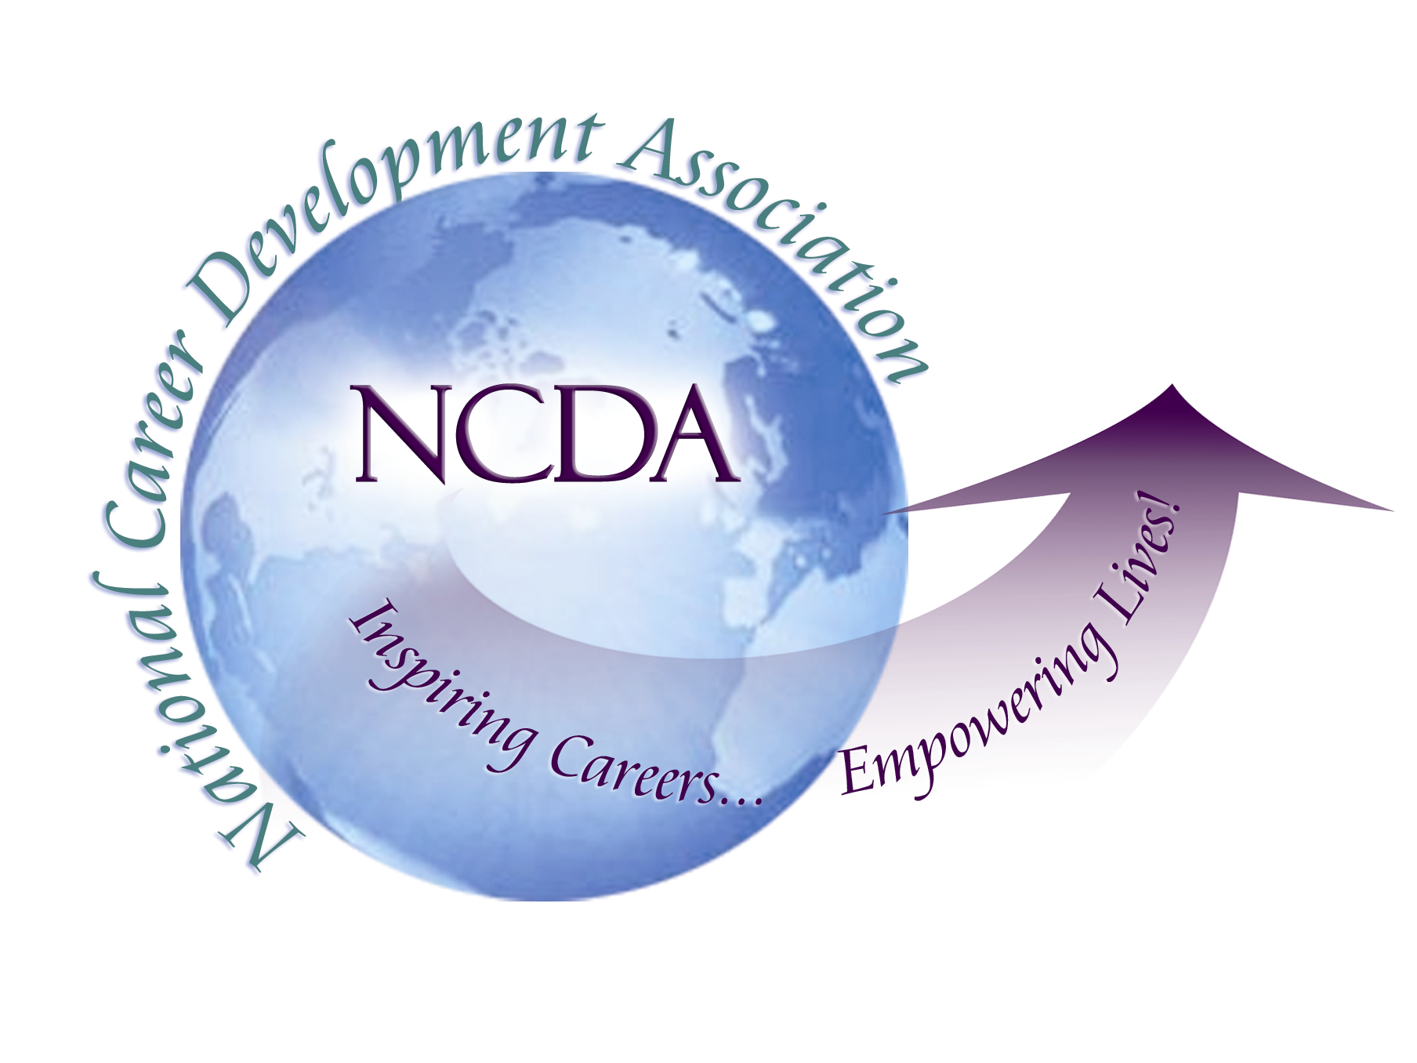
305 N. Beech Circle
Broken Arrow, OK 74012
918/663-7060
Fax: 918/663-7058
www.ncda.org

National Career Development Association
Leadership Academy
Project Summary

Participant(s): Thomas R. Stowell, EDS, GCDF

Board Mentor: Rebecca Dedmond (Trustee at Large) and Pat Schwallie-Giddis (NCDA President)

Leadership Academy Class: LA IV, 2009-2010

Project Title: Enhancing NCDA’s Government Relations and Public Policy Outreach by Building Relationships in Washington, Improving Communications with Members, and Centralizing Resources

Project Description:

As a professional association, NCDA has an opportunity to advocate on behalf of the profession and membership at the local, state, and national level. The National Career Development Association, through the bylaws, has established the Government Relations Committee. The purpose of the committee is track legislation at the federal level, provide information and guidance to the membership and board of directors, and improve the overall understanding of the adopted legislative agenda.
My Leadership Academy Project focuses on three key areas in order to strengthen our legislative outreach. These areas area: building relationships with lawmakers and administration officials in Washington, DC, streamlining and improving communication and outreach to the membership, and developing and centralizing resources related to legislative advocacy and NCDA’s platform on the Association’s website.

Summary/Conclusion:

Since becoming Chair of the Governement Relations Committee in 2009, I have come to recognize that our membership desperately wants to advocate for our profession. Many members have indicated that while they want to be involved in advocacy, they simply don’t know where to start. This feeling is understandable given the air of mystery that often accompanies the legislative process and inner workings of Congress. As a small professional association with limited resources, we must rely on volunteer advocates and the association’s leadership to engage in conversation with our legislators, neighbors, and partners to move our public policy agenda forward. One of the best things that our association can do is to provide training, support, resources, and direction to our members so that their voices are heard. The conclusion of this leadership academy project helps to ensure that these resources, training, and support opportunities are more easily accessible to our members. We still have more work to do, but the results of this project will move us in the right direction.
Results/Recommendations:

Results: The following is a comprehensive listing of accomplishments/results that support the goals of this leadership academy project:
Building Relations with Congress and Administration Officials in Washington, DC
- In Fall 2009, planned and co-hosted a reception in the Nation’s Capitol in honor of National Career Development Week. Attendees included NCDA members, friends, legislators, and partners. Partnered with Pat Schwallie-Giddis, NCDA President to bring to light issues related to practitioner preparation and career planning. A new GWU graduate certificate program in Career and Workforce Development, which Pat and I designed, was unveiled at the event.
- Connected with retired Capitol Hill staffers who provided advice and guidance relative to NCDA’s legislative agenda, outreach, and public policy positions.
- In late Summer 2009, participated in a meeting of National Collaborative for Career and Workforce Policy Development.
- Connected with legislators and ranking officials in the Obama Administration through telephone calls, letters, and in-person visits to discuss pending legislation and the importance of developmental career guidance programs. Connected career development and the current economic situation to make specific points related to worker sustainability and career planning.

Streamlining and Improving Communication and Outreach to the Membership

- Instituted a new quarterly government relations newsletter. This newsletter provides updates to all individuals on the Government Relations e-mail list and includes examples of successful advocacy, outreach, and partnerships. In the future, this publication should expand to highlight successes at the local and state level.
- Provided information and updates on pending legislation (in the form of newsletter updates and targeted “act now” e-mails to those on the Government Relations Committee e-mail list and the Board of Directors on an as-needed basis.

Developing and Centralizing Resources Related to Legislative Advocacy and NCDA’s Platform

- Utilizing material generated by members of the GR Committee, streamlined information and worked with Central Office to envision a website filled with information related to Government Relations. This site should be live prior to the 2010 conference.
- Wrote an article for Career Convergence in August 2009 titled “Capitol Briefing: Mobilizing for Change”.
- Recruited to write an article on the merits of practitioner preparation and the GCDF Program, to be published in the Career Planning and Adult Development Journal (under guest editor Debbie Osborn, NCDA President-elect-elect).
- Participated in an interview project with NCDA focusing on the GCDF program and the importance of practitioner preparation.
- At the direction of the Board, worked with Pat Schwallie-Giddis to organize the specifics of a featured session with Stephanie Vance (the advocacy guru) at the 2010 NCDA Conference in San Francisco. Met with Stephanie to discuss the format of the presentation, which I will moderate.

Advocacy and Support:

- In response to e-mails from members, provided information and guidance in the area of public policy, advocacy, and legislation.
- Presented to state leaders and interested NCDA members on the topic of public policy and legislation with Martha Russell, Skip Niles, Dennis Engles, George Richard, and Thomas Phillips at the 2009 NCDA Conference.
- Presented to the Board of Trustees an update on Governement Relations activities at a March 2010 meeting held in conjunction with the American Counseling Association Conference in Pittsburgh, PA.

Recommendations:

As a professional association, NCDA should continue to enhance resources, information, and guidance available to our members. We must also take a more active role in legislative advocacy. To that end, it is recommended that the Board consider either establishing a staff position based in Washington, DC or enter into a contract with a consultant who can follow legislative issues important to our members. This recommendation is made in recognition of the important role that NCDA can play in the legislative process. A dedicated staffer who can focus their time on the legislative agenda, making connections with staffers on the Hill, and sensitizing members and the Board to important issues will help to ensure that the voice of our organization resonates in DC and at the state level.

