National Career Development Association
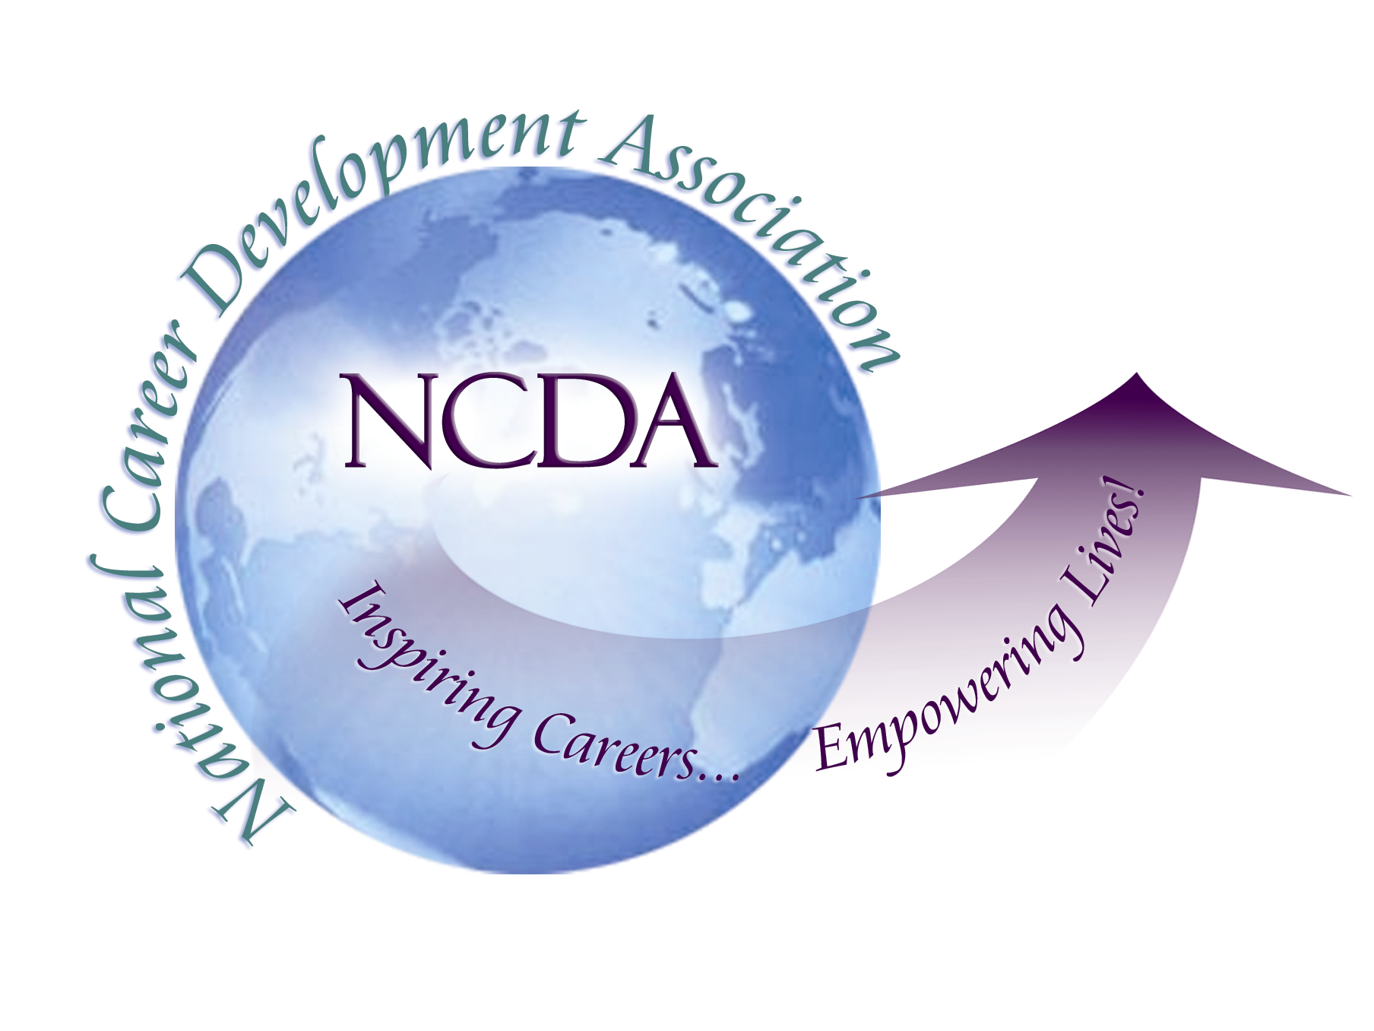
305 N. Beech Circle
Broken Arrow, OK 74012
918/663-7060
Fax: 918/663-7058
www.ncda.org

National Career Development Association
Leadership Academy
Project Summary

Participant(s): Cori Shaff

Board Mentor: Alberto Puertas and Charles Lehman

Leadership Academy Class: LA IV, 2009-2010

Project Title: Leading Your Career Development Association With Your Strengths To Engage Board Members and Recruit Emerging Leaders

Project Description: Interviewed 14 past and current state and national Career Development Association (CDA) leaders. Reviewed research on positive psychology, strengths-based leadership, mentoring, and engagement. Synthesized interviews and research to identify four topics in which to provide ideas and recommendations for state and national CDA leaders.

Summary/Conclusion: Through the research and interviews, the outcome of applying strengths in a role creates engagement with and excitement about the role. Additional benefits include increased creativity, productivity, and an optimistic view of tasks and responsibilities. My final conclusion was that based on a strength based approach to leadership in state and national organizations:
- Board members can use their self-awareness to recognize and chose opportunities to serve the organization that best fits with their strengths.
- The president can engage the board to establish and work towards a collective vision for the association.
- Board members can recognize potential leaders and engage them in leadership positions.
- Board members can mentor incoming leaders so that consistency is maintained in the association.

Results/Recommendations:
Board members can increase self-awareness of strengths by:
- Identifying their strength by taking time to discover areas of excellence and enjoyment.
- Integrating strength into view of self and being intentional about using strength in a variety of situations.
- Changing behavior by committing to a daily practice of utilizing strengths in a variety of situations.
This approach can help CDA board members to identify and understand their strengths and thus volunteer for a position with the confidence that they will be successful in their role. Current leaders can assist incoming leaders with this process by first modeling a strengths-based approach to leadership. Leaders can model this approach by clearly communicating their strengths to board members and being open to feedback from the board. Current leaders can share with others specific examples of how they have used their strengths to accomplish their board tasks and any positive outcomes they have experienced as a result of using their strengths.
The president can engage the board with a collective vision by creating a space to brainstorm and plan for the year. An important piece of the brainstorming is the board leader taking time to build relationships with all board members as a means to identify potential topics to include in the vision. Lastly, an important piece of establishing a vision is to identify what has been done in the past and what was successful. While a new leader will have innovative ideas about new opportunities, it is crucial that they also take the time to understand the context of past accomplishments. When the leader honors the past and all board voices, board members are more likely to be engaged in their position. One interviewee noted the importance of the CDA’s relationship with NCDA headquarters (HQ) as a means to understand the past, policies, and procedures. CDA leaders will find value in forming a relationship with NCDA HQ staff.
All board members can recognize and engage emerging leaders by looking for the following:
  - Can the individual do the role? (i.e. competence)
  - Do they have any relevant experience?
  - Is this role the best use of their natural talents?
  - Does the individual have the desire for the position? Do they seem enthusiastic about the opportunity?
When recruiting emerging leaders with these characteristics, current leaders can utilize several resources to identify potential members. Leaders can be aware of potential in new and prospective members, graduate students, members who recently moved from another state CDA, and long-time members who have not yet had a leadership role. Currently, a new practice is being established in Colorado that will be useful in engaging elect positions and recruiting emerging leaders.
Lastly, board members can serve as a mentor for emerging leaders. Along with current research,
I identified a working model for mentoring programs in state and national CDAs.
- Identify the purpose of the relationship. While there may be several purposes, it may be most useful to establish one main purpose to focus on.
- Plan for success. The relationships must be tailored to meet the needs of the CDA and the individuals involved.
- Provide outline and guidelines for the relationship. Once the purpose of the relationship has been established, the mentor and mentee must establish a set of measurable and realistic goals to work towards.
- Continuously evaluate the relationship, especially in the beginning. Both parties can work together to identify a type of ‘check-in’ process.
- Make the mentoring relationship process official by adding to state or national CDA bylaws, if applicable and interested.
The benefits of establishing a mentoring relationship are endless; for emerging leaders this is an opportunity for them to fully understand and engage in their new position. For existing leaders this is an opportunity to build new relationships and to share their expertise and experience with new individuals.
Given the research, phone interviews, and my own experience, I believe that our state and national CDAs will benefit from using a strength-based approach to complete tasks, engage others, and recruit emerging leaders. Existing and emerging leaders can take time to identify their strengths and to then look for opportunities to apply their strengths in their leadership role. Using this strength-based approach, leaders can utilize their strengths to engage the existing board and encourage all board members to use strengths in their board role. Lastly, board members can use strengths to recruit and mentor emerging leaders.

