National Career Development Association
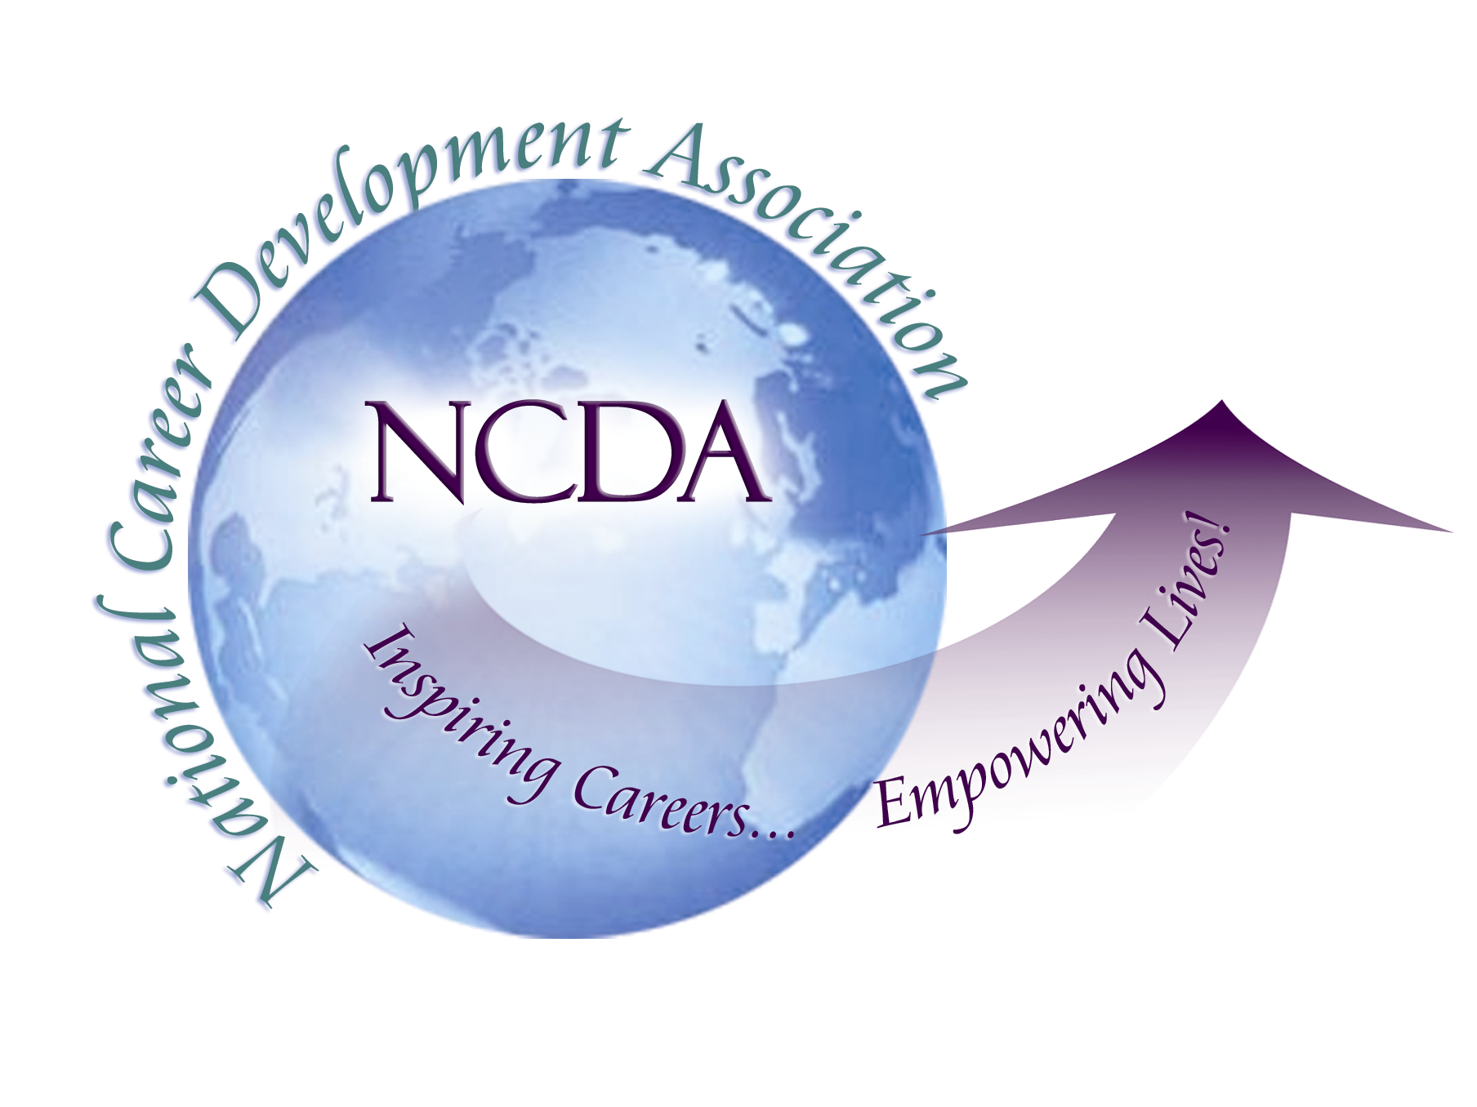
305 N. Beech Circle
Broken Arrow, OK 74012
918/663-7060
Fax: 918/663-7058
www.ncda.org

National Career Development Association
Leadership Academy
Project Summary

Participant(s): Stephanie T. Burns, LPC, NCC

Board Mentor: Dr. Brian Taber

Leadership Academy Class: LA IV, 2009-2010

Project Title: National Career Development Association Membership Study

Project Description: The primary aim of this study was to understand the subjective experience of membership in the National Career Development Association (NCDA). This study was performed to assist the NCDA’s board in understanding members’ views about NCDA membership to potentially inform marketing and programming development to attract additional members at national and state levels. The two specific objectives of this mixed methods Q-methodology and qualitative research study were (a) to understand the values members attached to membership in the NCDA and (b) to develop a practical understanding of the concept of membership in the NCDA.

Summary/Conclusion: The findings of this study have offered a practical understanding of the complexity of membership in the NCDA. Although only 16 NCDA members performed the Q-sort procedure, there were enough participants to find statistically significant views. The resulting two groups with differing views on the subjective experience of membership in the NCDA suggests that NCDA members are motivated to some degree by several known models of association membership.
The expectancy-value theory model (also called purposive incentives) suggests members join if they perceive that membership will result in a valued outcome, such as influence or respect. An active commitment to the career counseling profession is the main drive of Group 1. Membership in the NCDA alone was not viewed as sufficient to demonstrate their commitment to the profession. The blend of university/college professors teaching career development and professionals practicing career counseling have served in leadership positions in the NCDA. The group not only wants to connect to current research and best practices through the NCDA, but are also the NCDA members who are responsible for delivering research and best practices content through the NCDA’s publications and conferences. Group 1 was not looking for the NCDA to provide them with clients or a career certification.
A second association membership dimension, informative incentives, focuses on obtaining information. A third association membership dimension, the social identity theory of association membership, suggests that members join when it increases their self esteem, professional identity, and status. Group 2 consists of clearly established career professionals who are most interested in the NCDA providing the latest information and certification. This group is focused on current research and best practices in the career development profession to improve their clinical practice along with the certification to establish their credentials. Members of this group were Caucasian, mostly female, professional members who had not served in NCDA leadership. The group was not looking for the NCDA to provide them with employment opportunities and was not attending the annual conference.
It is worth noting that Groups 1 and 2 did not have a theme associated with the cost of NCDA membership being prohibitive, which follows the exchange theory model or utilitarian incentives of voluntary association membership. In this theory, members join an association when they perceive the benefits to outweigh the costs. Second, organizational justice theory states that members join an association because of the perception that the association’s policies, practices and operations run fairly. Neither of the 2 groups mentioned a perception of the NCDA’s policies, practices and operations running fairly or unfairly. It is again worth noting that neither group embraced solidary incentives of voluntary association membership, which focuses on social interaction opportunities.
This study suggests that NCDA membership is complex and not explained by one model of voluntary association membership. The two groups representing divergent subjective viewpoints on NCDA membership include members focused on (a) active commitment and (b) the latest information and certification. These two groups are worthy of further study. In addition to this study furthering the public good of voluntary association membership, the narratives generated by NCDA members can benefit the association’s strategic planning and marking strategies in the future at the national and state levels.

Results/Recommendations: The following recommendations must be interpreted cautiously considering that only 16 NCDA members took the Q-sort, which directed the findings. Based upon the data collected, NCDA’s marketing efforts should cater to the 2 statistically significant viewpoints on membership in the NCDA. Group 1 was made up of professors and practitioners who emphasized publications, presentations leadership roles, research, and the latest information on career development best practices. Due to their desire to publish and present, Group 1 was attending the national conference. Group 2 was primarily made up of practitioners who were looking for career certification to establish their credentials and the latest information on career development best practices. Due cost and time constraints, Group 2 was not interested in attending the national conference.
It is important to note the commonalities between the groups. Both groups looked to the NCDA to offer best practices and research in career development. Neither group was concerned about the NCDA offering social interaction opportunities, the cost of NCDA membership, or the “fairness” of the NCDA’s operations.
There may be more that 2 viewpoints on membership in the NCDA, which could be found with greater participation in the study. The NCDA is encouraged to continue to promote this study with the membership to add additional subjects, which will confirm or even expand upon these findings.

