National Career Development Association
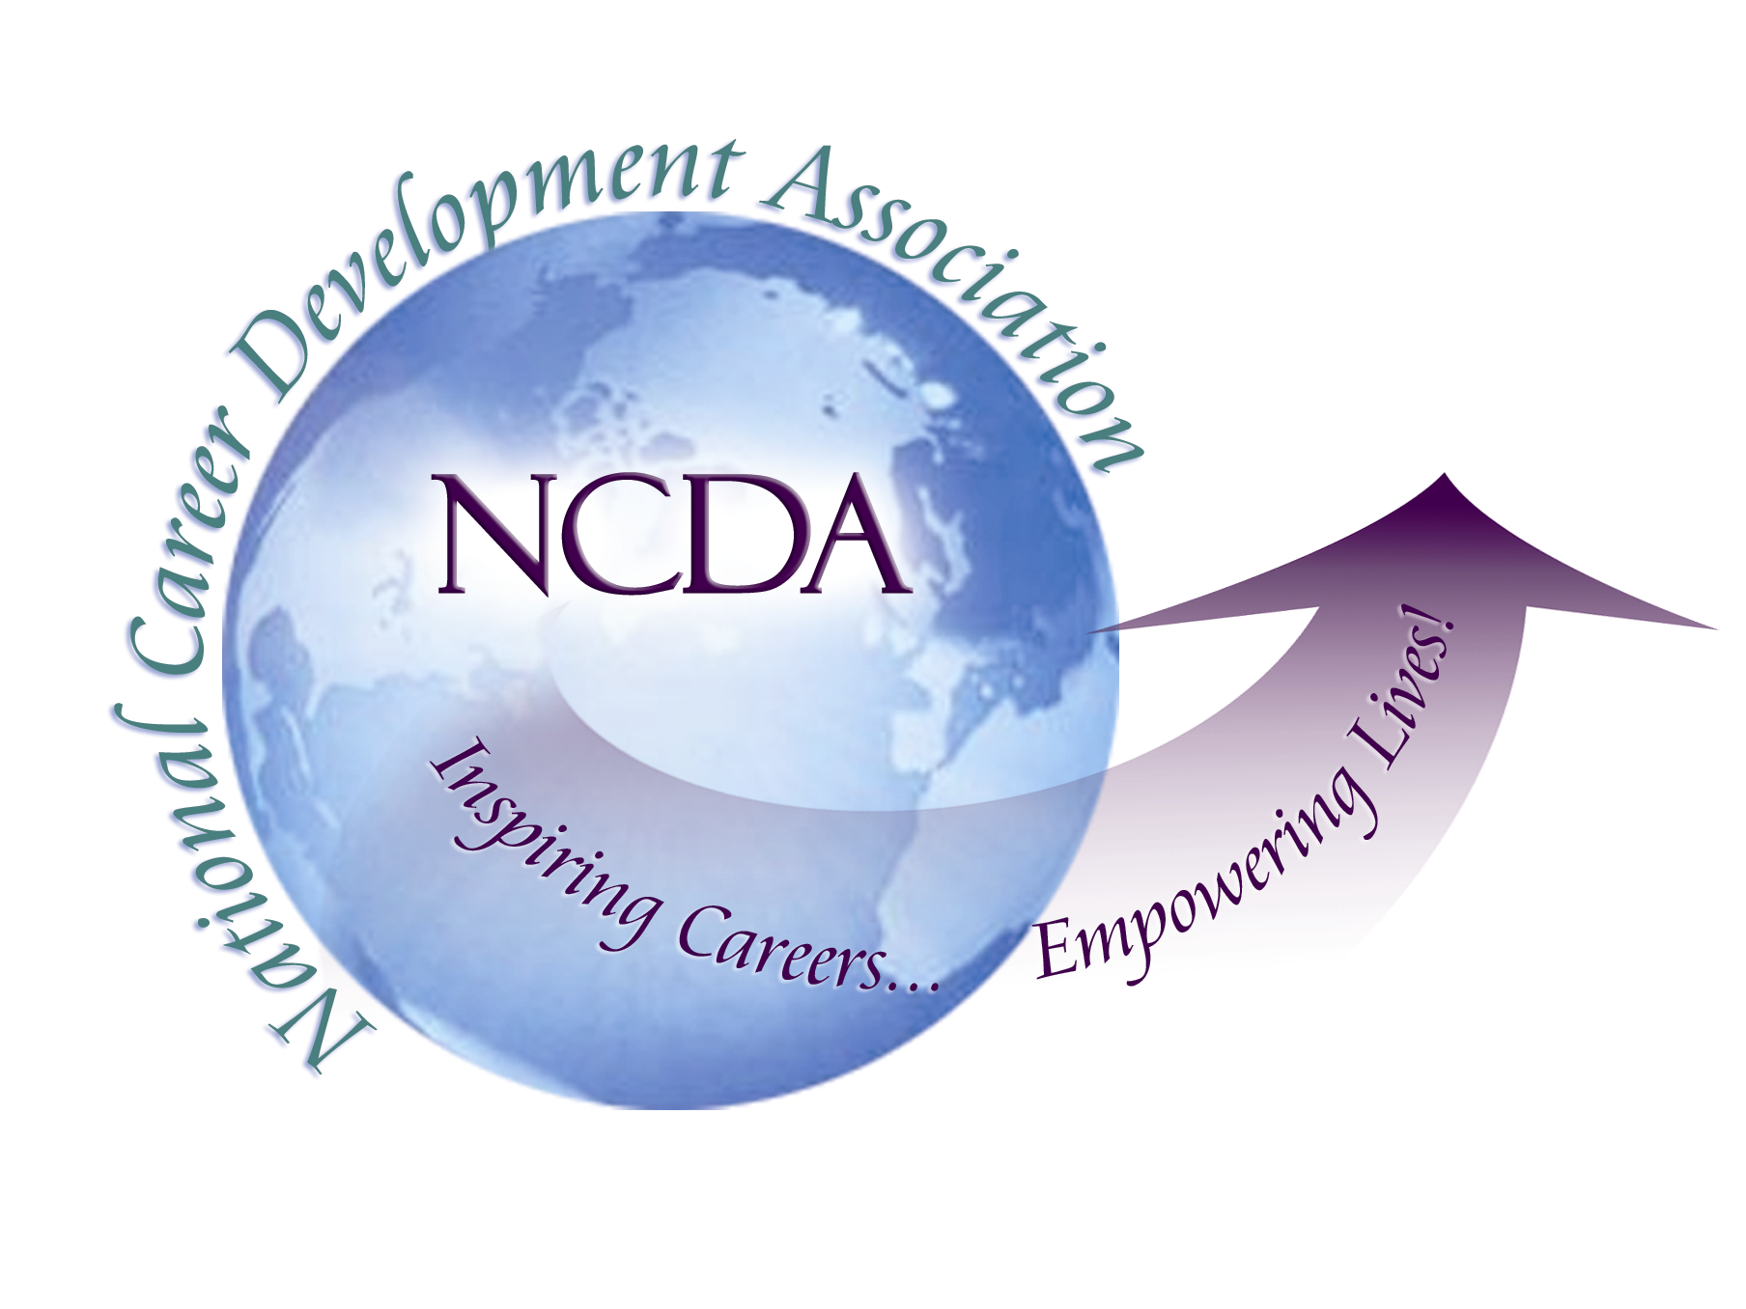
305 N. Beech Circle
Broken Arrow, OK 74012
918/663-7060
Fax: 918/663-7058
www.ncda.org

National Career Development Association
Leadership Academy
Project Summary

Participant(s): Joyce Donahue

Board Mentor: Charles Lehman

Leadership Academy Class: LA IV, 2009-2010

Project Title: Using Technology to Make ACDA More of a “Statewide” Organization

Project Description:

Arizona is, physically, a very large state with the greatest population concentrated in the metro Phoenix area. Historically and currently, almost all of ACDA members have lived in metro Phoenix. For my leadership project, I wanted to talk to leaders in other states and learn how they are using technology to overcome the challenges of geography and create organizations that serve entire states. Through my benchmarking conversations, I discovered some new uses of technology and some great “high-touch” ideas as well.

My first activity was to survey Arizona members of NCDA. Although the sample was small, I learned that respondents who did not belong to the state organization, either did not know about ACDA or had forgotten to renew their membership. These respondents expected the state organization to provide information about professional resources, opportunities for networking, information on Arizona trends and workplace issues and CEUs. I also discovered that most individuals living outside “The Valley” would be willing to drive to Phoenix for an all day workshop or to hear a nationally renowned speaker. There was also interest in attending smaller events, if they were held locally.

Through my benchmarking phone conversations with other state leaders, I learned how other organizations were successfully using various forms technology in the following areas:

- Communication with members
- Programs and meetings
- Payment management
The most common and most frequently used resource is the organization website. Some organizations have a member or several members take on the responsibility of updating the web, while others pay for the service. There can be a separate web page for each active region within a state.

“Google Groups” and “Google Docs” were mentioned as tools for group communication. There is no charge for either of these. Some states are using “Linkedin”. Colorado board members take turns initiating Linkedin discussions with a new topic each month. Several states have fan pages on Face Book, are tweeting on Twitter and have electronic newsletters. Maryland has an electronic job board that is password protected for its members.

Maryland offers online courses. Courses and programs can be offered, through “Go to Meetings”, as live webinars as well as recorded and put on line. I was told that the fees collected from the first webinar covered the annual subscription cost for Go to Meetings. These online courses are also available through NCDA.

I discovered the live and recorded tele-interviews offered twice a month through Careerwell. This resource allows professionals hear industry leaders and to earn CEUs whenever and wherever it is most convenient for them. The cost for a state CDA subscription to Careerwell is proportional to the number of its members. http://www.careerwell.org

Two states are using “Go to Meetings” for board meetings. “Second Life” was mentioned as an ideal vehicle for board meetings since a virtual space inhabited by avatars would be created. However, developing the expertise required to use “Second Life” does take a considerable time investment.

Several states use “PayPal” to handle payment for membership and events and are very pleased with it.

The goal of my project was to investigate how other state organizations are using technology; however, I also discovered some excellent and innovative face-to-face and in-person solutions for overcoming the challenges of geography. The locations for meetings, board meetings and conferences can be rotated throughout various regions of the state. Colorado has “Regional Connection Chairs” who find speakers and arrange monthly breakfast meetings at a local restaurant. The organization pays for the chairs’ breakfasts but all other attendees simply order from the menu and pay for their own meal. Oregon holds semi-annual industry tours and varies the location from one region of the state to another. Board members from the various regions of a state give an organization a broader focus and greater appeal. I also learned how effective personal phone calls, following email reminders, are for building membership.

Summary/Conclusion:

www.gotomeetings.com

MD, PA,

www.facebook.com

OR, PA, CA

www.linkedin.com

OR, PA, CO, MD, CA

www.twitter.com

OR, PA, MD

www.paypal.com

OR, MD

www.wordpress.com blog

PA

www.careerwell.org

Dr. Sally Gelardin
info@careerwell.org

Results/Recommendations:

When the users are comfortable with technology, the benefits are amazing – both in terms of the time saved and the potential for relationship building. Members who have technical expertise and those who love to experiment with and learn to use new technologies are great resources. I was told that many new professionals, younger recent graduates, do have these skills and are delighted to share them. Learning to use new technology can be fun and incorporating the teaching into CDA programs could be a strong benefit for all members in the organization. Associations would be wise to welcome young, tech-savvy professionals into leadership positions and learn from them.

Fostering regional connections – formal and informal, events, programs and networking -- is critical to building a statewide organization. I realized that many small local face-to-face events are far more practical and effective than trying to bring everyone together to one central location. Websites, Facebook, Twitter, Linkedin, Blogging, and virtual meetings are all options for building stronger connections.

I will be sharing my findings with the ACDA Board in early June. This meeting is going to be a brainstorming session, including current and elect board members as well as members who have an interest in shaping the future of the organization. Later in the summer, the new board will meet for a strategic planning session to decide which ideas to implement and plan the coming year.

