National Career Development Association
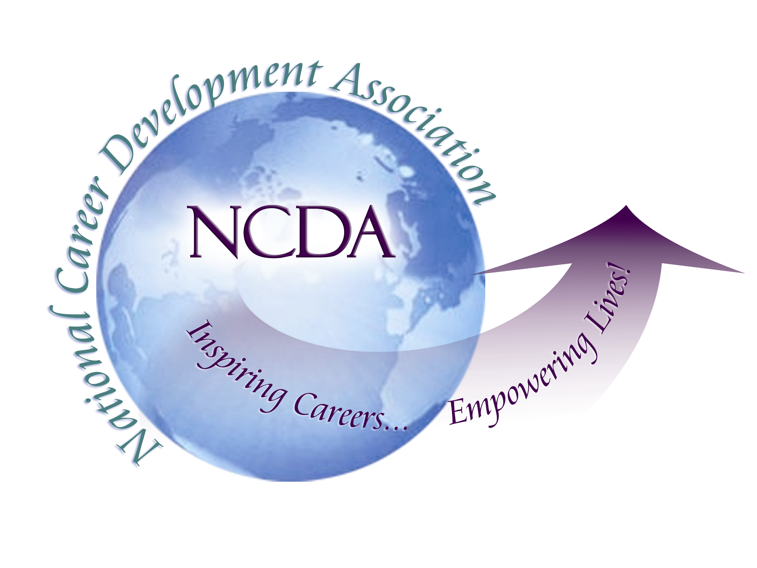
305 N. Beech Circle
Broken Arrow, OK 74012
918/663-7060
Fax: 918/663-7058
www.ncda.org

National Career Development Association
Leadership Academy
Project Summary

Participant: Fatima Wilson, CDFI

Board Mentors: NCDA President Cheri Butler and Dr. Brian Taber

Leadership Academy Class: LA V, 2010-2011

Project Title: The Creation of the National Vocational Guidance Association in 1913:
Crucial Issues Facing Vocational Counselors at the Time

Project Description: The National Career Development Association (NCDA) will be celebrating its centennial anniversary in Boston, Massachusetts in 2013. It is befitting that the centennial will be celebrated in the very city where Frank Parsons and his colleagues founded the Vocation Bureau: “the first organization to provide a systematic process for providing vocational guidance and counseling” (Herr & Shahnasarian, 2001). As the centennial anniversary is being planned, it is apropos to revisit the past and get to know the pioneers and visionaries who started this great organization. Accordingly, “Celebrating Our Past: Achieving Our Dreams” is the theme of the 2011 NCDA conference to be held in San Antonio, Texas. In keeping with this theme, the purpose of this project is three fold:

(1) to identify the major events and figures that contributed to the emergence of
vocational guidance;

(2) to describe the rise of the vocational guidance movement leading up to the
creation of The National Vocational Guidance Association in 1913;

(3) to review the papers which were presented at the 1913 convention and outline the
most crucial issues facing vocational guidance counselors at the time.

Summary / Conclusion: For a movement to take root and be successful, several factors must converge: time, place, people and a critical issue. Such factors were present to usher in the vocational guidance movement in the late 19th and early 20th centuries in the United States. The vocational guidance movement emerged and was firmly established during a period of turmoil characterized by the irrevocable change of the American economic, social and political landscape. The industrial revolution transformed the U.S. from an agrarian to an industrial economy bringing newcomers from all parts of the country as well as a large number of immigrants from Europe to the cities. This new population converged towards the big cities where manufacturing and industrial jobs were available. Due to the influx of the newcomers to the cities, social reformers began to call for vocational guidance. Frank Parsons, considered the founder of vocational guidance, provided the vision for the movement. Other like-minded people including educators, economists, lawyers, ministers, psychologists, and social workers were ready to advance the cause of vocational guidance as a mean to effect social justice. This broad coalition of pioneers coalesced around the pursuit of shared interests encapsulated by the progressive era: improving the lives of the most vulnerable members of society: children, women, unskilled workers, immigrants while honoring their human dignity by providing them with the tools to improve themselves. One way to address this critical issue was through vocational guidance and vocational education. (Parsons, 1909; Brewer,1942; Herr, 2001; Zytowski, 2001; Savickas, 2009).

The place was the Vocation Bureau, created in Boston in 1908 as a new department in the Civic Service House. The main protagonists included the philanthropist Pauline Agassiz Shaw who had founded the Civic Service House in 1901 to provide educational opportunities for immigrants and poor people to help them find work. Under the recommendation of Meyer Bloomfield, she also provided the funding to open the Vocation Bureau with Parsons as its first Director. Bloomfield, a social worker and graduate from Harvard University, had been appointed to head the Civic Service House. The mottoes of the Vocation Bureau were: “Light, Information, Inspiration, Cooperation” (Parsons, 1909, p. 92). Its mission was to educate the under-privileged and immigrants on the importance of making good vocational choices so that they could improve their lives, create a better future for themselves, their families and their communities; thus escaping the vicious circle of poverty. Three vocational guidance pioneers worked along side with Parsons: Ralph Albertson, close friend of Parsons, Lucinda Wyman Prince and Philip Davis. They all carried the title of “Associate Counsellor” (Parsons,1909; Brewer, 1942; Savickas, 2009; Sensory-Briddick, 2009).

In his first and only report, dated May 1st, 1908, Parsons stated that he and his Associate Counsellors interviewed 80 young men and women from the ages of 15 to 39. All but 2 declared that the interview with the Counselor was “the most important hour of their lives” (Cited in Brewer, 1942, p. 303). Parsons recommended that vocational guidance be grounded in a scientific method by advocating the use of a variety of physical and psychological tests in order to obtain a holistic and accurate understanding of each individual. He also advocated that practitioners should undergo professional training as doctors and lawyers did; thus anticipating the creation of the counseling profession with its own credentials. Parsons had intended to teach vocational guidance courses to train counselors in October 1908, however, due to his untimely death on September 26th, 1908, Ralph Albertson took over the teaching (Brewer, 1942).

In 1909, Albertson made sure that Parsons’ book “Choosing A Vocation” was published posthumously. Parsons’ blue book served as the catalyst for propelling the vocational guidance movement forward (Brewer, 1942; Savickas, 2009).

When Bloomfield took over the leadership of the Vocation Bureau in 1909, he was determined to advance the cause of vocational guidance by creating alliances with practitioners in the field as well as with other stakeholders. The Commissioner of Education for Massachusetts, Dr. David Snedden, suggested that a committee be formed to plan the First National Conference on Vocational Guidance. In November 1910, educators, social workers and business people from 35 cities were invited to participate in the conference that took place in Boston (Brewer, 1942; Pope, 2009; Savickas, 2009). As Parsons had stipulated in his first report, the most critical issue discussed at the conference was the need to implement some form of vocational guidance within the school system itself. A large number of young people between the ages of 14 and 16 were leaving schools to go to work without knowing anything about the world of work (Brewer, 1942). As Bloomfield put it, they were “unguided, unprepared, and uninformed” (Cited in Savickas 2009, p. 263). The goal was to help young people acquire some knowledge of the occupations that they were going to enter and to guide them in selecting a suitable occupation: “a vocation” rather than “a job” (Brewer, 1942).

No conference was held in 1911. However, in 1910, Frederick J. Allen had been appointed Assistant Director of the Vocation Bureau in order to start a publication to disseminate information primarily to school counselors in the Boston School system. Thus, The Vocational Guidance-News Letter was created in 1911 (Brewer, 1942).

The Second National Conference on Vocational Guidance took place in October 1912 in New York City. A special committee was charged to investigate the possibility of creating a national organization for vocational guidance. After resolving some initial disagreement, a plan to create a national organization was approved. Forty speakers presented papers at the conference. Again, the main focus was on the welfare of the same group of children and the need to create some form of vocational guidance within the school system itself. It was reported that 132,000 children were working in unskilled jobs, so-called dead-end jobs in New York City (Brewer, 1942).

At the third national conference, held in Grand Rapids, Michigan from October 21 - 24 1913, “The National Vocational Guidance Association” (NVGA) was founded, five years after the death of Frank Parsons. 274 participants from 26 states attended the conference. The first NVGA officers were selected: Frank Leavitt as President; Alice M. Barrows as Vice-President; Jesse B. Davis as Secretary; James S. Hiatt, as Treasurer; an Executive Council was also selected: Meyer Bloomfield, M. Edith Campbell, Gorge P. Knox, O. W. Burroughs, and E, M. Robinson (Brewer, 1942; Davis, 1956b, Pope, 2009).

Preeminent leaders, Professor Frank Leavitt of the University of Chicago, Chairman of the organization committee; Owen R. Lovejoy, General Secretary, National Child-Labor Committee; Dr. Leonard P. Ayres, Director of Education, Sage Foundation; Meyer Bloomfied, Director of the Vocation Bureau, Boston; Helen T. Woolley, Director Child Labor Division, Cincinnati Public Schools; Jesse B. Davis, Vocational Director, Michigan; - to name a few – presented the papers at the 1913 conference. The papers provided insight on the most critical issues faced by vocational guidance counselors at the time of the creation of the NVGA. These issues can be summarized as follows:

- As was the case with the previous two conferences, the most critical issues were: (1) the welfare of the same group of youths who continued to leave schools in large number to go to work without any preparation; (2) the call for the implementation of some form of vocational guidance within the school system itself throughout the country to avoid the waste of human capital was increasingly becoming louder. Added to this call, was the moral imperative to abolish child labor.

- It was reiterated that the main goal of vocational guidance was to teach students the difference between “a vocation” and “a job” and to encourage them to stay longer in schools. A vocational survey done in New York City indicated that out of 101 boys between the ages of 14 and 16, only 5 boys were pursuing an occupation with some prospect for advancement while 96 of them were in so-called “dead-end occupations”.

- The call for educational reform was reiterated. The purpose of which was to make education more relevant to students with an infusion of vocational material throughout the curriculum so that students would stay longer in school; much like Jesse B. Davis’ Vocational Guidance Model in Grand Rapids, Michigan.

- Vocational guidance should be seen as a means to promote democracy in an educational setting.

- The need to continue to study occupations with a new angle: differentiating “constant” from “variable” occupations. “Constant” occupations could be found in all parts of the country whereas “variable” occupations were localized in specific areas.

However, new issues were brought forward:

- The challenge for vocational guidance was to develop psychological tests “to select people for positions rather than selecting positions for people”.

- The necessity to develop professional training for vocational counselors was discussed.

- Differentiating between manual and mental abilities was detrimental to the child and to the progress of society. Furthermore, it was inaccurate. The testing of 149 children in Cincinnati indicated that those who did best in mental tests also did best in physical tests; suggesting a strong correlation between the two abilities.

- To effectively implement vocational guidance in the school system, more money was required to reduce class-size, hire more teachers/counselors, buy equipment and create departments of research for economic and psychological information.

- Use of advocacy was : vocational guidance counselors must be prepared to challenge each industry regarding wages, hours, unemployment and hygienic working conditions.

- Developing placement and follow-up work in the school system in collaboration with employment bureaus and charitable agencies; the latter could help with supervising the young people in the work place.

- Continuation schools in Cincinnati as a means of vocational guidance.

- How to study an industry for the purposes of vocational education and vocational guidance.

At the end of the conference, a round-table discussion followed. Jessie B. Davis, considered to be “the first school guidance counselor”, discussed his vocational guidance program through the use of English composition in the Grand Rapids High School public system. He is credited for being the first person to implement a systematic guidance program in the public schools as early at 1907(Pope 2009, p. 257; Brewer, 1942; Davis, 1956b).

The third conference was declared to be the most successful so far. It remained so until 1920 (Brewer, 1942). NVGA conventions continued to be held annually until the U.S. got involved in the First World War in 1918. Jessie B. Davis served as the second NVGA president during 1914 -1916 and Bloomfield as its third during 1916–1918. The NVGA “almost died” if it were not for the dedication and tireless work of John Brewer from Harvard University and Katherine E. Ball from the University of Minnesota. Fortunately for us, the NVGA was saved and “revived” in 1920 with its original name preserved thanks to the efforts of Jesse B. Davis; John Brewer served as its fifth President in 1920 –1921 (Brewer, 1942; Davis, 1956b; Pope, 2009). In 1985, the NVGA was renamed the National Career Development Association (NCDA).

In the last one hundred years, much has been accomplished and yet much remains to be done. As mentioned earlier, the vocational guidance movement emerged and was firmly established during a period of turmoil characterized by the irrevocable change of the American economic, social and political landscape. Today’s career development professionals are facing challenges that are similar to the ones that their predecessors faced when they started this work in the beginning of the 20th century. As a result of a combination of factors, including the globalization of the economy, the outsourcing of manufacturing jobs, the information technology revolution, the current economic crisis, the high rate of students dropping out schools, to name a few, today’s unemployment is close to 10%, with some areas of the country being more affected than others. Hence, a growing number of dislocated and under -employed workers from diverse backgrounds are seeking the help of career development professionals.

For the first fifty years of the 20th century, Parson’s three-step model: (1) self- assessment (2) information gathering (3) decision –making; served as the theoretical framework used by vocational counselors to provide vocational guidance and it “continues to be a remarkable milestone in the evolution of career development practices” (Herr, March 2001). However, Parson himself was aware of the limitations of his model as he supplemented it with various techniques and called for the need to develop new psychological tests to improve the counseling process. In the last fifty years, career development has been revolutionized by the creativity and innovation brought about by John Holland, Donald Super, John Krumboltz, Sunny Hansen, JoAnn Harris-Bowlsbey as well as numerous other scholars. Being a dynamic field, career development continues to evolve as society changes. As a result, today’s career professionals are better equipped than their predecessors to assist their clients.

Another similarity pertains to the role of advocacy in the profession. From the beginning, advocacy was an integral part of vocational guidance to effect social justice. In fact, it can be said that it was its “raison d’être”. This tradition of advocacy has recently been rediscovered by NCDA through the hiring of the Chairperson of the NCDA Government Relations Committee to advocate directly to the U. S. Congress in Washington D.C. on behalf of the organization, its members and its constituents. The newly revised Mission Statement of the organization: “NCDA inspires and empowers the achievement of career and life goals by providing professional development, resources, standards, scientific research, and advocacy” encapsulates all that the pioneers of vocational guidance had dedicated their life work to achieve (NCDA website, October 2010). Parsons, in particular, would be very proud of the new mission statement, as he had advocated for the very same things in his 1908 report and his book, “Choosing A Vocation”.

Equally important is the choice of Texas State Senator Leticia Van de Putte, one of the Keynote Speakers at the 2011 NCDA Conference. Senator Van de Putte is “a strong advocate for children, veterans, improved access to health care, quality education, and economic development issues” (Registration Brochure, 2011, p. 3).

Conclusion: For the last 100 years, the organization has endured many trials and tribulations to finally emerge in the 21st century as a strong and vital organization with international chapters in Japan and Egypt. The organization is still committed to its original goal of helping people from diverse backgrounds and over the life span find their “vocation” so that each individual can achieve her / his dream and live in harmony with himself / herself and with other members of the human family. As career counseling and career development are becoming worldwide phenomena, the organization continues to address issues related to race, ethnicity, multiculturalism, gender, class, and sexual orientation through the use of scientific research, career development theory, technology, best practices, professional development and advocacy. Thus, impacting positively the lives of millions of people nationally and globally as well as continuing the tradition started by our pioneers of effecting social justice through career counseling and career development.

Results:

First, from a personal point of view, learning about and from the forefathers and foremothers of the vocational guidance movement was an inspirational, educational and rewarding experience. I was surprised and delighted to learn that women and immigrants were among the pioneers who shaped the vocational guidance movement. Pauline Agassiz Shaw, a philanthropist, provided the funding to open the Vocation Bureau. Lucinda Wyman Prince, described as the “first female counselor” had been a successful educator before becoming one of the three Associate Counselors working along side with Parsons. Helen T. Woolley, a renowned psychologist, served as the sixth NVGA President in 1920-1921. M. Edith Campbell was primarily a social reformer; both women worked together in the Vocational Bureau of Cincinnati advocating for the welfare of women and children. Meyer Bloomfield, born in Romania, started as the Director of the Civic House, became Director of the Vocation Bureau, served as the third NVGA President in 1916-1918 and continued to assume other prominent roles. Philip Davis, from Russia, was one of the three Associate Counselors working with Parsons. Hugo Münsterberg, born in Germany, known as the founder of applied psychology, was recruited to work at Harvard University. (Parsons, 1909; Brewer, 1942; CDQ, 2009).

Second, although Parsons is credited for being the founder of vocational guidance, others such as George Merrill from San Francisco, Eli W. Weaver from New York, and Jesse B. Davis from Grand Rapids, Michigan must be mentioned as each in his own way, made an attempt at implementing some form of vocational guidance in an educational setting before Parsons started his work in the field (Brewer, 1942).

Third, an interesting finding was pointed out by Goodman: from the beginning of the movement, “there were two different approaches” to vocational guidance. Parsons “started with the individual as his point of reference” (Goodman, 2009, p. 23). On the other hand, Bloomfield, who had little faith in psychological tests, “based his ideas on social theory” (Savickas, 2009, p. 271). Bloomfield believed that “the job of guidance was to help individuals figure out how they fit into their environment” (Goodman, 2009, p. 23). As explained by Savickas, “Today (Bloomfield’s) approach is called ‘person-in-environment’, meaning that the person is embedded in and inseparable from the environment. (…) (T)he unit of analysis is the transaction or experience. This more constructivist model contrasts to the positivist model of person-environment fit (my italics) in which the unit of analysis is the interaction between isolated person variables (e.g., ability or interests) and isolated environment variables (e.g., job requirements or rewards)” (Savickas, 2009, p. 271).

Fourth, another interesting finding pertains to Jesse B. Davis. Pope pointed out that Davis, who had started advising his students on vocational choices as early as 1885, had anticipated Parsons’ three-step model that was developed in 1909. Davis used the model that Professor Thurber had applied to help him select a career: “(a) (Thurber) ‘helped me know myself’ (self-knowledge), (b) ‘opened my eyes to the possible fields’ (gather occupational information), and (c) ‘made certain that I had made my own choice’ (i.e., understand the relationship between these issues and make a decision” (Pope, 2009, pp. 250-251). Davis refined his model and implemented a systematic guidance program in 1907 when he became principal of Grand Rapids Central High School. Through English composition, students explored various aspects of the vocational process. The themes mirrored Parson’s counseling model: “Ambition” for the first year; the “World of Work” for the second; “Choice of a Vocation and Preparing for it” for the third and ‘Service’ or the use of one’s vocation as a loyal citizen serving his community’ for the last year. Davis’ vocational model came to be known as the “Grand Rapids Plan” (Pope, 2009, pp. 253; Davis, 1956b, p. 179).

Fifth, Goodman also pointed to another interesting finding about Jesses B. Davis. According to Goodman, Davis “foresaw Super’s implementation of self concept career development theories with his belief that vocational guidance for an individual ‘means a conception of himself as a social being in some future occupation’ ” (Goodman, 2009 p. 23, Pope 2009, p. 254; Davis, 1956b p. 207).

Sixth, the papers presented at the 1913 conference provided insight into crucial issues facing vocational guidance counselors at the time of the creation of the National Vocational Guidance Association. Reading the original documents in the manner in which they had been presented at the conference gave me the impression of being one of the attendees. One could imagine the gestures, the various intonations of the voice, the laughter generated by amusing and ironic comments. Thus, giving authenticity to the powerful voices that still resonate 100 years later. The speakers engaged the audience by asking theoretical questions. They were fearless: speaking the truth as they saw it, not mincing their words, asking difficult questions, searching for answers, some of which, they knew they could not find in the immediate future; projecting their aspiration into the future and reaching out to all of humanity: those present in the audience as well as the future generations of career professionals who would proudly stand on the shoulders of these giants and diligently commit themselves to addressing the questions that they asked so many years ago. These fearless pioneers were strongly committed to advocate for the most vulnerable members of society: children, women, unskilled workers and immigrants in order to improve their lives through vocational guidance and bring about social justice.

Of crucial relevance for the vocational guidance counselors at the time:
- The necessity to develop new psychological tests “to select people for positions rather than selecting positions for people” indicates a shift from the focus of “what is to be chosen” to a new focus on “the characteristics of the chooser”(Ayres 1913; Herr 2001). This new paradigm shit anticipated John Holland’s theory.

- The call for the necessity to expand the training of vocational guidance counselors to include the use and interpretation of psychological tests anticipated the development of tests specifically designed for vocational counseling.

- Having the knowledge to be able to work with diverse population anticipated the need to develop theories about and for multicultural counseling.

- The ability to do research to stay current in the field anticipated that vocational counseling would be a dynamic field able to change as society changes.

- In short, the creation of a counseling profession with its own credentials was called for.

Seventh, in a relatively short period of time, twelve years after the submission of his report, Parson’s vision was implemented as most schools had some form of vocational guidance program by 1920. Jesse B. Davis is credited for helping achieve this goal.

Eighth, being immersed in the trials and tribulations of the pioneers who were shaping one of the most important movements of the 20th century, renewed my commitment to continue the work that they started more than 100 years ago, that of helping people from all walks of life find their “vocation”, their “calling” which in turn provides meaning to their lives. Thus, living up to the NCDA’s motto “Inspiring Careers … Empowering Lives!”

Finally, I hope that this project will stir the curiosity of my colleagues of the Leadership Academies V and VI to want to learn more about the genesis of this great organization and immerse themselves in its glorious history.

Recommendation: I am sure that the following idea has been thought of and is probably being planned or even implemented as I write this report. Nevertheless, I would like to respectfully suggest that a special section to celebrate the organization’s past history and accomplishments be created on the NCDA website. Abstracts / synopsis with links to main articles could be included so that career development professionals can easily access this wealth of knowledge. It could be something similar to the Convergence Magazine.

This will be especially helpful for the career professionals from Qatar and Egypt who were trained by NCDA master trainers in 2009. The recent trip to Perú by the NCDA leadership in August 2010, suggests that in addition to Japan and Egypt, more international chapters will be joining NCDA in the future. As career counseling and career development are becoming worldwide phenomena, some of the new international colleagues joining the profession might like to study the history of NCDA to learn more about the founding of the organization. As we are reminded by Savickas: “to know any field well, practitioners must know its founders” (Savickas, 2009, p.195). Who knows, it might inspire some of our new international colleagues to translate the work of our pioneers into different languages; thus making the voices of the pioneers resonate into the 21st century. Would it be a great way of paying homage to the pioneers of vocational guidance?

From: “Celebrating Our Past: Achieving Our Dreams”

To: “A Bridge to a Brighter Future!”

