National Career Development Association
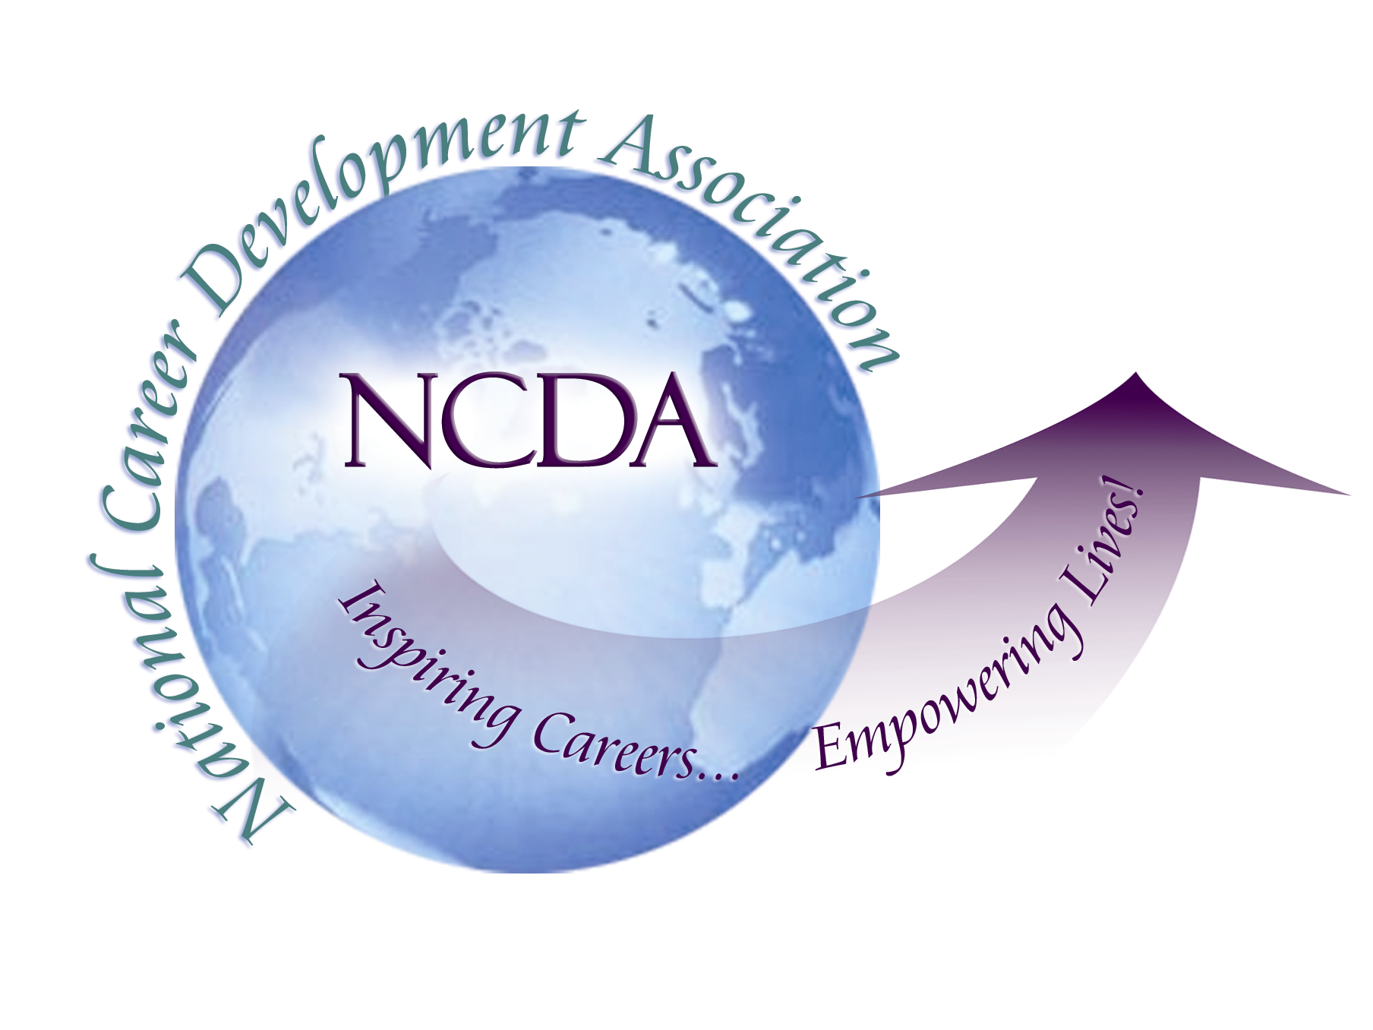
305 N. Beech Circle
Broken Arrow, OK 74012
918/663-7060
Fax: 918/663-7058
www.ncda.org

National Career Development Association
Leadership Academy
Project Summary

Participant(s): Jamie Johnson

Board Mentor: Marsha Boettger

Leadership Academy Class: LA V, 2010-2011

Project Title: Creation of a Plan of Action for the Redevelopment/Revitalization of the Kentucky Career Development Association

Project Description: The purpose of this project is to bring back and build the Commonwealth of Kentucky’s Career Development Association. One of the main goals is to rebuild membership, develop new energy and connections as well as provide professional development activities for career development professionals in the commonwealth of Kentucky.

Summary/Conclusion: Last summer we began the task as a board to review the membership trends, and evaluate the future needs of the organization. Under the direction of Kentucky Counseling Association and support from Brian Taber and Marsha Boettger, we established a strategic plan we are working towards in the next two years.

Strategic Plan Goals:

- Redefine structure of Board Membership to represent all professions related to career development (K-12/College/HR/Private Practice).

- Develop KCDA Corporate Identity and Marketing Plan

- Increase membership to mirror special interest groups
  - Build Professional Development opportunities
  - Quality networking time
  - Consistency in events and communications

While our original timeline has been delayed, we are still on track with redeveloping the organization.

Results/Recommendations

On April 28, 2011 we held our Spring Drive-In meeting. We voted on key issues related to expanding the board and restructuring the organization as well as increasing the membership fees from $10.00 - $20.00 annually. The membership approved the addition of six Liaison positions, which will provide future leadership opportunities and will give the organization the leverage and connection needed to reach the various constituents of the Career Development field. A Communications Officer position was approved and the Board is currently searching for someone to fill this position.

I will begin the role of Past President starting July 1, 2011. I will continue work on the website, newsletter and social media projects. The incoming President will focus on the branding/marketing project as well as the continued membership drive. In addition, we are working on partnering with Eastern Kentucky University (EKU) and KACE (Kentucky Association for Colleges and Employers) to offer a Strong Interest Inventory Certification training at EKU in December 2011.

Suggestions for future CDA’s:

Approach your opportunity to serve with “Positive Uncertainty/Planned Happenstance.”
During my term as President, I personally went through some personal changes and as result, moved to another state to take a new job opportunity. While the transition did cause some disruption and issues to resolve, we were able to turn things around and continue our progress towards recreating KCDA.

Also, with our state members expanding to the far counties of the commonwealth, I found communication through email was very important. Creating regular networking/professional events instead of meeting only twice a year, helped begin to rebuild the membership. Several long-time members commented that they were pleased to see KCDA back in action again. We also plan to implement the use of technology in our future conferences, starting with spring 2012. Some state members are not able to travel for events. Budget constraints have prevented many members from participating in professional development activities. A good example is the attrition from the Kentucky Community College and Technical College system because of the budget cuts and changes. Attending KCDA events were considered important, but when KCTCS counselors’ roles changed, they no longer participated in KCDA. I highly suggest any CDA build up their programming to meet the specific needs of their members. We found when we discussed programming options with our members during the annual meetings; they really enjoyed the networking and professional development activities like the Strong and SkillScan Trainings.

Also, we recognized the importance of making our events and programming available to all members. While a large number of the membership live in central Kentucky, we hope to increase membership around the commonwealth. As a result, we are seeking to move the locations of our fall and spring meetings to various areas around the commonwealth to reach our membership. For example, we plan to hold our spring 2012 conference in Louisville, KY or Covington, KY (Northern Kentucky area).

It has been a rewarding and challenging experience working through the Leadership Academy this past year as KCDA President. I did not realize I would face some personal challenges along with the typical challenges transition brings to any situation. While my personal transition affected my goals in this process, it did not affect the overall experience. I learned to refocus my plan to better fit the situation. The new President and incoming President- Elect are ready to take on the challenges ahead. I look forward to supporting their efforts, though I am “across the miles” in North Carolina. I will complete my commitment to KCDA. We have only just begun!

