NCDA Speaker’s Bureau

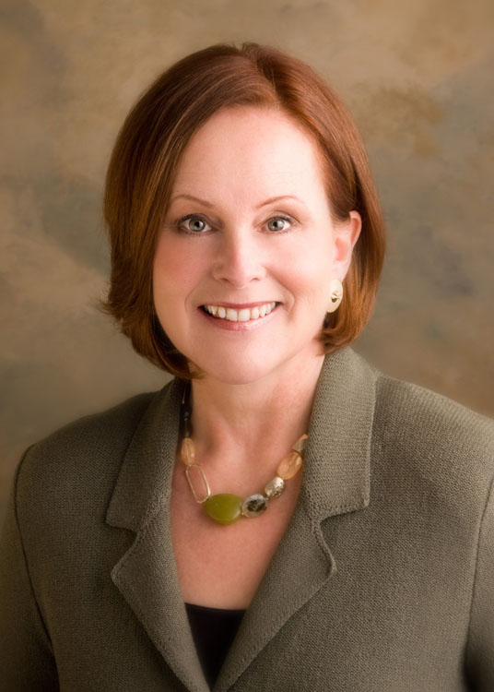

Brief bio: Barbara Babkirk is a Master Career Counselor with a record of success over 22 years guiding career transitions for individuals ranging from executives and attorneys to artists and entrepreneurs.

Her business, Heart At Work, is focused on career counseling and second half of life career transitions. She also offers customized outplacement programs and services.

An engaging communicator and public speaker, Barbara writes a work-related blog for MaineJobs.com, Maine’s largest newspaper site. She speaks publicly on topics related to work and meaning and leads an annual women’s retreat to France.

Presentation titles: Defining Your Edge: How To Increase Your Value in the Marketplace
Reflect, Renew, Regroup: Effective Ways to Re-Engage With Your Work
Recognizing What You Are Called To Do: Vocation in the Second Half of Life
Reinvent Yourself in the Second Half of Life
What Really Matters? Matching Meaning, Passion and Your Unique Contributions at Midlife and Beyond
Fees: $1500-$3000 plus travel and accommodations and cost of handouts
Format: Didactic and interactive with specific takeaways and discussion or Q&A
Length of sessions: 1-2 hour presentation/keynote preferred
Availability: Dates are negotiable with at least a month’s advance notice. Typically out of the country the month of September of any year.
Follow up: Individual career counseling sessions may be arranged by phone or in person at an hourly rate.

