National Career Development Association
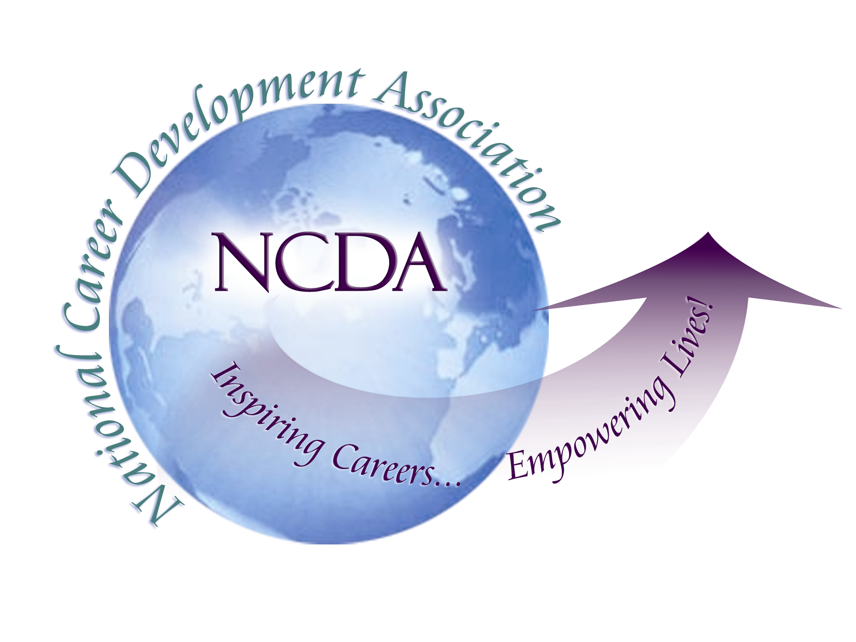
305 N. Beech Circle
Broken Arrow, OK 74012
918/663-7060
Fax: 918/663-7058
www.ncda.org

National Career Development Association
Leadership Academy
Project Summary

Participant(s): Lisa Severy

Board Mentor: Natalie Kauffman

Leadership Academy Class: LA I, 2006-2007

Project Title: Optimizing NCDA Relationships with Local, State, and Regional Associations

Project Description:
- State Career Development Associations (CDAs) have diverse goals, concerns, missions, and challenges. Structurally, they are directly affiliated with State Counseling Associations (CAs) in much the same way that NCDA is affiliated with ACA. While the state CDA and CA relationships work well in some states, others are struggling.
- At the same time, associations divided by state line may limit the potential of groups in the same geographic region (such as high population density in groups of small states or low population density across large states). As an example, Colorado is divided by a mountain range that makes is easier to affiliate with counselors in Wyoming and/or Utah than with Colorado counselors on the other side of the mountain.

In light of these concerns and issues, this project assessed current status of state affiliations with NCDA culminating in a set of recommendations for maintaining the status quo, offering alternative arrangements at the state level, or creating new subgroups based upon local or regional (rather than stat) distinctions.

Summary/Conclusion:
Survey results indicated that:
- State Career Development Associations (CDAs) are well connected to their state Counseling Associations, communicating regularly and providing mutual support. Half of those who responded indicated they had a strong affiliation with another 18% indicating a moderate affiliation. The other 30 indicated a weak affiliation or no affiliation at all.
- State CDAs also feel connected with NCDA headquarters with communication once or twice a year.
- State CDAs did not feel connected to their Regional Trustees very much at all, with many (59.1%) indicating they never communicate with their Regional Trustee.
- The strongest aspects of affiliation with the state Counseling Associations included financial and administrative benefits, dual membership opportunities, and being a part of the counseling community.
- The most frustrating elements of the affiliation with state Counseling Associations included poor communication, confusion over joint memberships, the requirement to share dues, and the exclusion of non-counseling practitioners.
- Other affiliations that state CDA’s reported as important included:
  - State Department of Education
  - State School Counseling
  - State College Counseling
  - State Marriage & Family Therapy
  - Local SHRM
- In terms of how local CDAs were organized:
  - Number of Members/Board:
    - Average: 81/7
    - Median: 100/7
    - Mode: 100/8
  - Frequency of Board Meetings per Year
    - Average: 3
    - Median: 2
    - Mode: 0,2,4
    - Five respondents indicated that their board never meets in person.
  - Mission Priorities
    - Training/Education/Professional Development
    - Networking
    - Political Activism/Advocacy

Results/Recommendations:
  - Very few respondents felt neutral about their relationship to the state counseling association.
  - Large CDAs (>100) with strong boards that meet regularly seem less connected to and have more complaints about the state counseling association.
  - Smaller organizations may need more support
  - Larger organizations are financially stable and would prefer independence
  - Although the mission and goals of most state CDAs are similar, there is a great deal of diversity in terms of membership, budget, board activity, and events.
  - The role of the Regional Trustee is confusing and most state presidents did not understand how to utilize this resource instead of using the NCDA office.

