National Career Development Association
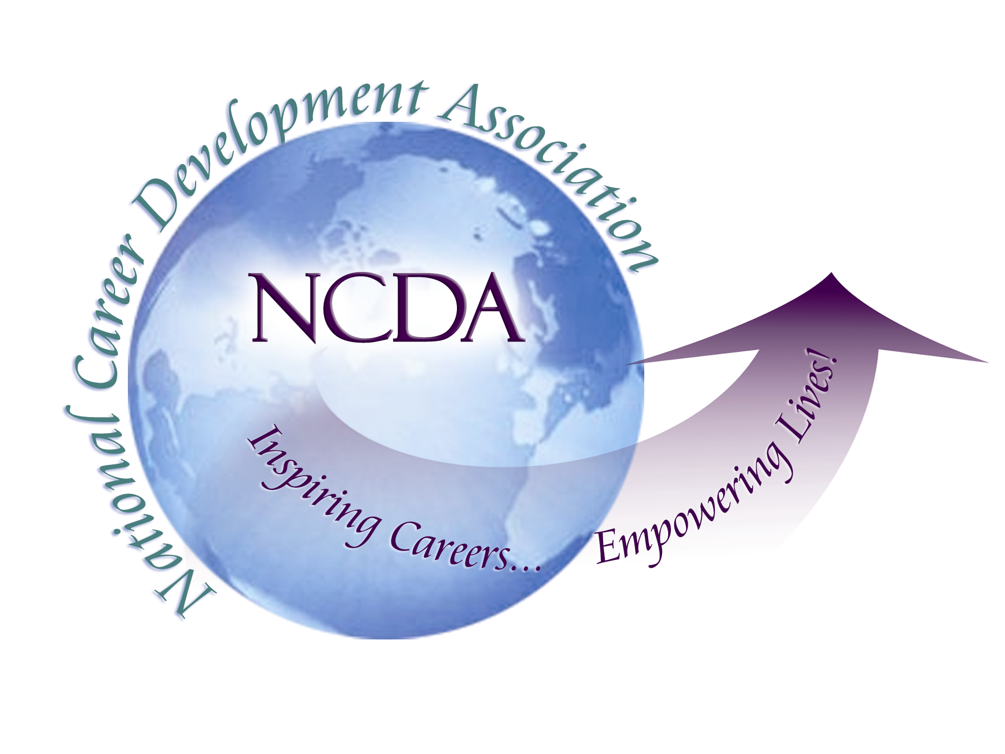
305 N. Beech Circle
Broken Arrow, OK 74012
918/663-7060
Fax: 918/663-7058
www.ncda.org

National Career Development Association
Leadership Academy
Project Summary

Participant(s): Robert Miles, Cindy Sproehnle, and Christopher East

Board Mentor:

Leadership Academy Class: LA II, 2007-2008

Project Title: Career Services in Community & Technical Colleges

Project Description:
- Increase understanding of what we do in our colleges and NCDA
- Further develop NCDA as a resource, promote NCDA membership
- Enable our colleagues to communicate with each other in new ways

Summary/Conclusion:
- Encourage communication among the members
- Promote research on adult career development and programs in 2-year colleges
- Consider special issue of CDQ on 2-year colleges
- Plan to contribute to Career Convergence and encourage others from 2-year colleges
- Encourage and highlight conference presentations
- Welcome continuation by Leadership Academy III team

