National Career Development Association
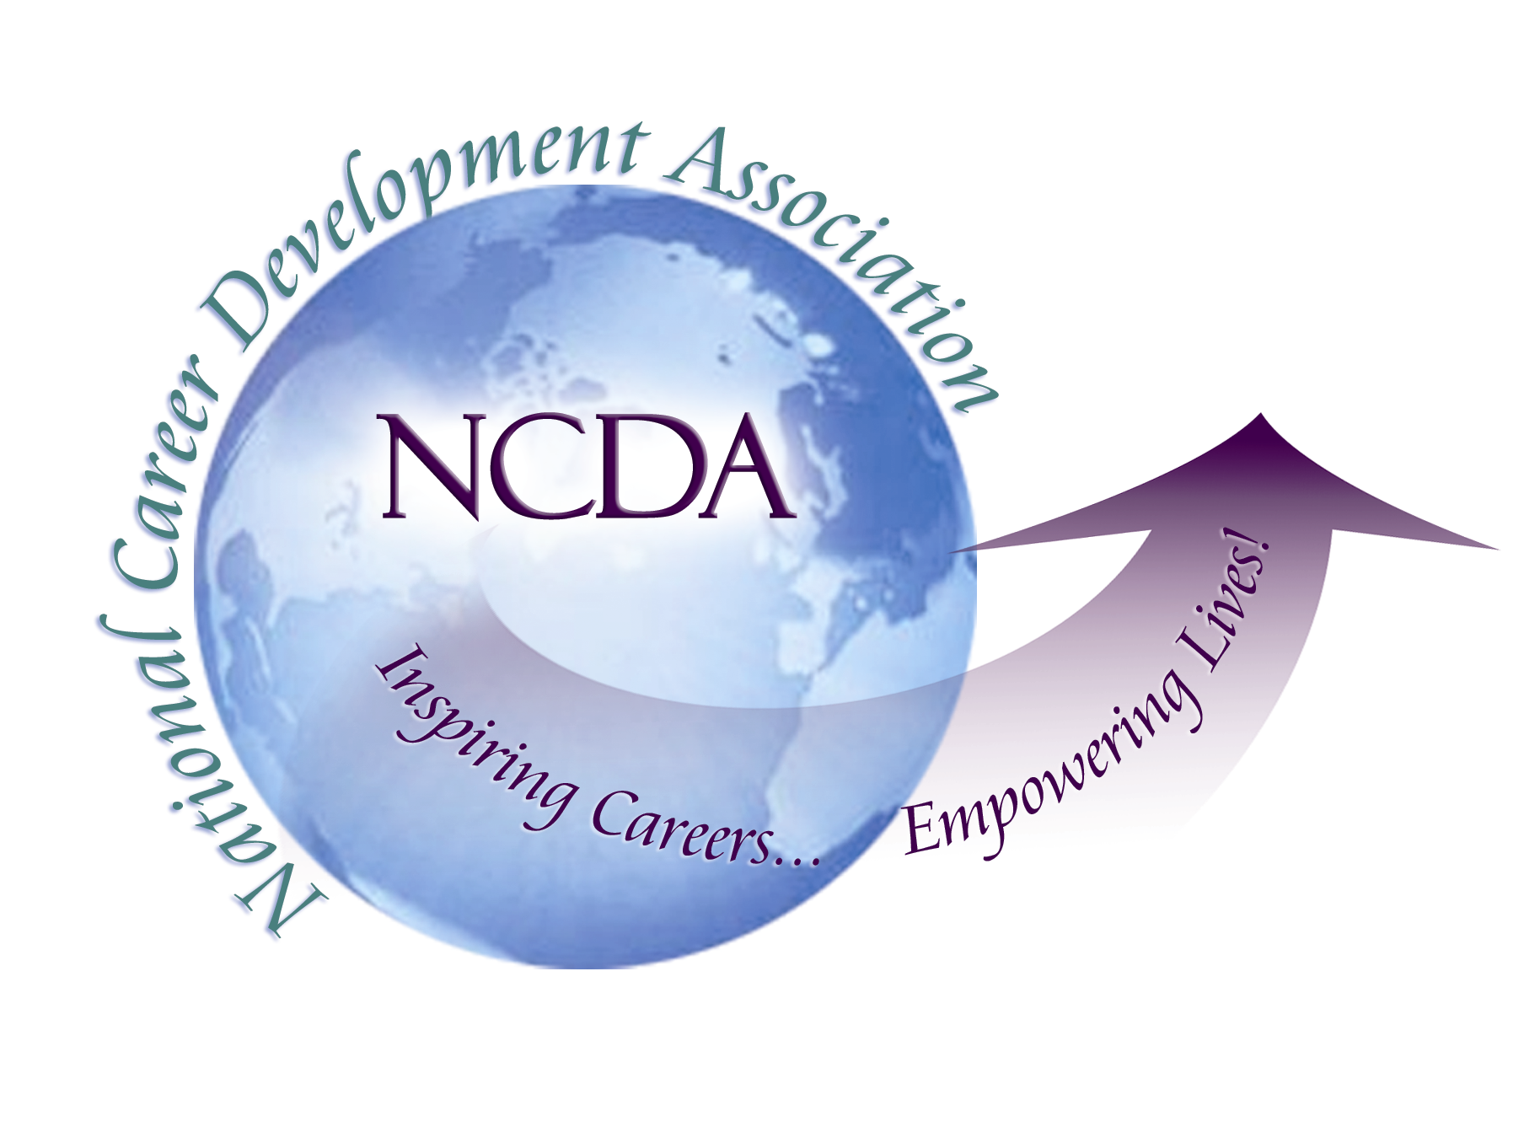
305 N. Beech Circle
Broken Arrow, OK 74012
918/663-7060
Fax: 918/663-7058
www.ncda.org

National Career Development Association
Leadership Academy
Project Summary

NCDA’s communication with CDA’s: What is NCDA doing well and what communication and resources would CDA’s like to see increase?
Christine Lundeen, Leadership Academy 2011-2012
Mentor: Michelle Beese

Who took the communications survey?
This survey was sent out via Survey Monkey to all presidents of the state CDA’s with the request that they send to their board members. There were 43 respondents.
Goals of the survey:
- To gauge how connected the state CDA’s feel to NCDA and NCDA leadership.
- Assessment of CDA’s awareness and view of services and resources NCDA has to offer.
- To increase CDA’s awareness of available services and resources.

Summary and Recommendations:
What NCDA does well:
- State CDA’s feel more connected to their regional trustee than they have in the past. In a 2007 survey by leadership academy participant Lisa Severy, 59.1% of the respondents indicated that they never communicated with their regional trustee. In this survey only 23.3% indicated they never communicate with regional trustees with 44.2% communicating at least 1-2 times per year.

- Over half, 67.4%, reported that they felt connected to NCDA headquarters. 90.7% of respondents reported that their CDA contacts NCDA headquarters 1 or more times per year. Multiple people commented that NCDA is very responsive when asked for information or CEU approvals. Additional comments seem to indicate that those board members that attend the national conference feel more connected than those that do not.

- The website is viewed as a very informative and positive resource with 74.4% rating the NCDA website as good or excellent. Board members are using a lot of the resources with the Resources Section, Poetry and Poster Contest and the Conference sections of the website being the most frequently used.
Areas where communication might be improved:
- There still might be some confusion as to the role and expectations of the regional trustees and when a CDA should use them as a resource rather than contacting NCDA headquarters. There also seems to be a need for more communication on NCDA interactions from the CDA presidents to the rest of the board so they too might feel a stronger connection and understanding of the role of the trustee and NCDA. Some survey respondents suggested the trustee attending part of a state’s board meeting occasionally via Skype or phone call.

- 53.5% of the respondents state that they do not actively use the State Division Handbook to run their CDA. One commenter felt they did not receive the updated handbooks early enough to incorporate in the new president’s cycle every year.

- Highlighting the many resources and services available on the website might help increase awareness – 69.8% of respondents felt that they were not confident that they knew all the resources available to them via the NCDA website.

- 39.5% reported that they are either unaware of the State Division Announcements or they are aware but never read them. Increased visibility and promotion of the State Division Announcements may increase a sense of connection with NCDA and the CDA’s viewing each other as a community.
Summarized from comments from final open ended question: One resource or area of support from NCDA that CDA’s would like to have increased support.
- Tips on growing the membership with comments on how to market more effectively and staying connected to members throughout the state.
- More information on best practices.
- Lists of potential activities and events for CDA’s.
- Speakers for events and professional development was mentioned several times in the comments with people want to better understand how to get speakers from NCDA and just more ideas for speakers in general.
- More contact with regional trustees and potential involvement in meetings.
- Legal support.
- More training sessions for state leadership at national conference.
- Career Mentoring for those with CDF credentials that are job searching.
- Increased announcements on what is happening on the NCDA board – initiatives being addressed.
- More scholarships for board members to attend the national conference to help feel connected.

