National Career Development Association
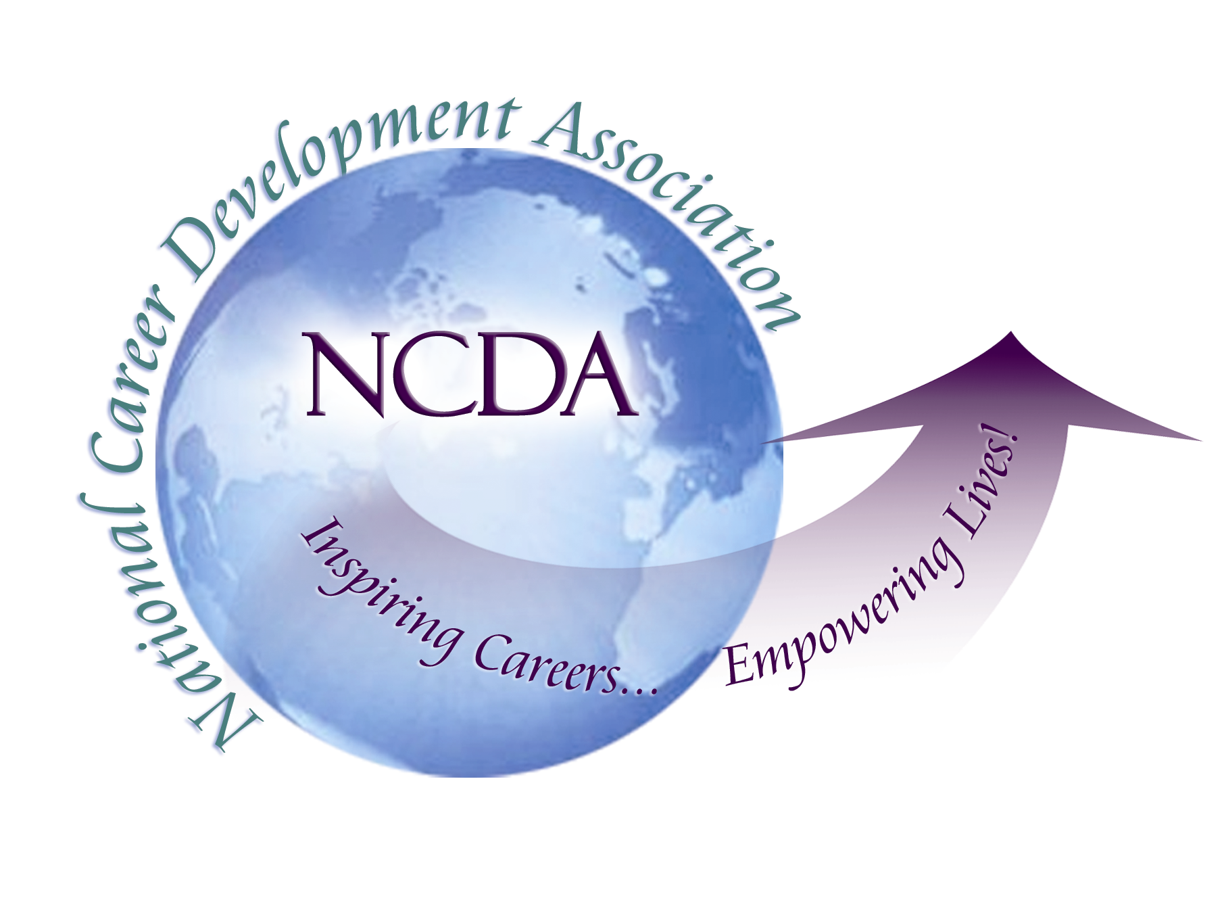
305 N. Beech Circle
Broken Arrow, OK 74012
918/663-7060
Fax: 918/663-7058
www.ncda.org

National Career Development Association
Leadership Academy
Project Summary

Participant(s): Kevin A. Tate

Board Mentor: David Blustein

Leadership Academy Class: LA VI, 2011-2012

Project Title: Looking to Our Roots: Opportunities in Social Justice for Career Development Professionals

Project Description: This was a study of expert opinion (Delphi method) about the career development challenges faced by traditionally marginalized populations in the context of the current economic crisis, as well as action steps that might be taken to address these challenges

Summary/Conclusion: Experts reported several types of career development challenges faced by traditionally marginalized populations. These experts also generated a ranked list of action items that might be carried out to address these concerns (see attached document for full list).

Results/Recommendations: See attached document for recommendations.

Looking to Our Roots:
Opportunities in Social Justice for Career Development Professionals

Recommendations for the NCDA Board

Kevin A. Tate
Marquette University

These recommendations to the NCDA board are a follow-up to a study designed to investigate the career development and work issues faced by traditionally marginalized populations in the context of the current economic crisis, as well as to generate strategies that may be used to address such issues (to review the full results of this study, please refer to the document titled Delphi Study Summary). The experts who responded to this study have outlined dire career development and work issues being faced by traditionally marginalized populations, but they have also given some clear, prioritized guidance on a way forward through these issues. As an organization, NCDA has incredible leverage to affect the lived experience of marginalized populations, and what follows are some beginning steps that the NCDA board might consider in order to improve the career development and work experience of those who have traditionally faced difficult, unfair, and oppressive circumstances.

Recommendations for Action

While it is clear that all of the action items put forth and ranked by the experts in this study are important, I will attempt to pull out two issues from these items that seem relevant to the mission and purview of NCDA. Further, I will provide initial ideas in terms of concrete actions NCDA might take in the near future in relation to these issues.

Issue 1 – Training & Professional Development
This issue was one of the four main categories of action items put forth by the expert panel. Below are some representative items that address the issue of training and professional development (see the end of this document for the full list of prioritized items).

“Increase knowledge, awareness and counseling skills in regard to contextual and cultural factors’ influence on the career development of traditionally marginalized populations.”

“Career counseling and programming should be culturally and contextually relevant to various traditionally marginalized population (e.g., networking, mentor development, career knowledge, and experiential learning) and should be developed in partnership with these populations when possible.”

“Increase knowledge of economic systems and their effect on clients’ career development.”

“Become knowledgeable about resources used to address systemic barriers (e,g, financial assistance, legal rights), as well as developing multilingual methods for communicating these resources to clients (e.g. having Spanish language materials for ESL clients).”

This issue clearly has a strong connection to the NCDA mission of “providing professional development” to career development practitioners (NCDA Mission Statement, 2012). NCDA might act on this item in the following ways.

- Intentionally solicit presentation proposals for the 2013 NCDA conference in Boston that address the issues put forth in the above items. Further, to ensure that a significant number of such presentations occur, a certain number of presentation “slots” could be set aside for said purposes. This would provide opportunity for quality professional development about these issues.
- Create a session/booth at the NCDA 2013 conference showcasing the multicultural career development resources (i.e. Resources for Diverse Audiences) located on the NCDA website.
- As the board moves forward in making choices about internal publications (e.g. monographs), it would also be prudent to include foci for such publications that address the issues put forth in the items above.
- Solicit and endorse a proposed PDI for the 2013 ACA conference that addresses the issues put forth in these items.
- Create a special edition of the Career Development Quarterly that addresses these issues.

Issue 2 – Advocacy & Awareness
This issue was also one of the four main categories of action items put forth by the expert panel. Below are some examples of these items.

“Increase knowledge, awareness and counseling skills in regard to contextual and cultural factors’ influence on the career development of traditionally marginalized populations”

“Advocate for the career development field to re-engage with its roots in social justice through practice, training, research and theory”

“Advocate for increased access to, and support for, educational opportunities for traditionally marginalized populations”

“Advocate for legislation and public funding that addresses unfair structures and practices related to the career development of traditionally marginalized populations, and do so collaboratively with such populations when possible”

“Advocate that employers increase awareness (e.g. the value of marginalized workers), implement training (e.g. challenging occupational stereotypes and implicit biases), and develop policies that increase access and equity for traditionally marginalized populations.”

These items are also clearly linked to NCDA’s commitment to advocacy (NCDA Mission Statement, 2012). What follows are possible action steps in regard to advocacy and awareness.

- Include awareness of the issues explicated in these items in the NCDA Legislative Agenda (2012). While this agenda certainly touches on issues connected to contextual and cultural factors’ influence on the career development of traditionally marginalized populations, there is no clear mission within the legislative agenda to raise awareness about, or push for action in regard to, such issues as the ones above.
- Advocate within ACA (e.g., governing council rep) about the centrality of career and work to the current social justice movement within our field. It is my own subjective perception that career professionals are not viewed by the counseling profession at-large as being on the “forefront” of the social justice movement. This is obviously not accurate, but may be an important issue to address.
- Create an advocacy agenda in relation to employers’ engagement with traditionally marginalized populations. This is a potential method for meeting some of the professional development and networking needs that NACE members may have. For instance, how might NCDA advocate with employers about the value diverse individuals bring to the workplace? This is a more vague suggestion, and depends on NCDA’s current relationships with employers, as well as the board’s philosophy on engagement with employers.

Summary
The above recommendations represent initial ideas for taking concrete steps toward improving the career development and work experience of traditionally marginalized populations. Taking such action is particularly important give the current economic climate, and the disproportionate toll it is taking on such populations. Of course, these recommendations are only a small subset of what might be done, but the important thing is that some action be taken. NCDA is a nationally and internationally recognized organization, and has the power and influence to make large steps forward in the movement toward a more just and humane world for workers world-wide. What is standing between where we are now and a more livable and workable world for everyone? The tough work that organizations such as NCDA were created to do.

Table 1 – Action Item Rankings (5 point scale where 1 = “item should be addressed within 5 years”, and 5 = “Item should be addressed immediately”)
Rank | Item | Category | Mean
1 | Increase knowledge, awareness and counseling skills in regard to contextual and cultural factors’ influence on the career development of traditionally marginalized populations | Training | 4.91
2 | Career counseling and programming should be culturally and contextually relevant to various traditionally marginalized population (e.g., networking, mentor development, career knowledge, and experiential learning) and should be developed in partnership with these populations when possible | Practice | 4.73
2 | Increase knowledge of economic systems and their effect on clients’ career development | Training | 4.73
4 | On college/university campuses, provide career services to marginalized students and alumni by collaborating with student and alumni organizations | Practice | 4.64
5 | Expand the vision of theory and research in the field of career development to include those who have been typically left out of the career development narrative | Theory & Research | 4.55
5 | Advocate for the career development field to re-engage with its roots in social justice through practice, training, research and theory | Advocacy | 4.55
7 | Career counseling and programming should be focused on increasing self-efficacy, resilience, client strengths, and building skill sets to overcome systemic barriers (e.g. racism, sexism, educational access) | Practice | 4.45
8 | New and effective interventions should be developed in order to increase critical consciousness and skill development among marginalized clients | Theory & Research | 4.36
9 | Increase clients’ knowledge of, and reframe beliefs about, various career paths and fields | Practice | 4.27
9 | There should be career development professionals from marginalized groups represented in career services organizations | Practice | 4.27
11 | Become knowledgeable about resources used to address systemic barriers (e,g, financial assistance, legal rights), as well as developing multilingual methods for communicating these resources to clients (e.g. having Spanish language materials for ESL clients) | Practice | 4.18
12 | Advocate for increased access to, and support for, educational opportunities for traditionally marginalized populations | Advocacy | 4.09
13 | Advocate for legislation and public funding that addresses unfair structures and practices related to the career development of traditionally marginalized populations, and do so collaboratively with such populations when possible | Advocacy | 4
14 | Advocate in general at the national and community level for the importance of work in the lives of all people. | Advocacy | 3.82
15 | Increase knowledge of legal regulations and protections that apply to traditionally marginalized populations | Training | 3.73
15 | New delivery models will need to be developed in order to make up for a shortage of career development professionals | Theory & Research | 3.73
17 | Advocate that employers increase awareness (e.g. the value of marginalized workers), implement training (e.g. challenging occupational stereotypes and implicit biases), and develop policies that increase access and equity for traditionally marginalized populations | Advocacy | 3.55
18 | Reestablish and create more programs for career counselors throughout the country; further, these programs should be designed to train future professionals meet the unique needs of traditionally marginalized populations, particularly in relation to the local contexts of the clients being served by program graduates | Training | 3.45

