National Career Development Association
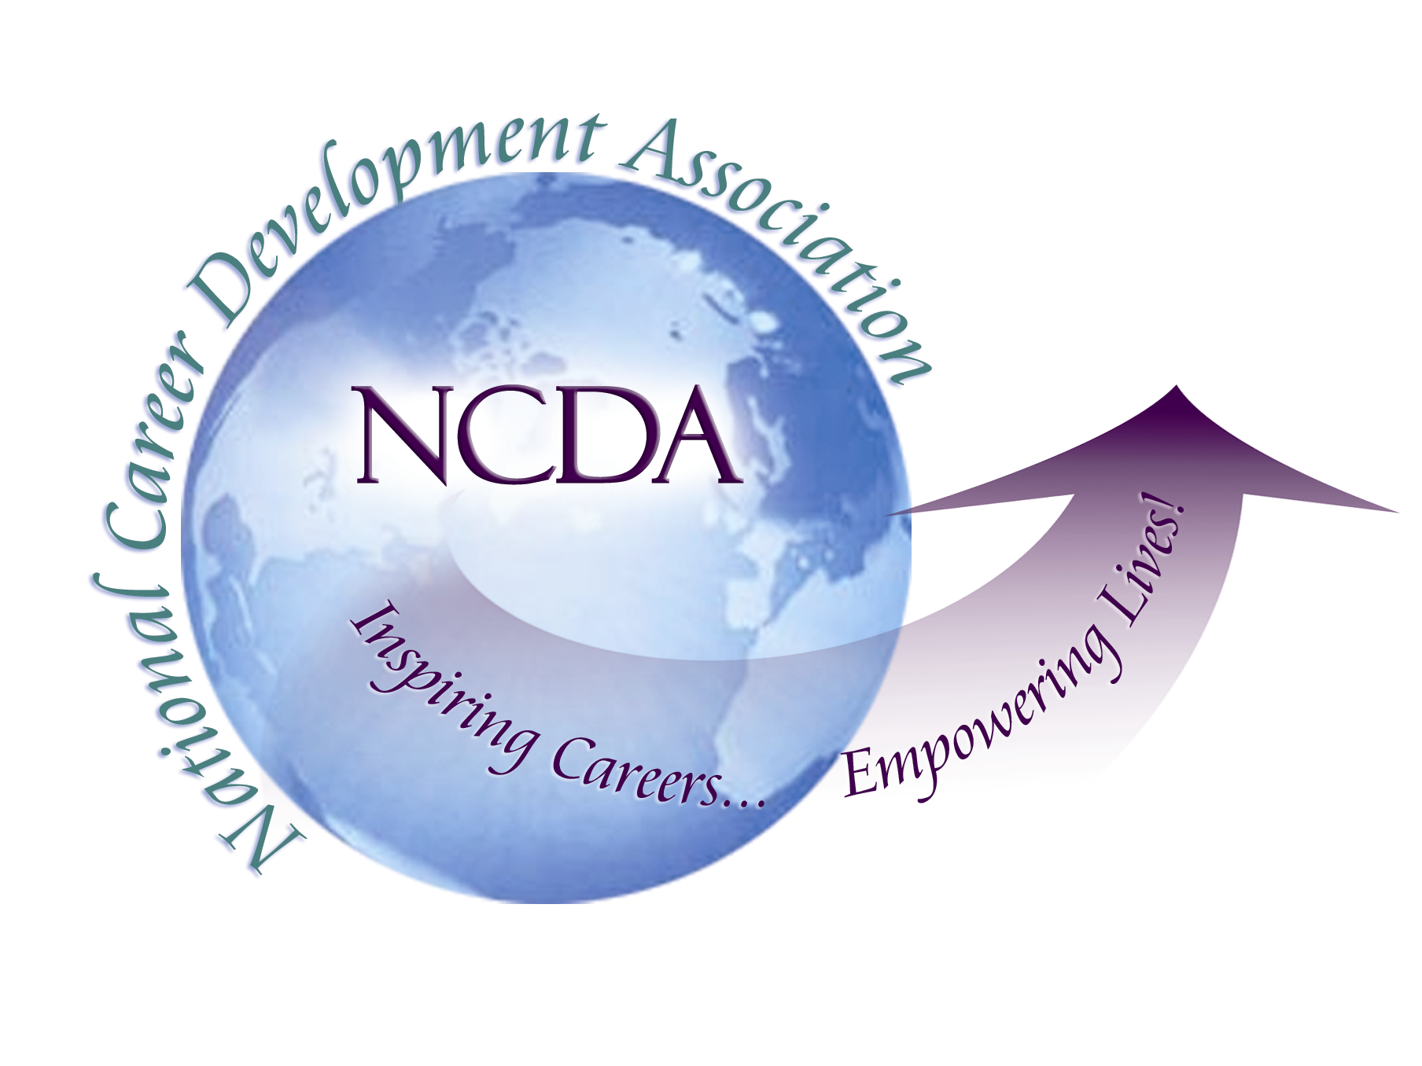
305 N. Beech Circle
Broken Arrow, OK 74012
918/663-7060
Fax: 918/663-7058
www.ncda.org

National Career Development Association
Leadership Academy
Project Summary

Participant(s): Stephen Cantine

Board Mentor: Brian Taber and Ron Cathey

Leadership Academy Class: LA VI, 2011-2012

Project Title: Evaluation of the Leadership Academy

Project Description:
- I surveyed Leadership Academy Participants, including current participants.
- My goal was to gain feedback about the Leadership Academy, its processes and identify any areas for improvement.

- I surveyed NCDA members who had not participated in the Leadership Academy.
- My goal was to find out what they knew about the program and what would influence them to participate.

- I Created a Leadership Academy brochure.
- My goal was to increase Leadership Academy awareness among nonparticipants.

Summary/Conclusion:
There were many interesting statistics that I gained as a result of the two surveys; some major ones are listed below.
- 57% of non-participant respondents stated that they didn’t know the Leadership Academy existed
- 73% of non-participant respondents stated that having a better understanding the Leadership Academy benefits would be a motivator for participating in the Leadership Academy
- 74% of Leadership Academy participants rated the application process as very good or excellent
- 32% of Leadership Academy participants have run for office since completing the program
- 94% of Leadership Academy participants stated they grew professionally

Results/Recommendations:
Below are recommendations that came from survey respondents, as well as my own recommendations
- Have Leadership Academy participants regularly update the board on their projects instead of just at the end
- Formalize a way for LA members to mingle more with the board
- More frequent support and over-arching goals discussion of Leadership Academy
- I would have liked to see some leadership training modules for the participants throughout the term
- I would have liked to be in touch with the other participants throughout the year in some capacity so that we could discuss our individual experiences during the process. - Create an online community communication format (e.g. Moodle)
- NCDA needs to do a better job of promoting the Leadership Academy. It is an awesome opportunity that not enough members know about
- There should be more opportunities for the first and second year classes to interact

