National Career Development Association
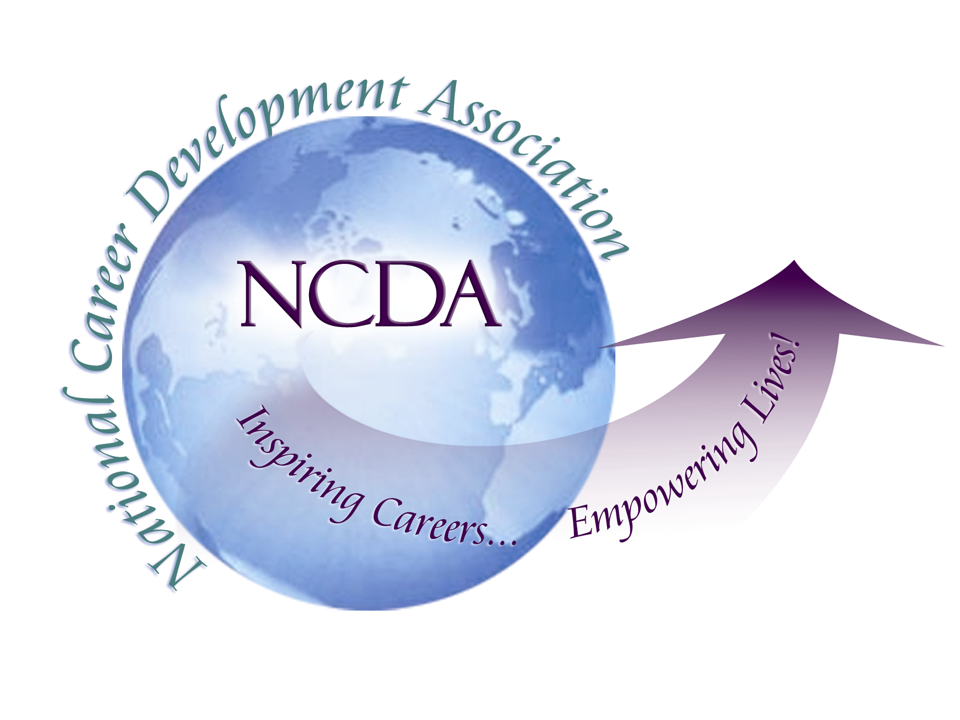
305 N. Beech Circle
Broken Arrow, OK 74012
918/663-7060
Fax: 918/663-7058
www.ncda.org

National Career Development Association
Leadership Academy
Project Summary

Participant(s): Ahmed Mostafa Kamal

Board Mentor: Cheri Butler

Leadership Academy Class: LA VI, 2011-2012

Project Title: CAREER DEVELOPMENT IN FOREIGN COUNTRY

Project Description:
What if the young Arabs are not sure of what kind of job or career they want? Not sure what to do with their life? Need some career direction?
Labor mobility will be facilitated by higher qualification requirements at all occupational levels, yet it is recognized across the MENA region that there is a gap between education outcomes and workforce needs. There have been initiatives to develop consistent, output based qualification frameworks, but these are long term plans that are faced with tremendous logistical and political challenges, and additional action is required to address immediate youth unemployment issues. The large numbers of young people in the MENA could turn into a real opportunity for the economies of this region, provided these young people have the right skills to access employment and enterprise opportunities.

Youth’s attitudes toward work and the requirements of work is also a contributing factor to unemployment. Many youth are oblivious to the proper way to present oneself, work in a team, and communicate professionally.
Keeping a balance between personal and professional life is quite important for any person. At times we get so much stressed out owing to the work pressure that the momentum is somewhere lost. Career counseling is one such practice that aids people by making a connection between passion to work, purpose to do a task and understanding and acknowledgement of work; and it is one of the most important sciences in life, to help people make the best career choices and hence reach career satisfaction. Unfortunately, this science is seriously lacking in the MENA market. There are very few and limited providers of this service. Besides, awareness about this science is minimal to non-existent. Consequently, people’s career choices are not ideal. Keep in mind that career planning is a continuous process that allows people to move from one stage to another stage as peoples life changes. They may even find themselves going back to look at who they are again after exploring how to get there. Learning to negotiate the career planning process now is essential, considering most people will change careers several times in a lifetime.

Summary/Conclusion:

This study illustrate the real life experience in the MENA Region “Mainly Egypt and some other Arab countries”; it talks about the following factors:
- Starting point;
- Implications;
  - Knowledge
  - Language
  - Fund
  - Career Information
  - Marketing
  - Human Resource
- Lesson Learned

Results/Recommendations:
The main purpose of this study is demonstrate the sequences I went through to initiate the career development field in Egypt, in order to give my own recommendation for establishing a regional chapter for NCDA. Taking into consideration all difficulties, challenges and issues I had since 2007 – 2012.
There is two ways of having the NCDA chapter in the MENA (Middle East and North Africa) region.
First; is to go and localized the chapter by country; meaning that each country can have NCDA chapter; and this model we can call it the distributed model.
Second; is to have one NCDA chapter for the entire MENA region and have representatives in each country; and we can call this as the centralized model; and I highly recommend this model than the distributed model.
Since NCDA is growing fast on the international level; there should be an international department in addition to the international committee that will be focused only on managing, supporting and sustaining the international initiatives since it all work under the umbrella of the NCDA.
Yet this will need some investment from the NCDA, but once it worked fine it will be a great channel for fund raising to the NCDA.

