National Career Development Association
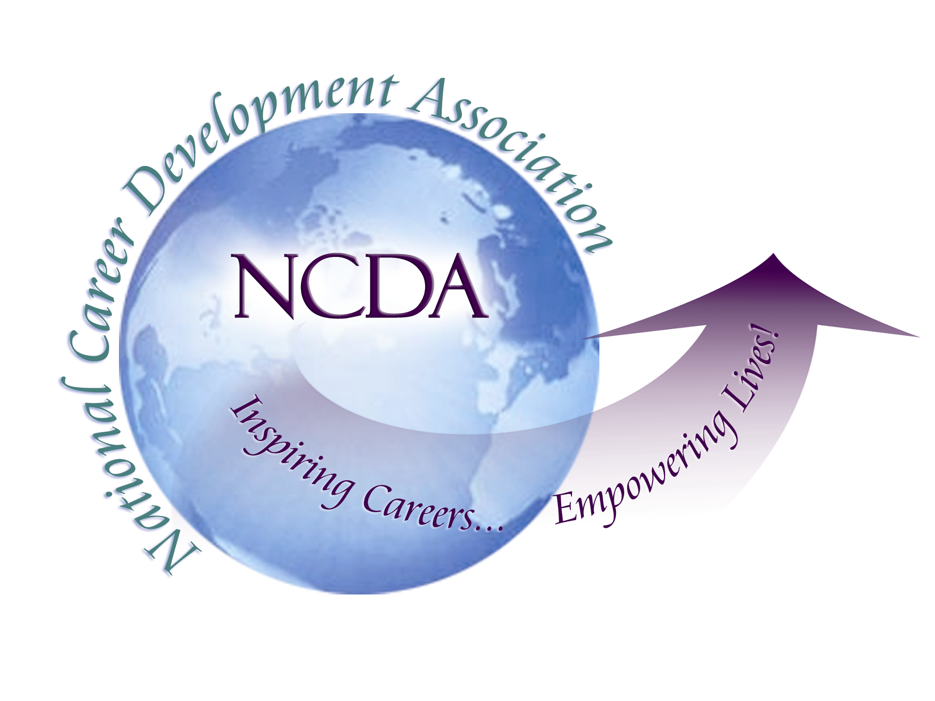
305 N. Beech Circle
Broken Arrow, OK 74012
918/663-7060
Fax: 918/663-7058
www.ncda.org

National Career Development Association
Leadership Academy
Project Summary

Participant(s): Marjorie L. Hendrickson, Jeanette James, Rebecca Ross, and Michael Frank

Board Mentor:

Leadership Academy Class: LA I 2006-2007

Project Title: The NCDA Brand Among Career Professionals

Project Description: This topic was chosen because how career professionals perceive NCDA affects its credibility, the ability to achieve its missions and goals, as well as attract membership.

Summary/Conclusion: A comprehensive survey was given to all NCDA members as well as additional professional associations. The data was then analyzed by combining the results of the open-ended, qualitative questions in logical groups. The group was narrowed to five key themes: Diversity of Membership, Focus of the Organization, Professional Development, Organizational Communication, and Local, State, & Regional Organizations.

Results/Recommendations: Specific recommendations were given for each key theme.

