National Career Development Association
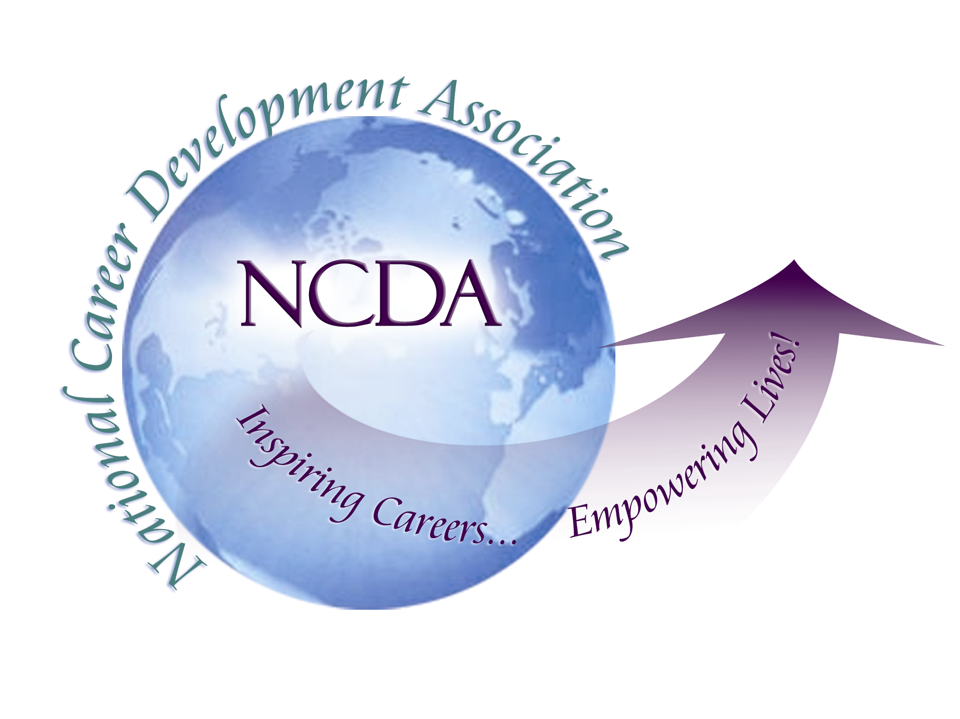
305 N. Beech Circle
Broken Arrow, OK 74012
918/663-7060
Fax: 918/663-7058
www.ncda.org

National Career Development Association
Leadership Academy
Project Summary

Participant(s): Diana Bailey

Board Mentor:

Leadership Academy Class: LA I, -2007-2006

Project Title: Public Policy Initiatives Supporting Linkages with NCDA and Workforce Development Outcomes for Current and Ex-offenders

Project Description: The public policy arena of career development and workforce development is extensive and complex. I had planned to partner directly with other academy members proposing a plan related to public policy, but in an effort to limit the size, scope and provide activity focus, I thought it best for submission individually, but with contact/linkage with other public policy partners and academy members as appropriate.

This project report and references summarize key elements of career and workforce development policies and practices for adults, specifically offenders usually needing a full range of preparation skills for employment in their career pathway. I will analyze these elements; provide references, reports, other professional contacts/agencies that can also provide input and analysis from others in the offender workforce development field. This crosswalk provides a summary document that will lead discussion and potential recommendations for the NCDA board and its partners.

Summary/Conclusion:
Appendices
-Policy resources related to the topic
-Websites for current info and updates
-Meta-analysis of secondary topics impacting career/workforce development
-NCDA article re Career Dev Services in MD
-Survey Questions: NIC blog, NCDA and ACRN list serves

Results/Recommendations:
-Link to policy priorities of NCDA
-Focus on doable, meaningful issues
-Identify/expand “partners” with common issues: CEA, ACRN, NIC at state/local levels as well
-Build evidence-based practices or policy revisions
-timeline, who, lead, etc.

