National Career Development Association
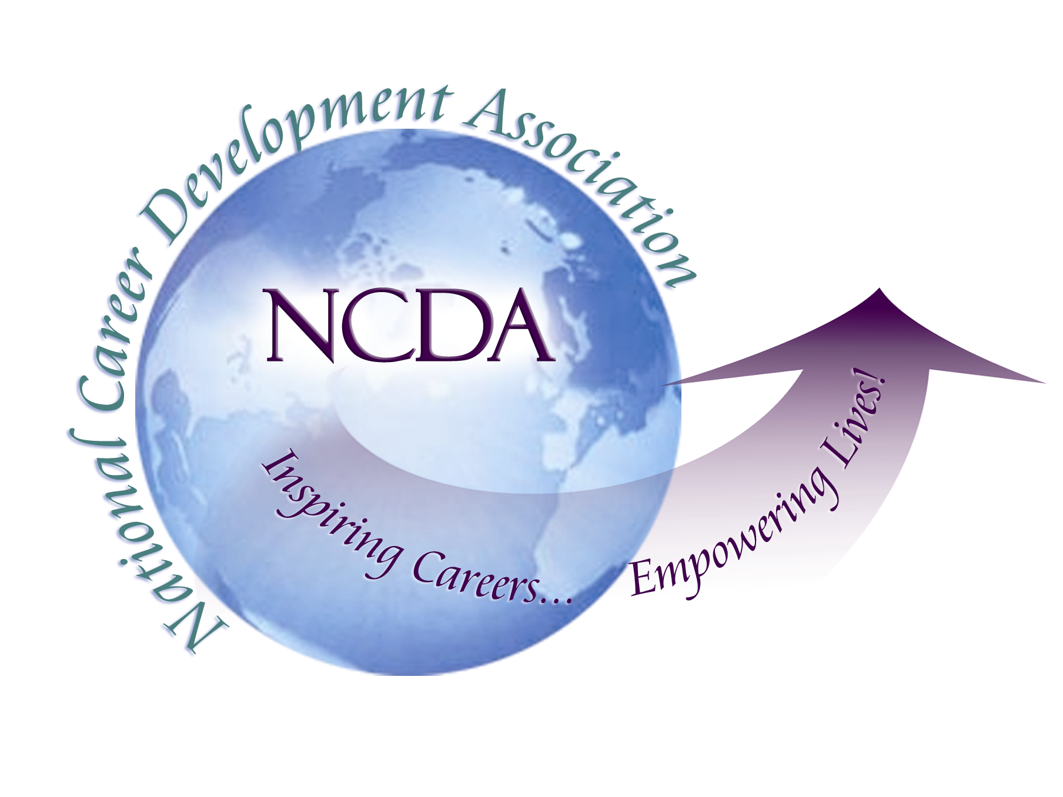
305 N. Beech Circle
Broken Arrow, OK 74012
918/663-7060
Fax: 918/663-7058
www.ncda.org

National Career Development Association
Leadership Academy
Project Summary

Participant(s): Maggie McCormick, Carol Mason Trotter

Board Mentor:

Leadership Academy Class: LA II, 2007-2008

Project Title: Strengthening the Partnership between NCDA and Business and Industry through Corporate Memberships

Project Description:
In today’s world, career development is a lifelong process. The National Career Development Guidelines reflect this tenet. The Guidelines also suggest that, in addition to specific job and transferable skills, adults need to have career management skills in order to adapt to a changing marketplace and workplace demands and to maintain job and life satisfaction in the midst of such change.

Every day, career development professionals in business and industry work to foster those skills and help adults make sound career decisions. They are champions of change management as they live and work in the midst of the world of work and help others to do so successfully. Given our shrinking labor force, they significantly contribute to their organizations’ talent management and succession planning as well. Whether or not they have counseling education, many are highly trained and skilled in adult career development.

The partnership between business and industry and NCDA is a logical relationship in which all members could benefit from the broadened perspectives and contributions. There are currently members whose employment involves business and industry (90 members or about 2% of our total membership.) A much smaller percentage of those members seem to actively participate or attend the conferences.

Purpose:

- To recommend a membership structure and fee that will be conducive to increasing membership from career development professionals working in business and industry
- To better market the benefits of NCDA membership to business and industry
- To promote participation in NCDA from members who are employed in business and industry

Results/Recommendations:
To increase membership and participation from career development professionals employed in business and industry, we propose the following:

- Group Membership/Single Billing – All members are subject to the same fee schedule for any other NCDA members, currently $23.00 for a new professional (first year of membership) and $55.00 for each year after that. Under a group membership structure, organizations would have the option of being billed and submitting a single payment for the membership fees for multiple employees. Along with payment for membership fees, organizations would need to submit a membership form for each individual joining or renewing membership, and to indicate for each whether or not it is a new or renewed membership. A group membership form, or other procedures, could evolve as the program grows.

Employees of a member organization could continue to join individually. The NCDA office is willing to work with an organization to facilitate common timing for renewals.

- Conference Registration Discounts – For career development professionals who are non-counselors, it is likely that the most relevant benefit of their membership – and the one that initially attracts them to be members - will be attendance at the annual NCDA conference. To encourage the participation of business and industry and thereby increase membership of this audience, we propose that there be a discount offered of 10% off conference registration and Professional Development Institute fees for 4 or more conference participants registered with the same check or credit card. The organization would need to submit a registration form for each participant.

- Additional Recommendations – In order to attract and sustain membership from career development professionals in business and industry, we recommend that there be continued efforts to provide the following:

  - Marketing – Development of marketing campaigns and/or materials to promote membership among career development professionals in business and industry
  - Presentation sessions – Content sessions that address the career development issues of adults in the workplace offered at conferences; encouragement of those members to submit proposals to present
  - Networking opportunities – “Birds of a feather” receptions, idea exchanges, and other networking opportunities should be offered at conferences
  - Articles – Submission of articles to NCDA publications regarding career issues of adults

