National Career Development Association
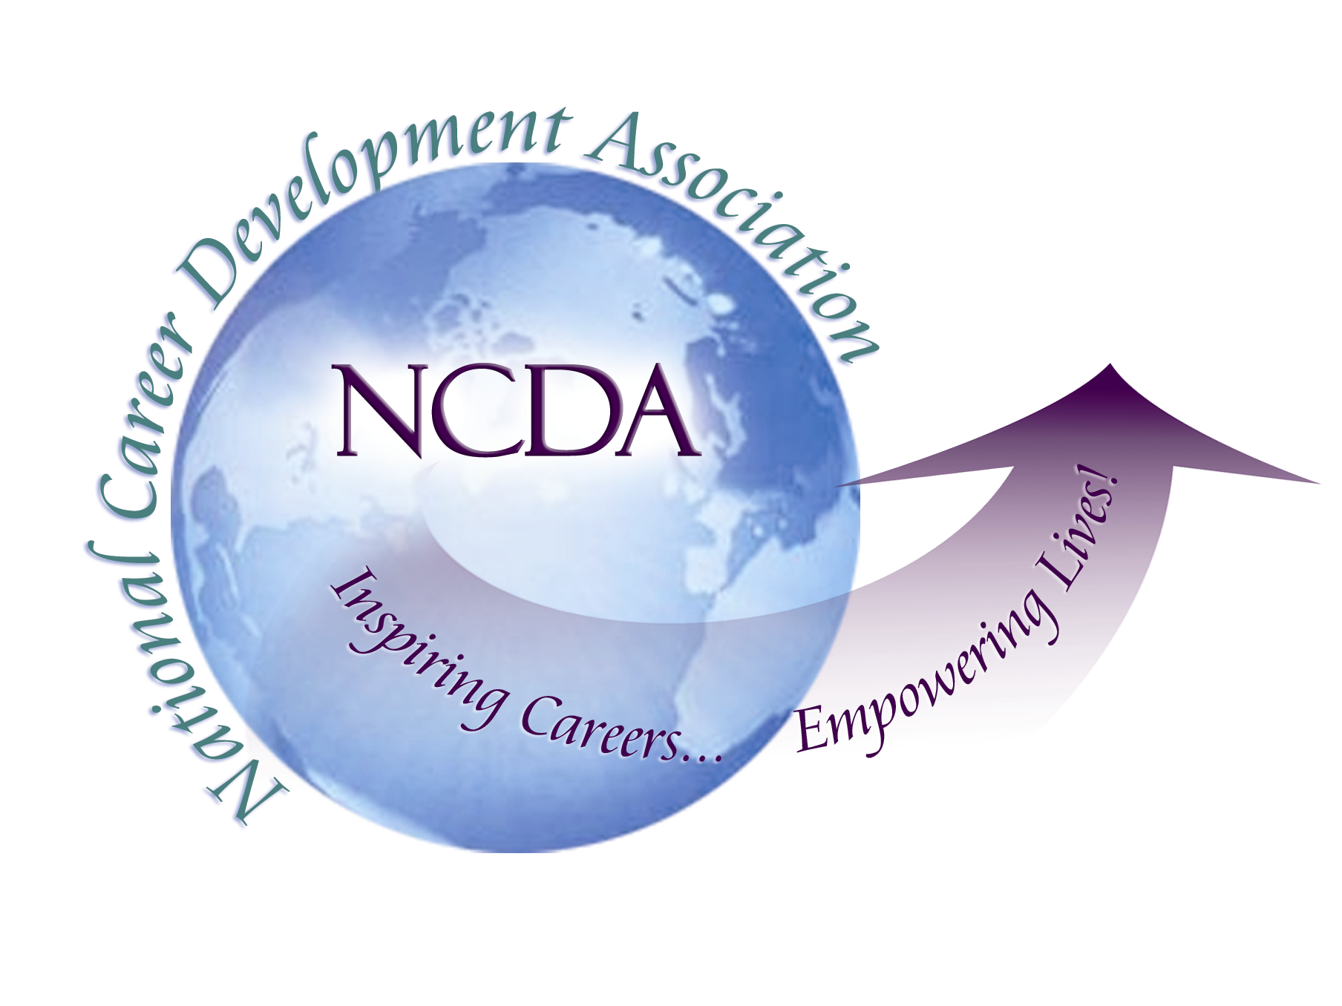
305 N. Beech Circle
Broken Arrow, OK 74012
918/663-7060
Fax: 918/663-7058
www.ncda.org

National Career Development Association
Leadership Academy
Project Summary

Participant(s): Julia Makela

Board Mentor:

Leadership Academy Class: LA II, 2007-2008

Project Title: Code of Ethics

Project Description:
After more than a year of effort by many dedicated professionals the National Career Development Association introduced a new Code of Ethics in July 2007. This was a significant event for our association, membership, and the field of career development as a whole. During this time, I was reminded that ethics can be a “hard sell” for professionals, both old and new. How many of our members would take the time to read this important document and fully understand the meaning behind the text? For this project, I intended to bring the Code of Ethics to life via an engaging and thoughtful case study method.

I began by soliciting case study suggestions from other members of the Leadership Academy and the greater NCDA members, as well as researching past issues that had been brought to the attention of the NCDA’s Ethics Committee. Every effort was made to acquire examples from the wide variety of career development settings that our association serves.

Summary/Conclusion:
As a product for the Leadership Academy experience, I presented five case studies which presented ethical challenges followed by guided discussion which addressed questions such as:

- What section of the NCDA Code of Ethics addresses this situation?
Each case study was directly tied to the new Code, and encouraged readers to familiarize themselves with the document.
- What additional information would be helpful regarding the situation?
Recognizing that no case study write up can address every detail of the encounter, readers were encouraged to brainstorm additional information that would be needed and/or helpful to address the situation.
- What response, or series of responses, might you take to address the situation?
Readers were encouraged to consider options and articulate action steps to address the difficult situations presented.

Following my presentation for the Leadership Academy, I was encouraged by the NCDA Board and Publications Development Committee to submit a proposal to turn this project into a monograph for the association.

That monograph is currently underway, expanding and enhancing the original product. It is designed to make the heavy, intimidating topic of ethics and professional standards accessible to career development professionals at all levels. It has the potential to engage and intrigue beginners-in-training who are attempting to navigate difficult situations, seasoned professionals who are looking to enhance their learning through shared experiences with colleagues, and all those in-between. The expected publication date for this resource is June 2009. Look for it in NCDA’s Career Resource Store!

