National Career Development Association
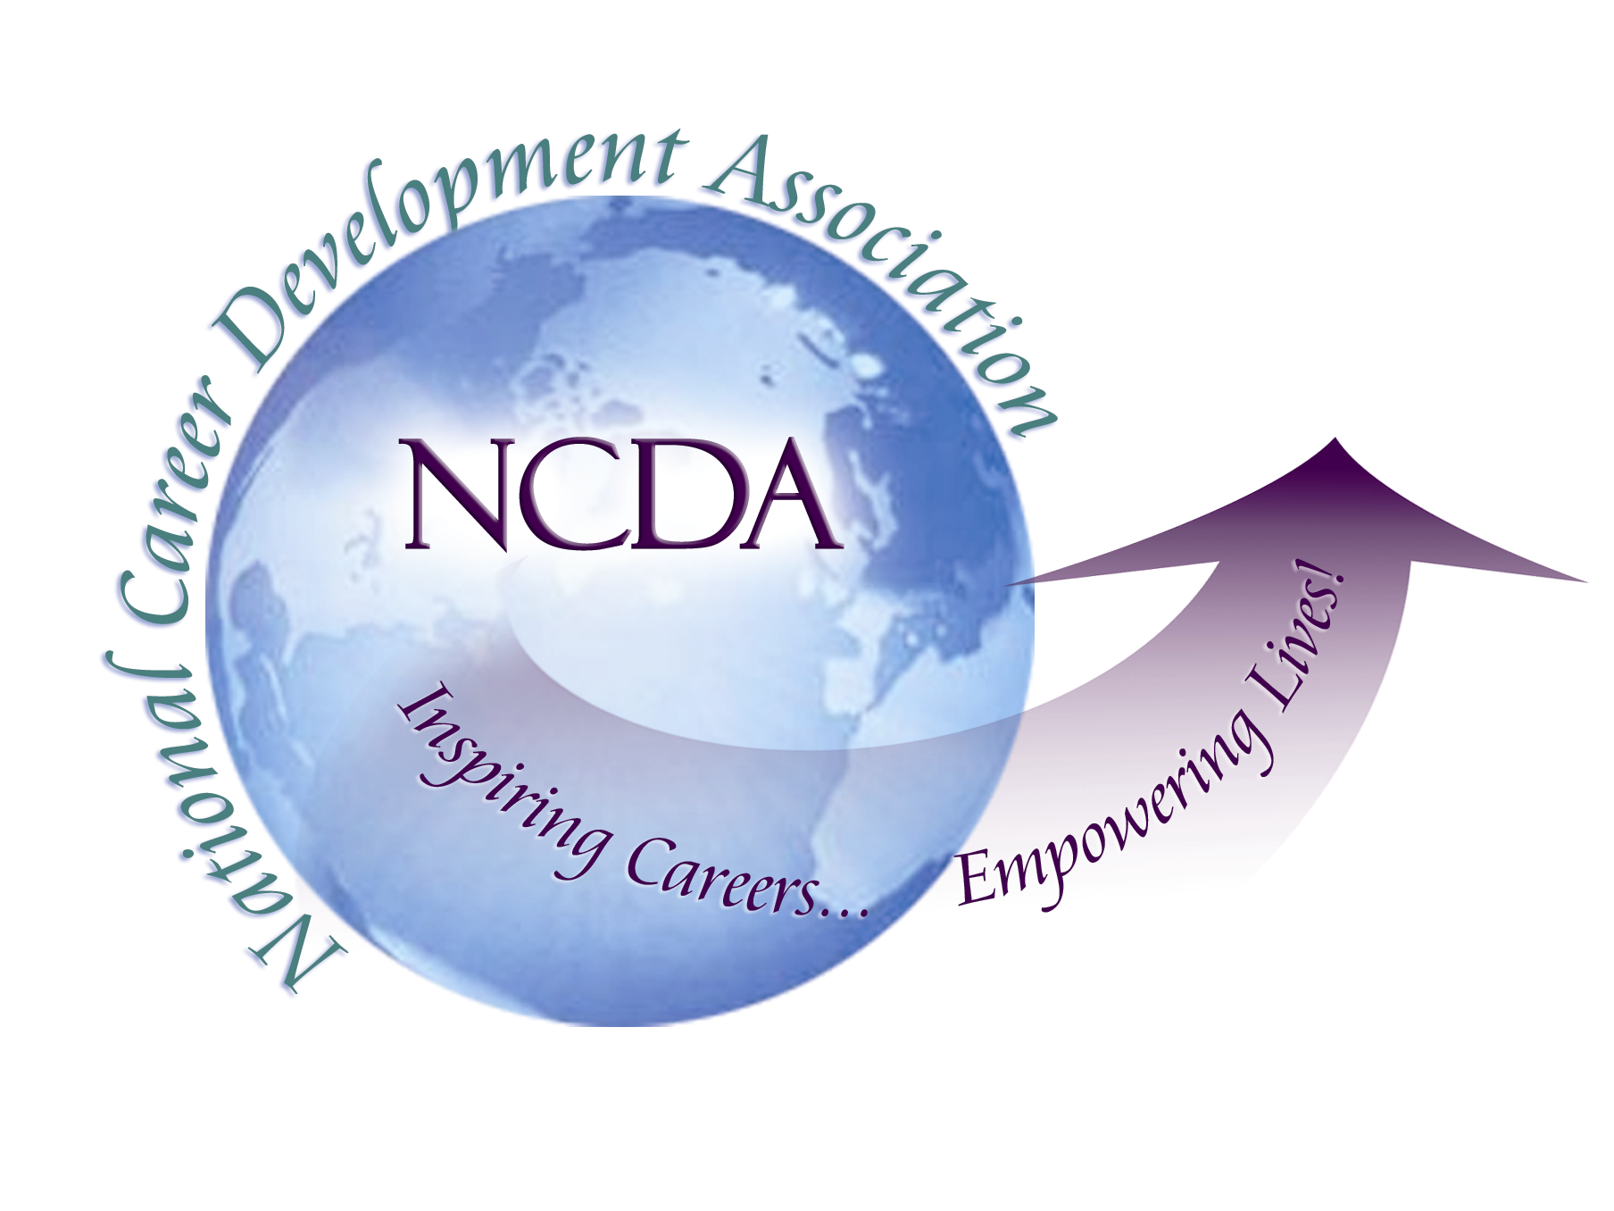
305 N. Beech Circle
Broken Arrow, OK 74012
918/663-7060
Fax: 918/663-7058
www.ncda.org

National Career Development Association
Leadership Academy
Project Summary

Participant(s): Zoe Payne and Tanya Campos

Board Mentor: Charles Lehman

Leadership Academy Class: LA II, 2007-2008

Project Title: Branding NCDA’s Website: Enhancing the Web Face of NCDA

Project Description:
In the 21st century, the successful utilization of internet technology is vital to career development and the potential growth of NCDA. As NCDA seeks to expand and enhance services to its membership throughout the nation and around the world, one of the primary portals of access to NCDA is via its website.

A thorough user review of current usage, needs, and ease of use of the NCDA website as it appears today carries the potential of broadening and strengthening the recent re-branding of the organization.

Summary/Conclusion:
As a result of this project, recommendations of possible ways NCDA can meet the web portal needs of its current member and non-member users will be developed with the hopes of attracting more members, enhancing services delivered to current users, and increasing conference attendance.

