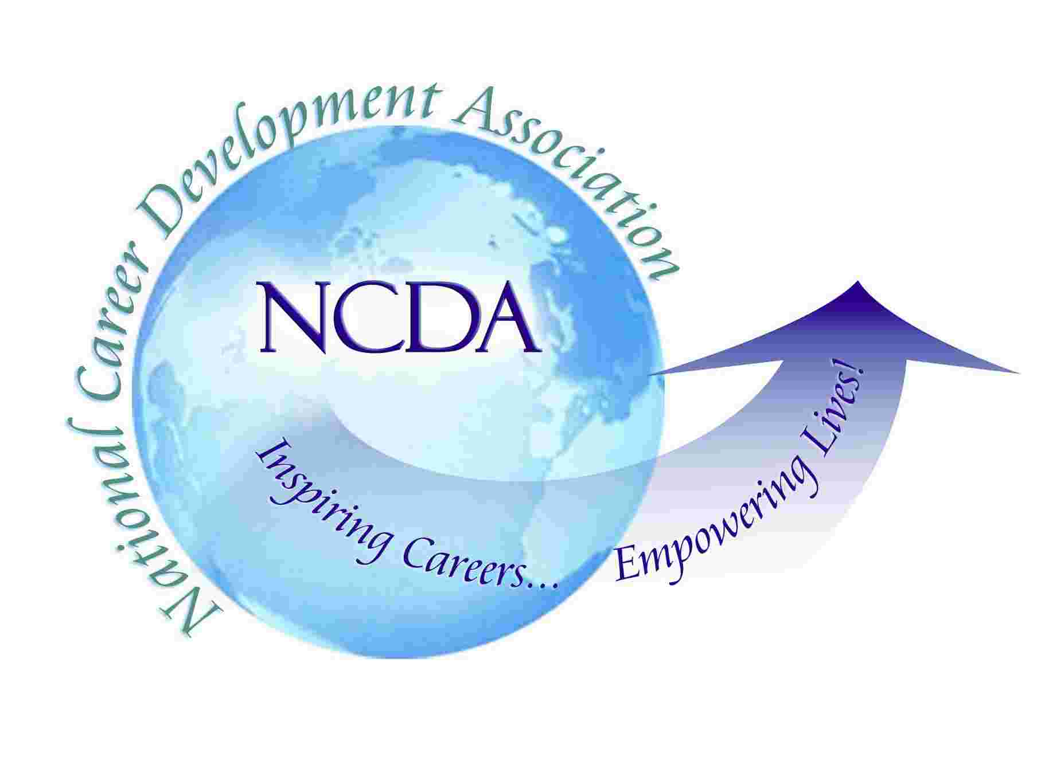
NCDA CDF Instructor Continuing Education Log

Record the activities that you attend for recertification of your NCDA CDFI Certificate. The activities must occur within the five-year certification cycle. You must obtain 75 hours during each five-year cycle. Any course or activity offered by an NBCC-sponsor or state licensure-approved provider that addresses one or more of the CDF competency areas is acceptable. You need only to send documentation if you are selected for a random audit.

Name:

My certification date is:

My expiration date is:

Dates | Course/Activity | Content Area | Provider/Sponsor Name | Type of Documentation | # of Hours

