National Career Development Association
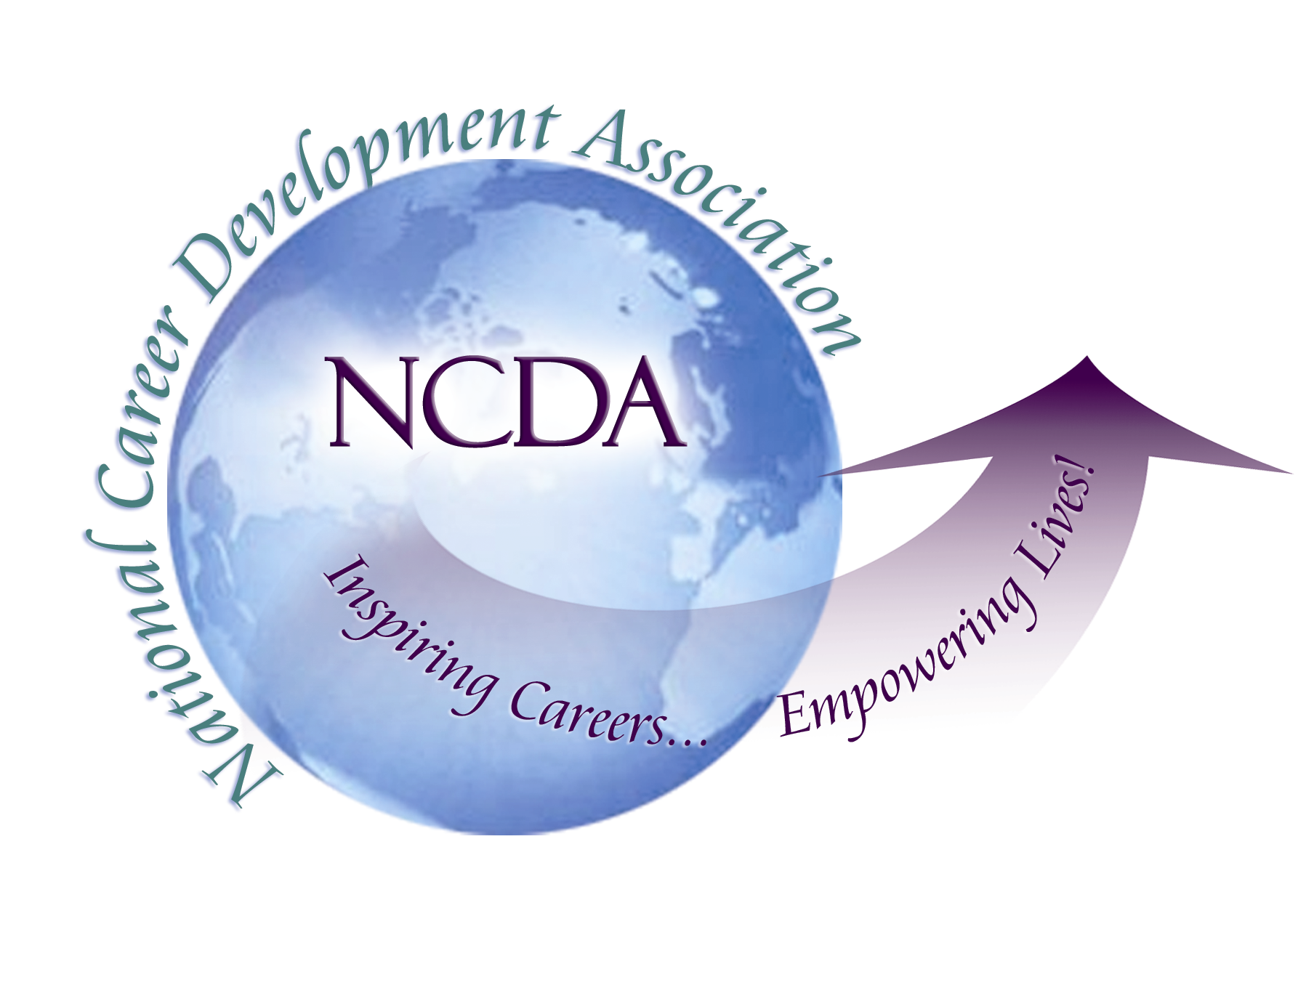
305 N. Beech Circle
Broken Arrow, OK 74012
918/663-7060
Fax: 918/663-7058
www.ncda.org

National Career Development Association
Leadership Academy
Project Summary

Participant: Dianne Brooks

Board Mentor: Michelle Beese, Western Region Trustee & Mark Danahar, President Elect
Leadership Academy Class: LA VII, 2012-2013

Project Title: Research current technology resources and assess membership interest in attending NCDA’s National Conferences and State and Local meetings via virtual means.

Project Description: It’s an honor and a privilege that we gather to celebrate the centennial anniversary of National Career Development Association (NCDA) in its birth place, Boston, Massachusetts, in 2013. One hundred years is a significant achievement in the life of any organization. As we celebrate the past we also recognize that we are standing on the brink or our second century and need to embrace the future. This goal of this project will gather information and interest in how NCDA can use virtual technology to enhance the successes of NCDA’s next 100 years.
The project was designed to gather information about virtual technology such as video conferencing to serve as an option (not to replace face to face) that members can use to attend NCDA conferences and meetings. The hope was to host a trail run of a virtual presentation at this year’s conference if preparation was feasible. In pursuit of this goal, I outlined the following action steps:

- Research the technological resources currently used for hosting virtual meetings.
- Gather information on the pros and cons of virtual meetings
- Create a survey to assess current membership interest for attending virtual conferences.
- Investigate costs accrued in hosting virtual meetings.

Summary/Conclusion:
We are currently facing some tough economic times, and budgets are tight. More than ever professionals are engaging in meetings via in person, by phone, or by virtual technology. The role of virtual meetings is evolving. But the virtual event is still in its infancy; it’s a child of the new millennium.
NCDA along with most organizations are still trying to understand just exactly what a “virtual event” is. Basically, virtual events are a gathering of people sharing a common virtual environment on the Web, rather than meeting in a physical location. There are many different kinds of virtual events; the following is a description of the more relevant types:

- Web conferencing: Collaborative interacting over the Internet
- Webcasting: Broadcasting over the Internet
- Webinar: Web-based Seminar
- Virtual Fair & trade show: 3D collaborative environment

Pro: Same Event for Less
Advancing technologies are making virtual events not only a less expensive replacement for physical meetings but also a superior one. Why do we have meetings and events? 1) to exchange information; and 2) to network. Virtual meetings and event technology can facilitate these two objectives easily.
Strengths of virtual meetings include lower travel cost and less time away from the office, they reach a wider audience, and they create easier ways to measure metrics of who attended. Technology allows virtual attendees to “enter” a building that can look like any convention center or meeting place. With a click of a button they can enter the conference hall, with a podium and audience, and choose which conference sessions they want to see and participate in.

Con: Can’t Replace Face to Face
Human face-to-face interaction is, and will continue to be, the most effective form of communication. Live meetings deliver the rich, potent experiences that virtual meetings can’t. They deliver motivation along with messaging, and create live networking opportunities.
Still, while virtual meetings will never entirely replace live ones, the technology has a place within physical events. The shortfalls of the traditional meeting model, with an on-stage presenter talking to a passive audience, have become clear with the rise of interactive and social networking tools. These advances have driven live meetings to incorporate better peer-to-peer and audience-to-presenter interaction. Today almost all live meetings use significant on-site and Web-based technologies. For example, cell phones have become interactive tools for sending text messages to presenters or to the large screen. These technologies allow attendees to get information without paper, interact real-time with presenters and one another, and build a community based on shared knowledge and interests—all while enjoying actual live contact with other human beings.

Costs for Virtual Meetings:
The cited benefits of hosting a virtual meeting is the savings of time and money as well as boosting the value of the live meeting itself. The cost variance is wide depending on the virtual event format and the audience outreach and participation. For instance if the event was only virtual it could mean saving 50% to 80% by wiping out the costs of venue rental, hotel rooms, transportation, and packing and shipping displays.

Survey Results: Electronic survey sent to NCDA members, October of 2012.
Participants were asked to respond to the following questions answering yes or no.
- If NCDA offered members an online option to attend the 2013, 100th Anniversary National Conference at a reduced cost, would you be interested in attending?
- Would it be convenient for members to have the option of logging into the online conference for one month after the event rather than just the week of the conference?
- If offered would you attend additional online NCDA seminars/workshops and educational trainings throughout the year to earn NCC and CEU credits?
- Have you attended an online conference, workshop, or seminar in the past year?

Results/Recommendations:
Results to the survey questions were very significant. Of the 612 participants, 80% percent of the responses to each question on average were (Yes) and 20% answered (No). This data shows a strong interest in having alternative options for attending NCDA conferences and meetings. Although we are at the early stages of virtual event technology development, best practices for strategic planning, event production, and measuring satisfaction with virtual events, my recommendation is that NCDA engage in creating virtual meeting alternatives to enhance future growth of the organization.

