NCDA Speakers Bureau

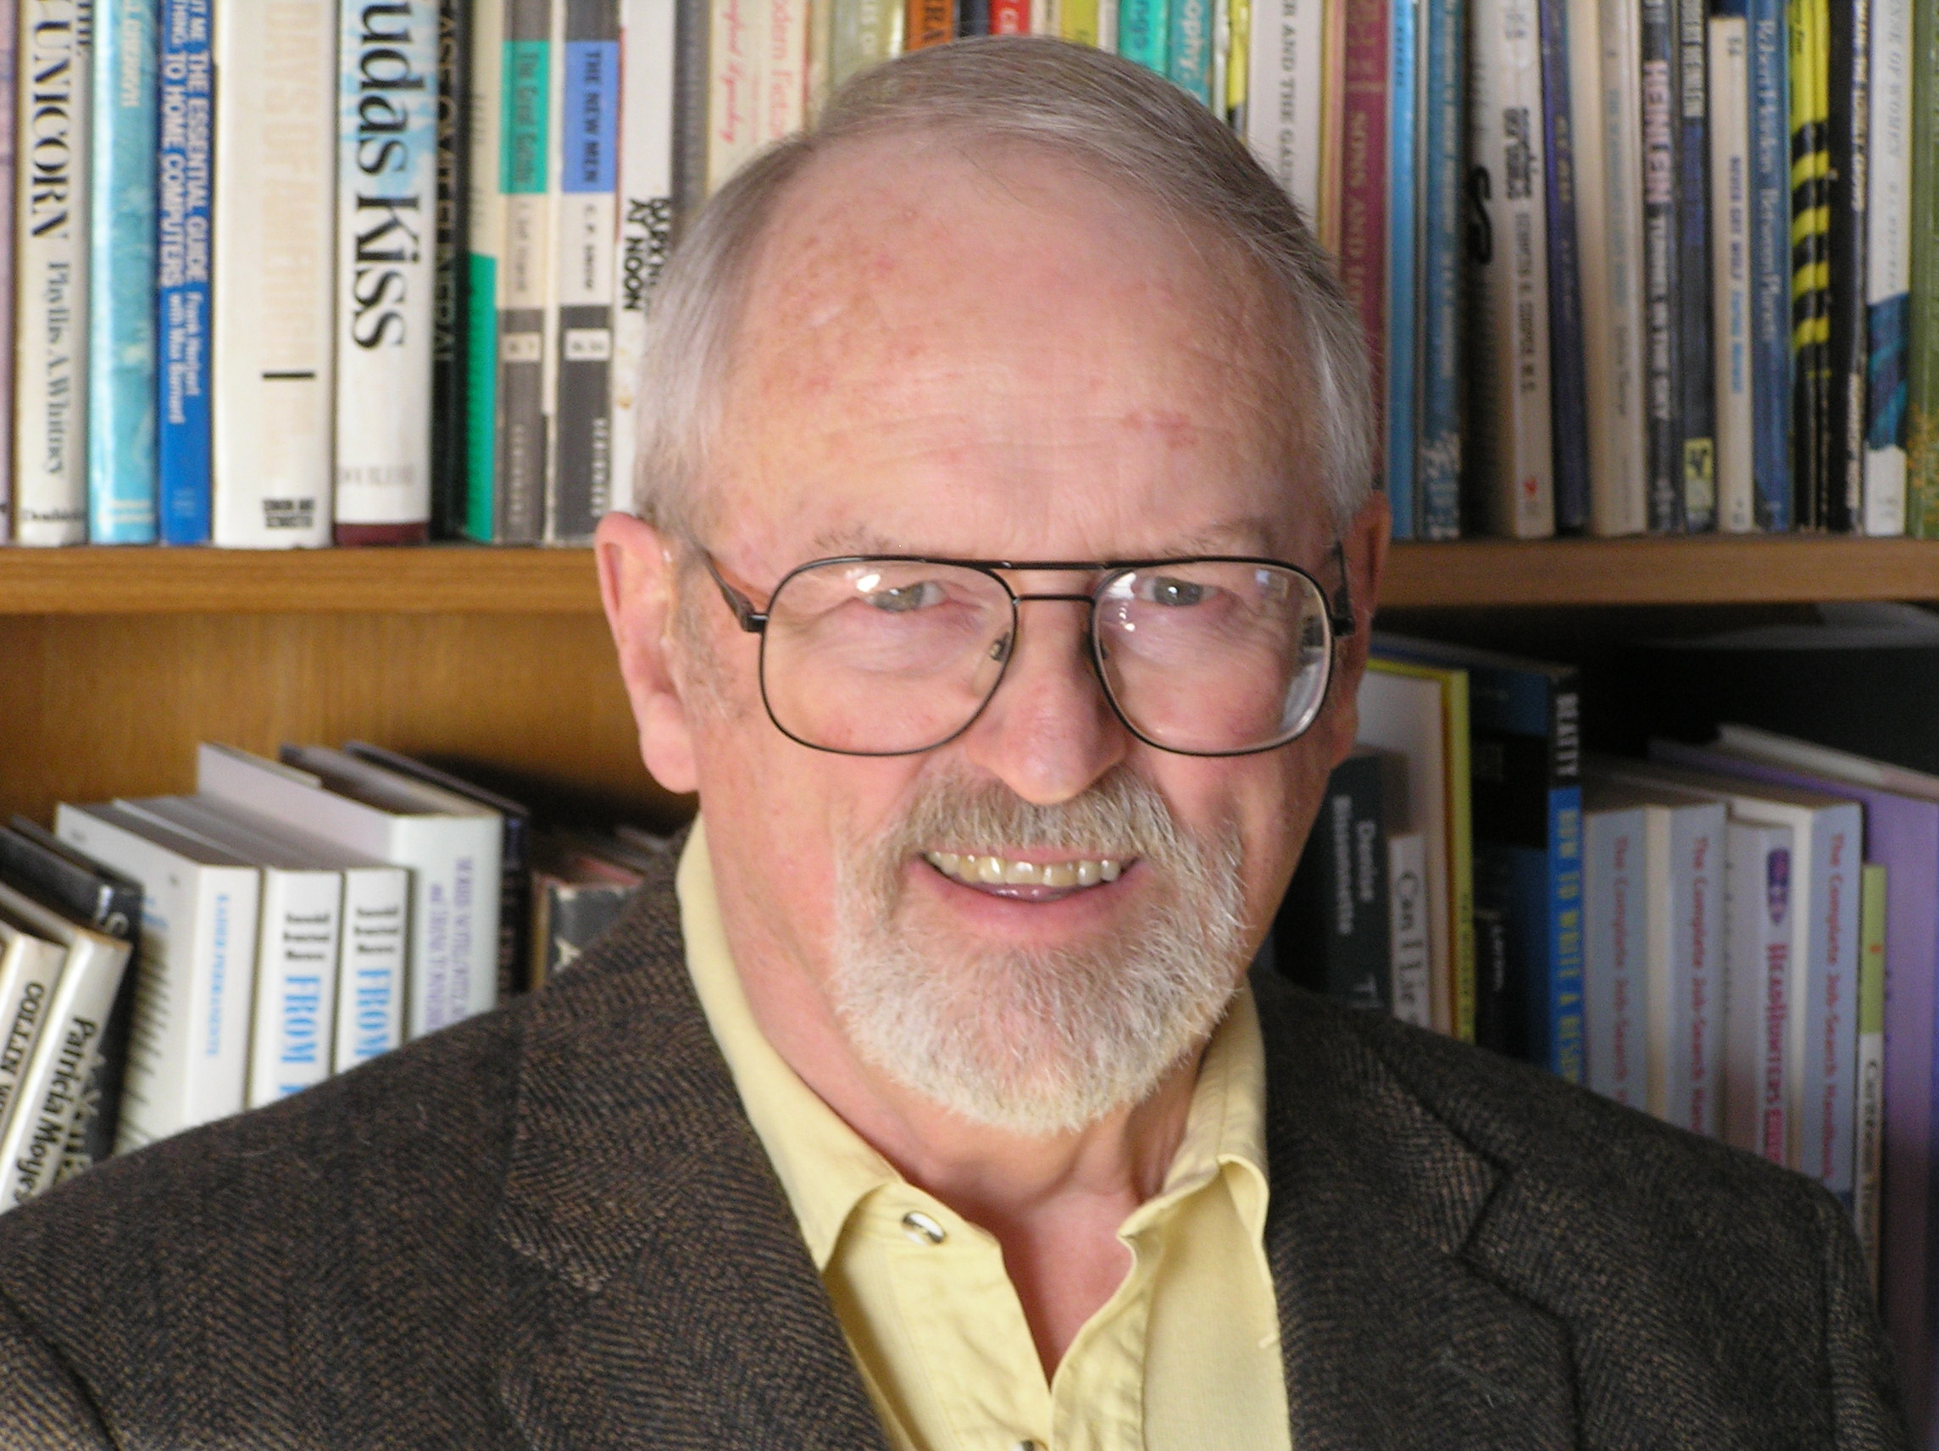
Richard Knowdell, NCC, NCCC,CCMF
P.O. Box 611930,
San Jose, CA 951611930
(408) 272-3085
rknowdell@mac.com
www.careernetwork.org
Member #: 4004619

Brief Bio: Richard is the President of Career Research & Testing, Inc. He has over 30 years experience as a career counselor and consultant to numerous organizations. Courses taught include Career Assessment Techniques, and Employee Career Development
Techniques. He has developed 4 popular career assessment instruments that have been translated into 9 languages.

Presentation Titles: Coaching Skills for Career Counselors
Identifying Transferrable Skills, Even with Resistant Clients
Establishing Employee Career Development Programs

Fee: Negotiable
Includes travel, accommodations and honorarium

Format: Lecture

Length of Session: 1 hour sessions and
Three-day Coach Certification Workshop

Availability: Throughout the year
Needs a couple weeks for scheduling.

Follow-up: Yes--Telephone or email assistance at no charge.

