National Career Development Association
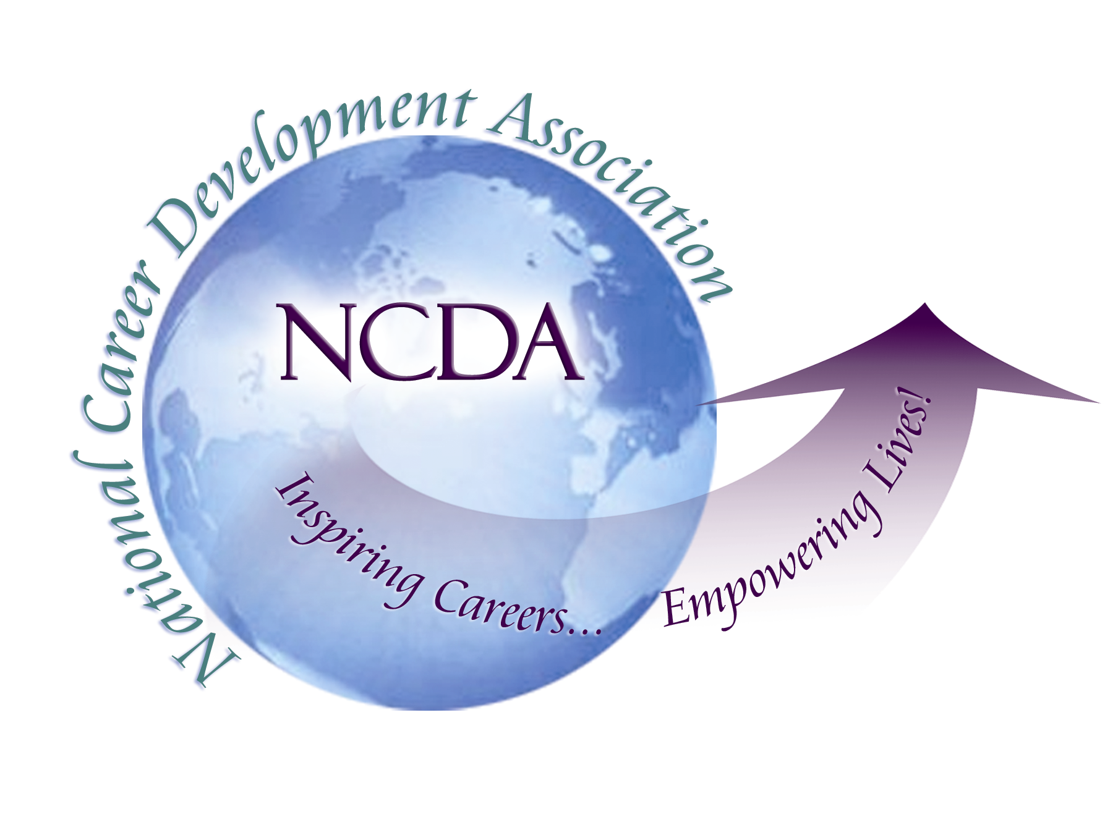
305 N. Beech Circle
Broken Arrow, OK 74012
918/663-7060
Fax: 918/663-7058
www.ncda.org

National Career Development Association
Leadership Academy
Action Learning Project Summary

Participant(s): Matt Morscheck

Board Mentor: Carol Vechhio

Leadership Academy Class: VIII

Project Title: #careerispersonal, a social media campaign to support inclusive practice.

Project Description: For my project, I’ve built an online campaign to reach out to counselors and therapists to create and inspire change towards inclusive practice with respect to themes of career and work in counseling and therapy. This project has also led me to develop assignments that I have used in teaching graduate students about importance of career/work themes and their interplay with mental health and wellness.

I’ve called this the #careerispersonal project and have identified a number of ways for people to participate in the campaign, including the following:

- Sign the #careerispersonal pledge to show your support of inclusive practice
- Send a tweet using the hashtag #careerispersonal to add your voice to the conversation www.twitter.com/#careerispersonal
- Upload a video to YouTube using the hashtag #careerispersonal www.youtube.com/#careerispersonal
- Are you a counselor educator? Review our classroom assignments, and consider submitting your own.
- Share the www.careerispersonal.com website with your colleagues and students.
- Connect with us on Twitter and Facebook.

Summary/Recommendations:

- The project was only just recently launched in May, and already has received positive attention, including visitors who have signed the Pledge, followers on Twitter and Facebook, and many visits to the website.
- I would very much like to partner with someone in the future to continue to grow and develop this campaign as a resource to counselors, therapists, and helping professionals – and those counselor educators who are looking for ways to integrate the #careerispersonal message into the classroom.

