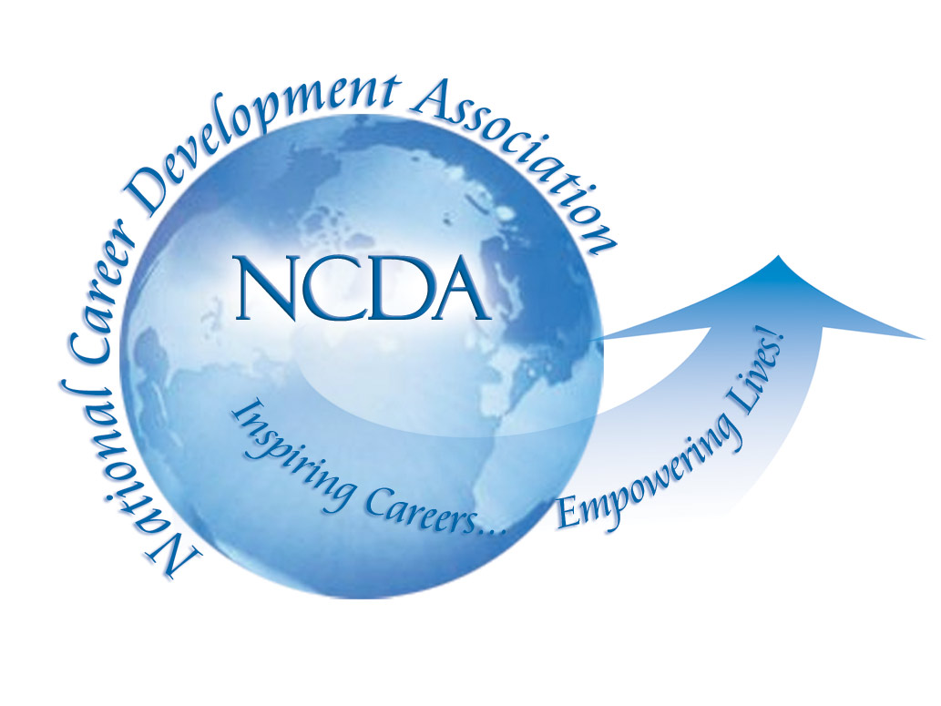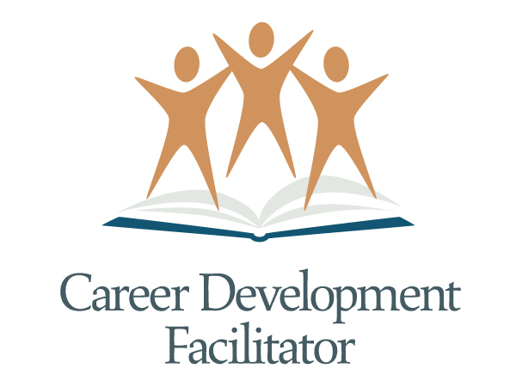

September 10, 2014

TO: NCDA Master Trainers, NCDA Career Development Facilitator Instructors, completers of the NCDA Career Development Facilitator Training Program and GCDFs™

FROM: Mary Ann Powell, NCDA Special Projects Director

SUBJECT: NCDA Career Development Facilitator Advisory Council –
Seeking Applicants for Veteran’s Representative

The National Career Development Association is seeking applicants to fill a position on the NCDA Career Development Facilitator Advisory Council. Below is the NCDA Career Development Facilitator Advisory Council Application Form and supporting documentation.

NCDA formed this Advisory Council to enhance the development and delivery of the NCDA Career Development Facilitator project to the field. We believe the Career Development Facilitator project is extremely beneficial to those seeking to obtain their GCDF™ certification and we want to enhance the long-term success of this project.

Applications will be accepted until October 20, 2014. Applications must be postmarked or emailed by October 20, 2014 to be considered. Individuals selected for the Advisory Council will be notified within 4-6 weeks. We encourage individuals from diverse backgrounds to apply for this open position.

The term of office for this open position is from appointment in fall 2014 to September 30, 2017. A Council meeting is being planned for March 2015 at a location to be determined by the Advisory Council. An additional meeting will be scheduled during the 2015 NCDA Global Conference in Colorado. It is required that council members attend all meetings. The Advisory Council will continue to meet throughout the year via periodic conference calls.

We hope you will consider submitting your application to serve on the NCDA Advisory Council. This Advisory Council has provided excellent direction for the NCDA Career Development Facilitator project over the past thirteen years. We are looking forward to the continued success this Advisory Council is demonstrating and the continued success of the NCDA Career Development Facilitator project. If you have any questions please do not hesitate to contact me at (918) 663-7060 or email mpowell@ncda.org.

National Career Development Association
Career Development Facilitator Advisory Council

The National Career Development Association is currently seeking applicants to serve on the NCDA Career Development Facilitator Advisory Council. The Advisory Council was formed to assist NCDA in planning the future direction of the NCDA Career Development Facilitator project. The Advisory Council is responsible for initiating new ideas, implementing those ideas and communicating with the specific group each council member represents. Activities of the Advisory Council include travel to a yearly meeting in January, February, or March and attendance at the annual NCDA Global Conference, periodic conference calls, and communication via e-mail. Additional activities include special projects such as resource guide development or marketing initiatives and special work groups such as Instructors of the Career Development Facilitator Curriculum, Master Trainers, or Online Learning. Council members are expected to serve on special projects and special work groups as needed.

The Advisory Council consists of 8 individuals serving a minimum 3-year term. The following outlines the Advisory Council and its rotation schedule.

We are currently seeking Council members for the following position:

- Representative with knowledge and experience in serving Military/Veteran Population (Must demonstrate knowledge of NCDA’s Career Development Facilitator program/training by one or more of the following: a completer of the NCDA Career Development Facilitator Curriculum, or a GCDF™, or a NCDA Instructor or a NCDA Master Trainer)
Term ends: September 30, 2017

Attendance at the yearly meeting in January, February, or March AND at the NCDA Global Conference are required. The Advisory Council will meet each January, February, or March in Tulsa, Oklahoma or at a location to be determined by the NCDA. All Advisory Council members are required to attend these meetings. NCDA will reimburse Advisory Council members for all travel related expenses to attend the yearly meeting in January or February. The Advisory Council will meet again during each NCDA Global Conference. All travel related expenses for this meeting will be the responsibility of each council member.

Additional comments and questions regarding the NCDA Career Development Facilitator Advisory Council can be directed to Mary Ann Powell, NCDA, 305 North Beech Circle, Broken Arrow, OK 74012, ph: (918) 663-7060 or (866) 367-6232, fax: (918) 663-7058 or email: mpowell@ncda.org.
National Career Development Association
Career Development Facilitator Advisory Council
Veteran’s Representative Application Form - 2014

Please complete this application form by October 20, 2014 and return it to: NCDA, 305 North Beech Circle, Broken Arrow, OK 74012. Questions? (918) 663-7060 or (866) 367-6232, fax (918) 663-7058 or email: mpowell@ncda.org

Name______________________________________________________________________________

Title_______________________________________________________________________________

Company___________________________________________________________________________

Address____________________________________________________________________________

City_______________________________________________ State__________ Zip______________

Phone___________________ Fax_________________ Email_________________________________

Please Check All That Apply:  I am applying to serve in the following capacity:  - Veterans/Military Representative | Please Check All That Apply:  I am currently a:  - Completed NCDA Career Development Facilitator Training or hold the GCDF™ credential  - NCDA Instructor of the Career Development Facilitator Curriculum  - NCDA Master Trainer

Representation from a variety of work settings is extremely important for this Advisory Council role. Please check the appropriate work setting box(es) below.
- Education; please specify_______________________________________________________
- Community/Government Agency; please specify_____________________________________
- Business & Industry; please specify_______________________________________________
- Other; please specify___________________________________________________________

Selection Criteria
In order to be eligible to serve on this Advisory Council you must meet one of the following criteria. Please provide appropriate documentation for each box checked. In addition to the information below, please include a resume or vita with your application form.

- Completed NCDA Career Development Facilitator Training or hold the GCDF™ credential
  - must be actively using CDF™ skills in daily work setting (resume)
  - AND completed an NCDA Career Development Facilitator Training Program
  - OR must hold a current GCDF™ Credential from CCE (copy of certificate)
  - AND must be a current member of the National Career Development Association.

- NCDA Instructor and/or Master Trainer of the Career Development Facilitator Curriculum
  - must be actively providing training to those seeking the GCDF™ credential or training instructors to utilize the NCDA Career Development Facilitator Curriculum (resume)
  - AND must be a current member of the NCDA Instructor Registry
  - AND must be a current member of the National Career Development Association.
Please answer the following questions. Attach additional pages as needed.

- The NCDA Career Development Facilitator Advisory Council is currently involved with several projects including the development of Resource Guides, development and implementation of marketing initiatives as well as innovative ways to enhance the NCDA program. As a potential NCDA Career Development Facilitator Advisory Council member, what are your professional interests and expertise? Please attach a short paragraph describing an accomplishment related to these professional interests.

- Online Learning
- Technology
- Ethics/Business Law
- Instructional Design
- Development of Curriculum or Training Materials Such as NCDA Resource Guides
- Marketing of NCDA Career Development Facilitator Projects
- CDF™ Professional Standards
- K-12 Expertise
- Higher Education
- Military/Veteran’s Needs
- Other, please specify________________________________________________

- One of the identified goals of the Advisory Council is to address the overall marketing of the NCDA Career Development Facilitator project. How would your skills, interests, and ideas help meet this goal? Please limit your response to 1 or 2 paragraphs.

- Identify three reasons you are interested in serving on the Advisory Council.

- Describe your experience in working with Veterans.

- The individual chosen for this position will be the lead Council member in exploring how Career Development Facilitator training could be utilized in educating staff working to assist Veterans in career choices or finding employment. Describe how you are qualified to work with the Council in this way.

Additional Criteria. Check all that apply:
- Must commit attend the NCDA Advisory Council Meeting in March 2015. (Expenses will be reimbursed by NCDA)
- Must commit to attend the NCDA Advisory Council Meeting held during the 2015 NCDA Global in Colorado. (Expenses are not reimbursed by NCDA)
- Must be willing and able to participate in periodic conference calls.
- Must have access to and effectively communicate using email.
- Must be willing to assume additional responsibilities identified by the Advisory Council.

Selection Process
Qualified applicants will be selected for membership on the Advisory Council based on their application forms. Those selected for open Advisory Council positions will be notified by October 20, 2014. Those not selected will be notified within 4-6 weeks following the closing of the application period.

