National Career Development Association
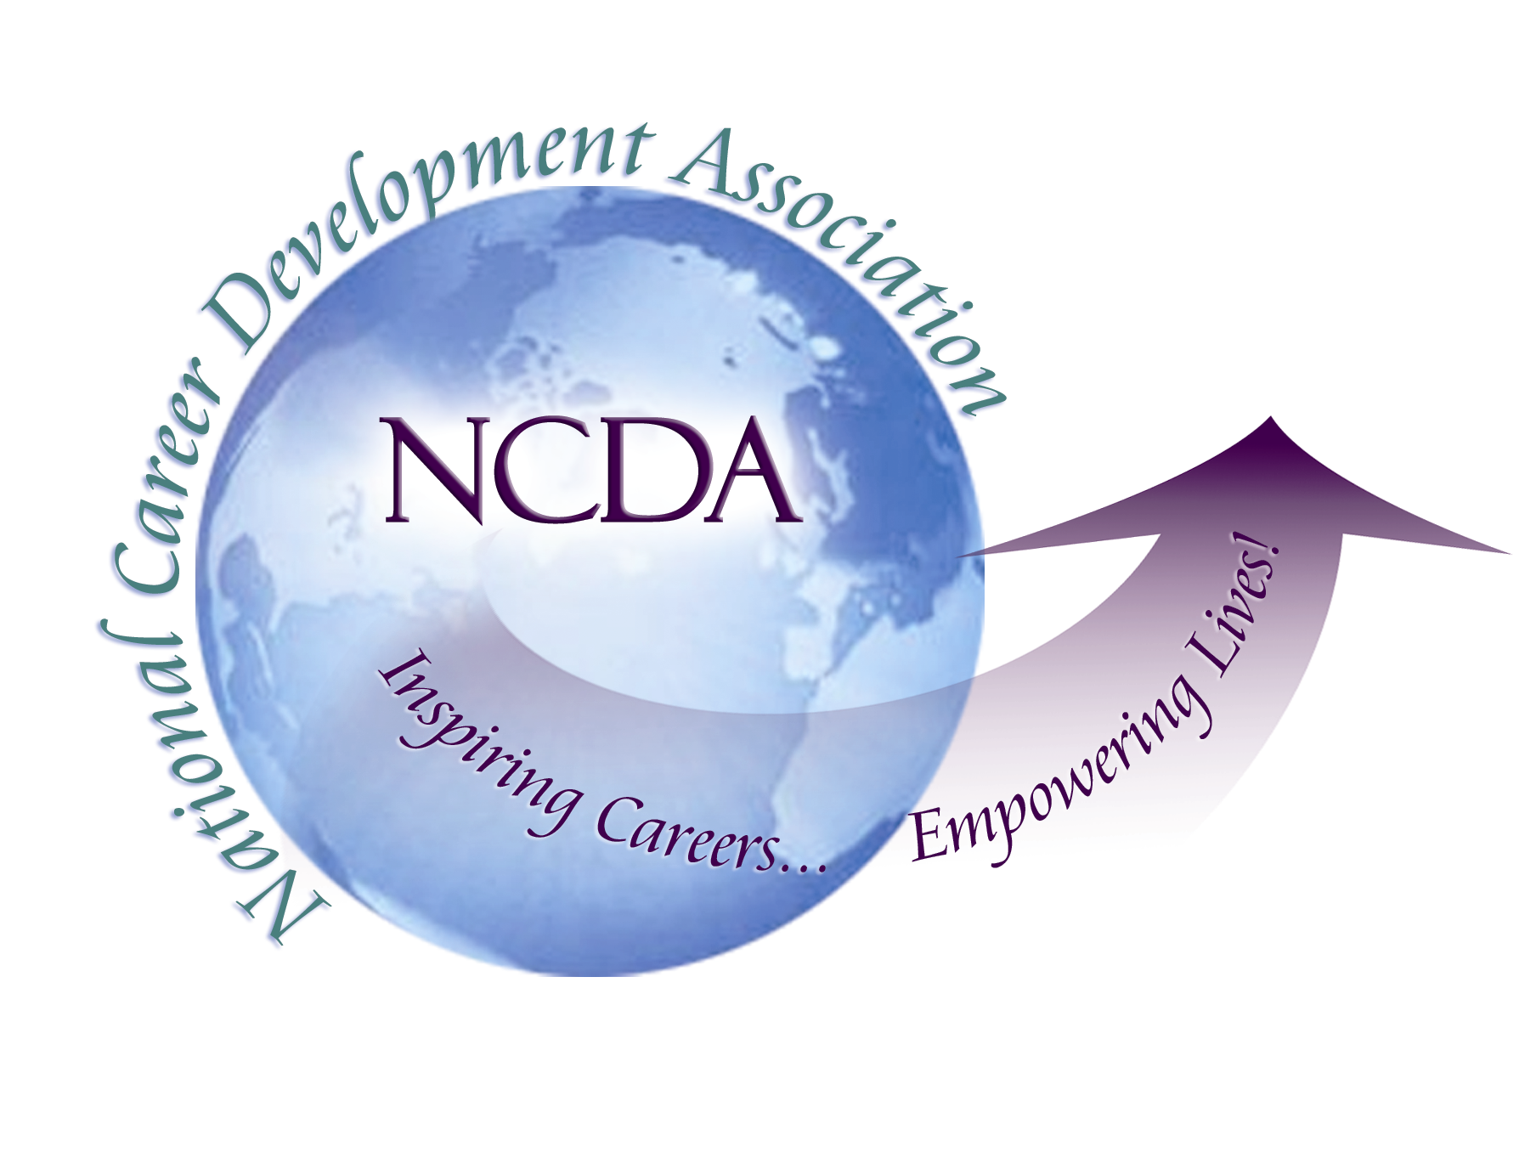
305 N. Beech Circle
Broken Arrow, OK 74012
918/663-7060
Fax: 918/663-7058
www.ncda.org

National Career Development Association
Leadership Academy
Project Summary

Participant(s): Julia Elliott

Board Mentor: Dr. Rebecca Dedmond

Leadership Academy Class: LA III, 2008-2009

Project Title: Disability Resources for the Practitioner

Project Description: Do you work with individuals who have mental or physical disabilities? Come and learn about the resources that are available to practitioners on the web who work in Secondary and Post-Secondary Education, Corrections/ Workforce Development, Counselor Educator’s and Research, and Private Practitioners.

Summary/Conclusion: As today’s overall workforce shrinks and the number of individuals with disabilities entering the current job market increases, it is important for Career Development practitioners to have immediate access to resources they can utilize when assisting their students/clients with disabilities in searching for employment. Having gathered resources from disability networks, leading university researchers, and individuals with disabilities themselves, the presenter has developed a list of helpful sources to assist in the areas of College and University Counseling, Correctional/Workforce Development, Counselor Educators and Researchers, k-12 Counselors and Educators as well as Private Practitioners devoted to helping others better prepare their students/clients for employment.

Results/Recommendations: Created a new heading on the NCDA website in the “Interest Area” section titled “Disability Resources for the Practitioner” that will list helpful resources for practitioners assisting individuals with a disability during the job search process. These sources include employment resources, assessment resources, professional development opportunities, publications, and related associations. Please find below the list of resources that will be added to the website. There are many additional resources that can be added in the future to enhance this site even more.

My recommendations for continuation of this project would be to keep the resources up-to-date and to add new resources to the list.

Employment Resources

Agrability Project
http://www.agrabilityproject.org/
The AgrAbility Project was created to assist people with disabilities employed in agriculture. The project links the Cooperative Extension Service at a land-grant university with a private nonprofit disability service organization to provide practical education and assistance that promotes independence in agricultural production and rural living.

Americans with Disabilities Act - ADA
http://www.ada.gov/
Information and Technical Assistance on the Americans with Disability Act

Association on Higher Education and Disability
http://www.ahead.org/
AHEAD is a professional membership organization for individuals involved in the development of policy and in the provision of quality services to meet the needs of persons with disabilities involved in all areas of higher education.

Disability Resources
http://www.disabilityresources.org/
Disability Resources, inc. is a nonprofit organization established to promote and improve awareness, availability and accessibility of information that can help people with disabilities live, learn, love, work and play independently.

disABLEDperson.com
http://www.disabledperson.com/
Creating Jobs for individuals, college students and veterans with disabilities

Employer Assistance & Resource Network - EARN
http://www.earnworks.com/
Provides employers with free consulting services and resources to support the recruitment and hiring of people with disabilities.

Employment and Disability Institute - EDI
School of Industrial and Labor Relations, Cornell University
http://www.ilr.cornell.edu/edi/
The Employment and Disability Institute (EDI) advances knowledge, policies, and practices to enhance the opportunities of people with disabilities through our projects, training, technical assistance, research, and publications.

Foremployers.com
http://www.foremployers.com/
ForEmployers.com uses technology and flexible design strategies (or universal design) to bridge the needs of the business community and the employment needs of people with disabilities. The site provides straightforward solutions and information that address everyday human resource issues, especially as they relate to current or future employees with disabilities.

HEATH Resource Center, the George Washington University
http://www.heath.gwu.edu/
An online clearinghouse on post-secondary education for individuals with disabilities.

Job Accommodations Network JAN
http://www.jan.wvu.edu/
JAN's mission is to facilitate the employment and retention of workers with disabilities by providing employers, employment providers, people with disabilities, their family members and other interested parties with information on job accommodations, self-employment and small business opportunities.

National Network of ADA Centers - DBTAC
http://www.adata.org/
The Disability and Business Technical Assistance Center (DBTAC) is a national network of 10 regional DBTAC: ADA Centers that provide the most complete and experienced services for up-to-date information, referrals, resources, and training on the Americans with Disabilities Act (ADA) to businesses, employers, government entities, and individuals with disabilities, as well as media and news reporters.

National Business & Disability Council - NBDC
http://www.business-disability.com/
The NBDC is the leading resource for employers seeking to integrate people with disabilities into the workplace and companies seeking to reach them in the consumer marketplace.

National Collaborative on Workforce and Disability for Youth - NCWD/Youth
www.ncwd-youth.info
NCWD/Youth is your source for information about employment and youth with disabilities.

Office of Disability Employment Policy - ODEP
http://www.dol.gov/odep/index.htm
The Office of Disability Employment Policy (ODEP) provides national leadership on disability employment policy by developing and influencing the use of evidence-based disability employment policies and practices, building collaborative partnerships, and delivering authoritative and credible data on employment of people with disabilities.

Office of Special Education and Rehabilitative Services - NIDRR
http://www.ed.gov/about/offices/list/osers/nidrr/index.html?src=mr
The National Institute on Disability and Rehabilitation Research (NIDRR) provides leadership and support for a comprehensive program of research related to the rehabilitation of individuals with disabilities.

Social Security Administration - SSA
http://www.ssa.gov/
The official website of the U.S. Social Security Administration

Social Security Administration Office of Employment Support Programs – OESP
http://www.ssa.gov/work/
Website provides information about benefits and services for Social Security recipients who want to re-enter the workforce. Separate sections offer a wealth of information for youth with disabilities, employers, beneficiaries, service providers, and advocates.

Social Security Disability Benefits
http://www.disabilitysecrets.com/
Applying for social security disability and SSI benefits, with or without an advocate can be difficult due to how long a claim may take and the high chance of being denied

USAJobs
http://www.usajobs.gov/
USAJOBS is the official job site of the US Federal Government.
It's your one-stop source for Federal jobs and employment information

U.S. Equal Employment Opportunity Commission - EEOC
http://www.eeoc.gov/
A US federal agency empowered by Congress, particularly since the passage of the Civil Rights Acts of 1964, to help enforce laws prohibiting discrimination in the workplace.

Vocational Rehabilitation & Employment Services
http://www.vba.va.gov/bln/vre/
The Department of Veterans Affair's Veterans Benefits Administration's Vocational Rehabilitation and Employment (VR&E) service is vested with delivering timely, effective vocational rehabilitation services to veterans with service-connected disabilities.

Vocational Information Services
http://www.vocrehab.com/
VocRehab Inc. is a Career Information Service company with extensive experience in vocational rehabilitation, assessment, and evaluation.

Career Assessments Instruments

Career Planning Begins with Assessment: A Guide for Professionals Serving Youth with Educational and Career Development Challenges
http://www.ncwd-youth.info/resources_&_Publications/assessment.html
The best decisions and choices made by transitioning youth are based on sound information including appropriate assessments that focus on the talents, knowledge, skills, interests, values, and aptitudes of each individual. This guide serves as a resource for multiple audiences within the workforce development system. Youth service practitioners will find information on selecting career-related assessments, determining when to refer youth for additional assessment, and additional issues such as accommodations, legal issues, and ethical considerations.

Federation for Children with Special Needs
http://www.fcsn.org/pti/topics/transition/tools/assessment.pdf
Assessment…the process of collecting information that can be used in decision making, career-planning, and service plan development for a young person.

Level 1 Career Assessment for Students with Disabilities: A Manual
http://www.vesid.nysed.gov/specialed/transition/level1careerassess.htm
The Level 1 Career Assessment is: a structured process that takes place over a 2 year period starting in middle school (age 12); the review of existing student information to assess basic skills and determine a student’s interests; the structured collection of information about the student’s interests and abilities outside the school environment that allow the student and family to work with the school in the career decision making process

National Center on Response to Intervention - RTI
http://www.rti4success.org/
Response to intervention integrates assessment and intervention within a multi-level prevention system to maximize student achievement and to reduce behavior problems. With RTI, schools identify students at risk for poor learning outcomes, monitor student progress, provide evidence-based interventions and adjust the intensity and nature of those interventions depending on a student’s responsiveness, and identify students with learning disabilities.

Resources for Test Takers with Disabilities
http://www.ets.org/portal/site/ets/
Provides information to applicants with disabilities who seek approval of reasonable testing accommodations for the GRE, Praxis, SAT, TOEFL, etc.

Wrightslaw
http://www.wrightslaw.com/info/rti.index.htm
What You Need to Know about IDEA 2004, Response to Intervention (RTI): New Ways to Identify Specific Learning Disabilities

Professional Development Opportunities

Creative Training Accelerating Talent

http://www.denveroptions.org/ctat
CTAT provides ongoing training and technical assistance for Denver Options staff, service agencies, the larger state of Colorado, and around the country.

Forensic Vocational Assessments with Specific Populations
http://www.rehabpro.org/events/forensic-vocational-assessments-with-specific-populations-webinar/
Webinar - June 24, 2009 - Presented by Judi Drew, Ph.D., Certified Rehabilitation Counselor, Voc Works
June 24, 2009
12:00 p.m. - 2:00 p.m. ET

2009 National Rehabilitation Association Annual Training Conference
"Embracing Change: New Days, New Ways"
http://www.nationalrehab.org/
Thursday, September 10th - Sunday, September 13th, 2009

IARP 2009 Forensic Conference
http://www.rehabpro.org/
Join us for the IARP 2009 Forensic Conference in Memphis, Tennessee at the Double Tree Hotel, Thursday, October 29 – Saturday, October 31, 2009
The Council of State Administrators of Vocational Rehabilitation
CSAVR Fall Conference
http://www.rehabnetwork.org/
November 15-19, 2009
Phoenix Hyatt Regency

National Council of State Agencies for the Blind
NCSAB Fall Conference
http://www.ncsab.org/
November 18-20, 2009
Phoenix Hyatt Regency

26th Annual Pacific Rim International Conference on Disabilities
http://www.rrtc.hawaii.edu/
April 12 & 13, 2010: Hawaii Convention Center, Honolulu, Hawai‘i
With its beginnings dating back to 1985, the Pacific Rim Conference has evolved into one of the top rated international educational offerings for and from persons with disabilities, family members, researchers, service providers, policymakers and nationally recognized professionals in the various disciplines in the diverse field of disabilities.

Publications

Disability Employment 101
http://www.ed.gov/about/offices/list/osers/products/employmentguide/index.html
This guide is a comprehensive analysis of hiring employees with disabilities that includes information about how to find qualified workers with disabilities, how to put disability and employment research into practice and how to model what other businesses have done to successfully integrate individuals with disabilities into the workforce.

Job Seeking Skills for People with Disabilities; A Guide to Success
http://www.csun.edu/~sp20558/dis/sh.html
This handbook for college students provides information about setting career goals and looking for work, including special considerations for job seekers with disabilities.

National Rehabilitation Information Center – NARIC
www.naric.com
Providing disability and rehabilitation-oriented information through online publications, searchable databases, and timely reference and referral data.

National Clearinghouse of Rehabilitation Training Materials
http://ncrtm.org/
The NCRTM is sponsored by the Rehabilitation Services Administration (RSA) and hosted by Utah State University. We serve the profession of Vocational Rehabilitation as a centralized resource for the development, collection, dissemination, and utilization of training materials; as a forum for advancing knowledge through applied research and open dialog; and as a marketplace for career and staff development.

Journal of Applied Rehabilitation Counseling
http://nrca-net.org/jarc.html
Is a journal of opinion and research in professional rehabilitation counseling and addresses the needs of individuals employed in a wide variety of work settings and with wide-ranging professional interests

Rehabilitation Education Journal
http://www.rehabeducators.org/publications.htm
This is a quarterly journal designed to bridge the gap between researchers, educators, and service providers.

Related Organizations

American Deafness and Rehabilitation Association -ADARA
www.adara.org
A long-standing, nonprofit association of professionals and interested persons promoting and participating in quality human service delivery to Deaf and Hard of Hearing persons
The American Rehabilitation Counseling Association - ARCA
www.arcaweb.org
An organization of rehabilitation counseling practitioners, educators, and students who are concerned with improving the lives of people with disabilities
The Commission on Rehabilitation Counselor Certification – CRCC
www.crccertification.com
This is an independent, not-for-profit organization dedicated to improving the lives of persons with disabilities.
The Council on Rehabilitation Education - CORE
www.core-rehab.org
accredits over 100 graduate programs in Rehabilitation Counselor Education (RCE) and promotes, through accreditation, the effective delivery of rehabilitation services to individuals with disabilities by promoting and fostering continuing review and improvement of master’s degree level RCE programs
The Council of State Administrators of Vocational Rehabilitation - CSAVR
www.rehabnetwork.org
Serves as an advisory body to the Rehabilitation Services Administration (RSA) and other federal agencies in the development of policies and administration of programs affecting the lives of persons with disabilities and impacting the national public program of vocational rehabilitation services
The International Association of Rehabilitation Professionals - IARP
www.rehabpro.org
Serves a diverse membership practicing in the fields of long-term disability management consulting, case management and managed care, forensics and expert testimony, life care planning, and Americans with Disabilities Act (ADA) consulting

The National Association of Multicultural Rehabilitation Concerns – NAMRC
www.namrc.org
Advocates for the rehabilitation needs of multicultural persons with disabilities; ensures the provision of quality and equitable services; and enhances the development of multicultural rehabilitation professionals
The National Council on Rehabilitation Education - NCRE
www.rehabeducators.org
A professional organization dedicated to quality services for persons with disabilities through education and research
The National Rehabilitation Association – NRA
http://www.nationalrehab.org/

A member organization that promotes ethical and state of the art practice in rehabilitation with the goal of the personal and economic independence of persons with disabilities
The National Rehabilitation Counseling Association – NRCA
www.nrca-net.org
A longstanding independent professional association representing professionals in the field of rehabilitation counseling across a wide variety of work settings
The Vocational Rehabilitation Association of Canada –VRAC
www.vracanada.com
National organization providing for the advancement of vocational rehabilitation and pre-vocational rehabilitation professionals in Canada

