National Career Development Association
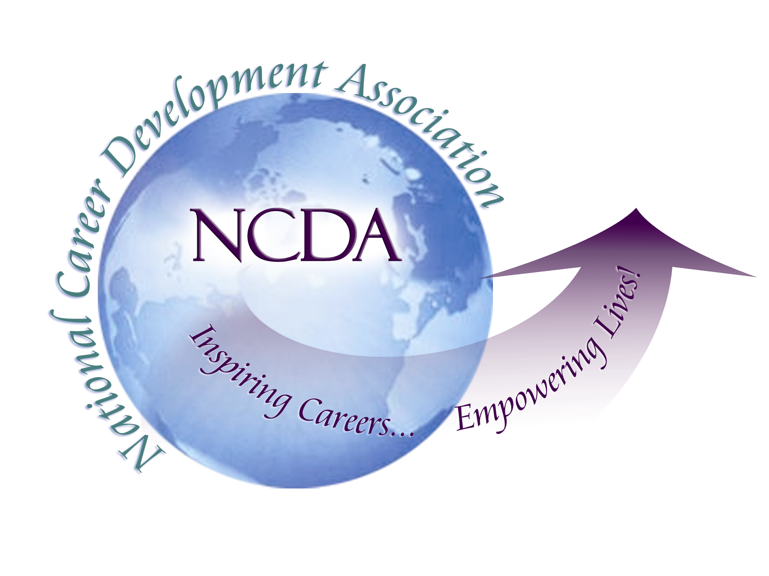
305 N. Beech Circle
Broken Arrow, OK 74012
918/663-7060
Fax: 918/663-7058
www.ncda.org

National Career Development Association
Leadership Academy
Project Summary

Participant(s): Jodi Schneiderman, Jeanne M. Hinkelman

Board Mentor: Alberto Puertos, Amy Benedict-Augustine

Leadership Academy Class: LA III, 2008-2009

Project Title: International Exchange Needs Assessment Project

Project Description:
We plan to conduct a needs assessment of all NCDA members to obtain information regarding interest level and support of a potential international exchange program for NCDA members to obtain cultural knowledge and skills working with international populations and issues. The following options will be presented:

1) job exchange among permanent employees for an extended time period,
2) host an international guest(s) for educational experience, including graduate internship, and/or
3) host an international guest(s) for short time period (day to a week).

In addition, we will be gathering information for the international committee’s project to have an international community/information exchange on the website.

Summary/Conclusion:
We are excited to help the international committee build an international community for members. The information from the survey has been sent to the head of the International Committee, Amy Benedictine-Augustine. It is now up to the committee and web person to put this on the NCDA website.

The work exchange survey received a total of 296 responses (44 non US residents). The survey demonstrated high interest in work exchange (72.2%) and work site/educational experiences (87.9%). In addition, there was a high interest among graduate students to participate in international internships. In addition, 85.8% of respondents were potentially willing to help facilitate the process (maybe and yes responses). Unfortunately, we did receive a low response (30) from decision making authorities in terms of interest and willingness to host or allow the exchange opportunity with their organization. Of the 30 responses, there was interest in hosting a site visit/educational experience (83.3%), hosting an international graduate intern (40%), and hosting a work exchange among employees (36.7%).31% would host someone who does not speak their native language. 46% said maybe. 80% said they would or maybe would be willing to allow a "sabbatical" for an employee who wants to work in another country (without an actual exchange).

Results/Recommendations:
These results clearly demonstrate an interest in building the international community and gaining multicultural competencies through international exchange and/or site visits. Alberto will be speaking to the board in St. Louis, which will help us establish next steps. Our recommendation is for NCDA to include some type of facilitation in work exchange or site visits, which may merely be listing organizations interested on the website.

