National Career Development Association
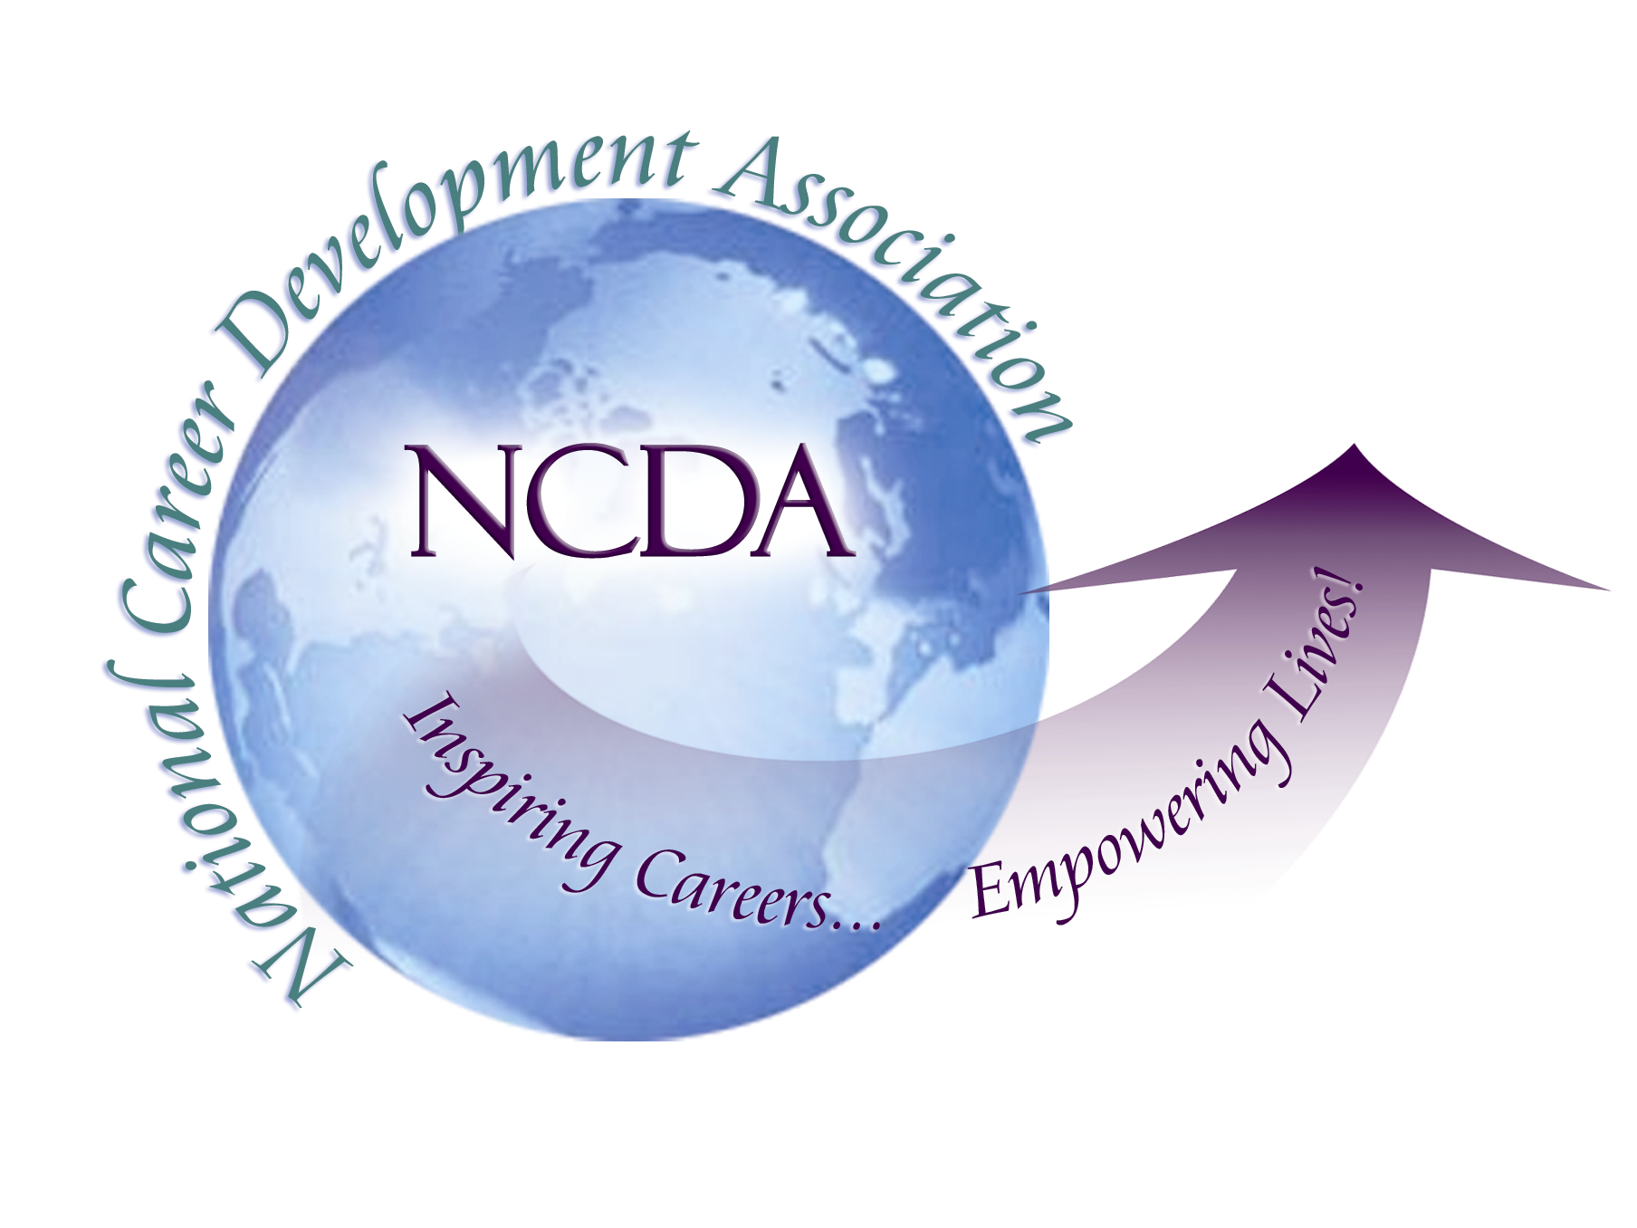
305 N. Beech Circle
Broken Arrow, OK 74012
918/663-7060
Fax: 918/663-7058
www.ncda.org

National Career Development Association
Leadership Academy
Project Summary

Participant(s): Dr. Gemma A. Williams

Board Mentor: Dr. Charles Lehman

Leadership Academy Class: LA III, 2008-2009

Project Title: Creation of a Speakers’ Bureau

Project Description: The purpose of this project was to create a Speakers’ Bureau that state career development associations can tap into for their professional development activities. With feedback from several NCDA leaders, I developed a form which was sent out via NCDA news to the membership in March and April, 2009.

Summary/Conclusion: Nineteen individuals completed the Speakers’ Bureau form and 17 provided brief bios and pictures. States represented are: California, Colorado, Washington DC, Indiana, Massachusetts, Minnesota, New York, Ohio, Washington State, Wisconsin, and Texas. We also have a couple international participants from Australia and British Columbia, Canada. These 17 were sent in to NCDA and will be uploaded to the NCDA website by the end of June.

Results/Recommendations: There is much interest in participating in this Speakers’ Bureau. Since many individuals missed the two advertisements, there have been requests for the next sign up period. As knowledge of this Bureau becomes widespread among the membership, many other states and foreign countries could be represented. It is recommended that:

- Sign up be on-going throughout the year so that even new members can sign up immediately. According to our past Membership Chair, this type of activity can “encourage more membership and increase retention.”

- Features such as “testimonials”—what individuals and groups say about the speakers and possibly short videos or YouTube clips be added to give prospective clients snapshots of the speakers’ presentations.

