National Career Development Association
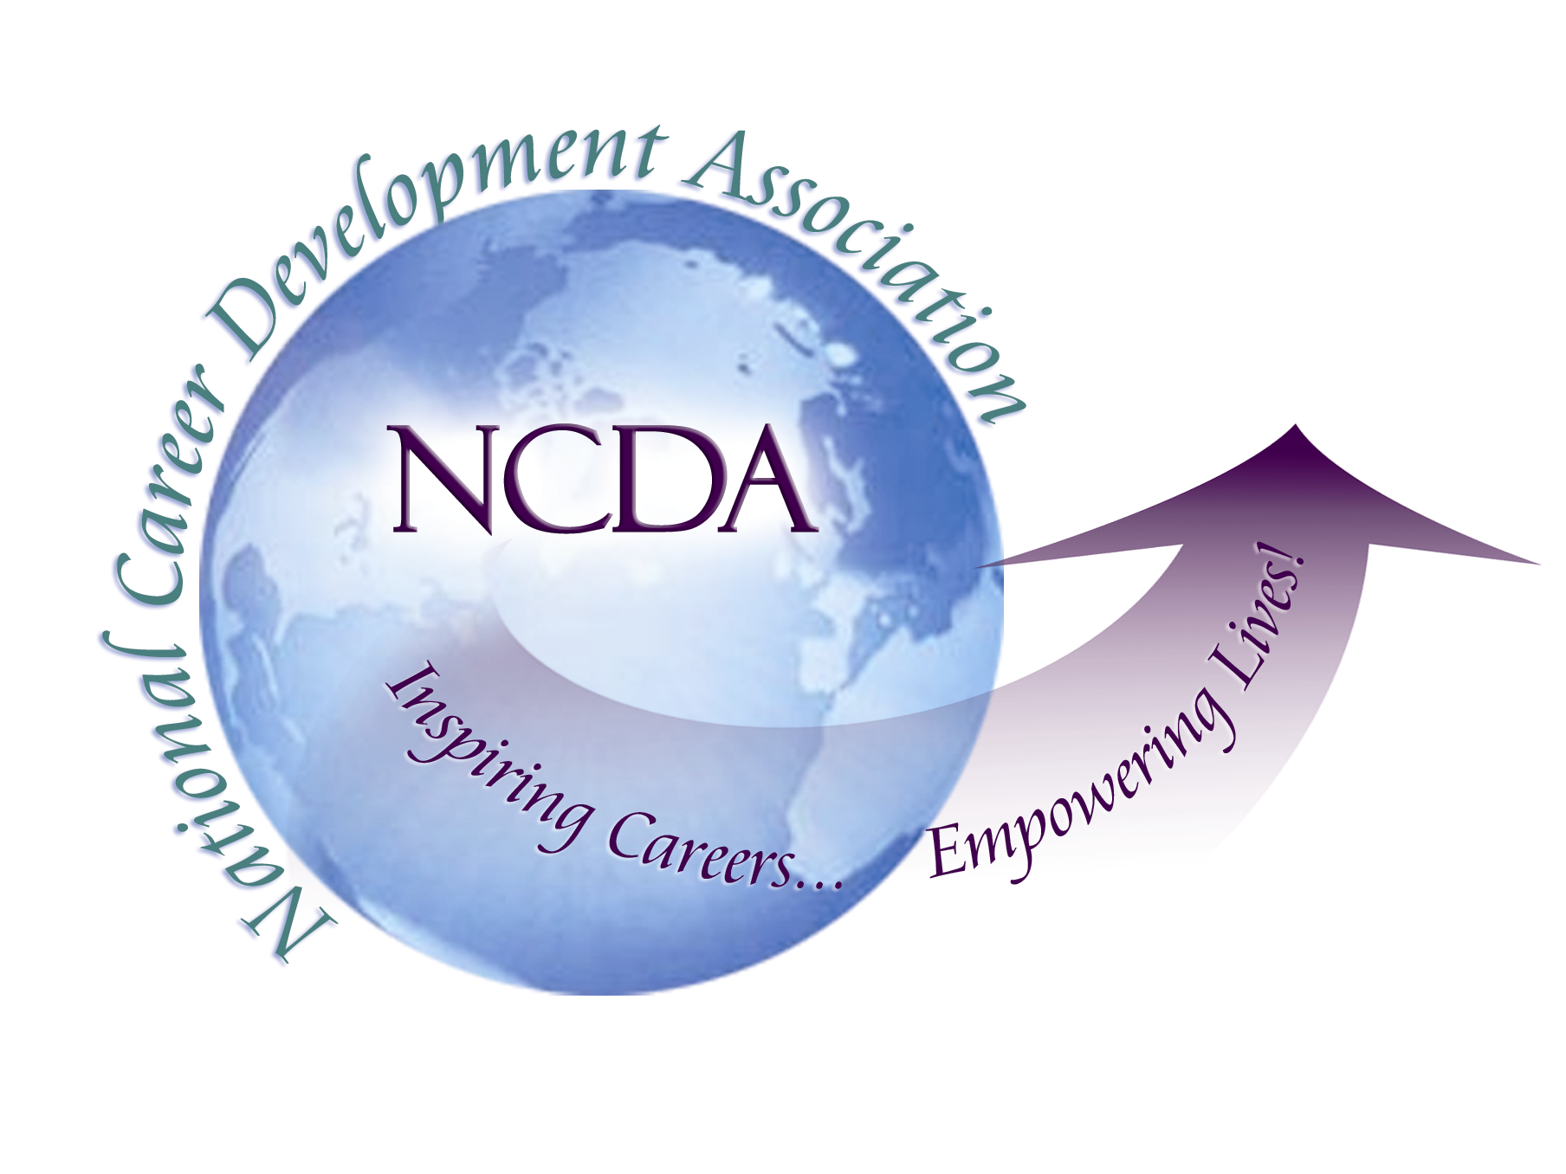
305 N. Beech Circle
Broken Arrow, OK 74012
918/663-7060
Fax: 918/663-7058
www.ncda.org

National Career Development Association
Leadership Academy
Project Summary

Participant(s): Laura DeMarse, Marcia Eagleson, Tom Dodson

Board Mentor: Darrell Luzzo

Leadership Academy Class: LA III, 2008-2009

Project Title: Green Careers

Project Description: Surveying the membership on green careers then using the data to formulate a resource to provide information to NCDA.

Summary/Conclusion: We had a total of 64 surveys completed and have compiled various themes in green careers relating to definition and values. Additionally we are compiling the qualitative data to report on suggestions to NCDA for resources and ideas the further educate and support this mission.

Results/Recommendations: We are working to compile a list of resources and possibly a listserv, other ideas are podcasts, job links and best practices to be housed on the NCDA website.

