National Career Development Association
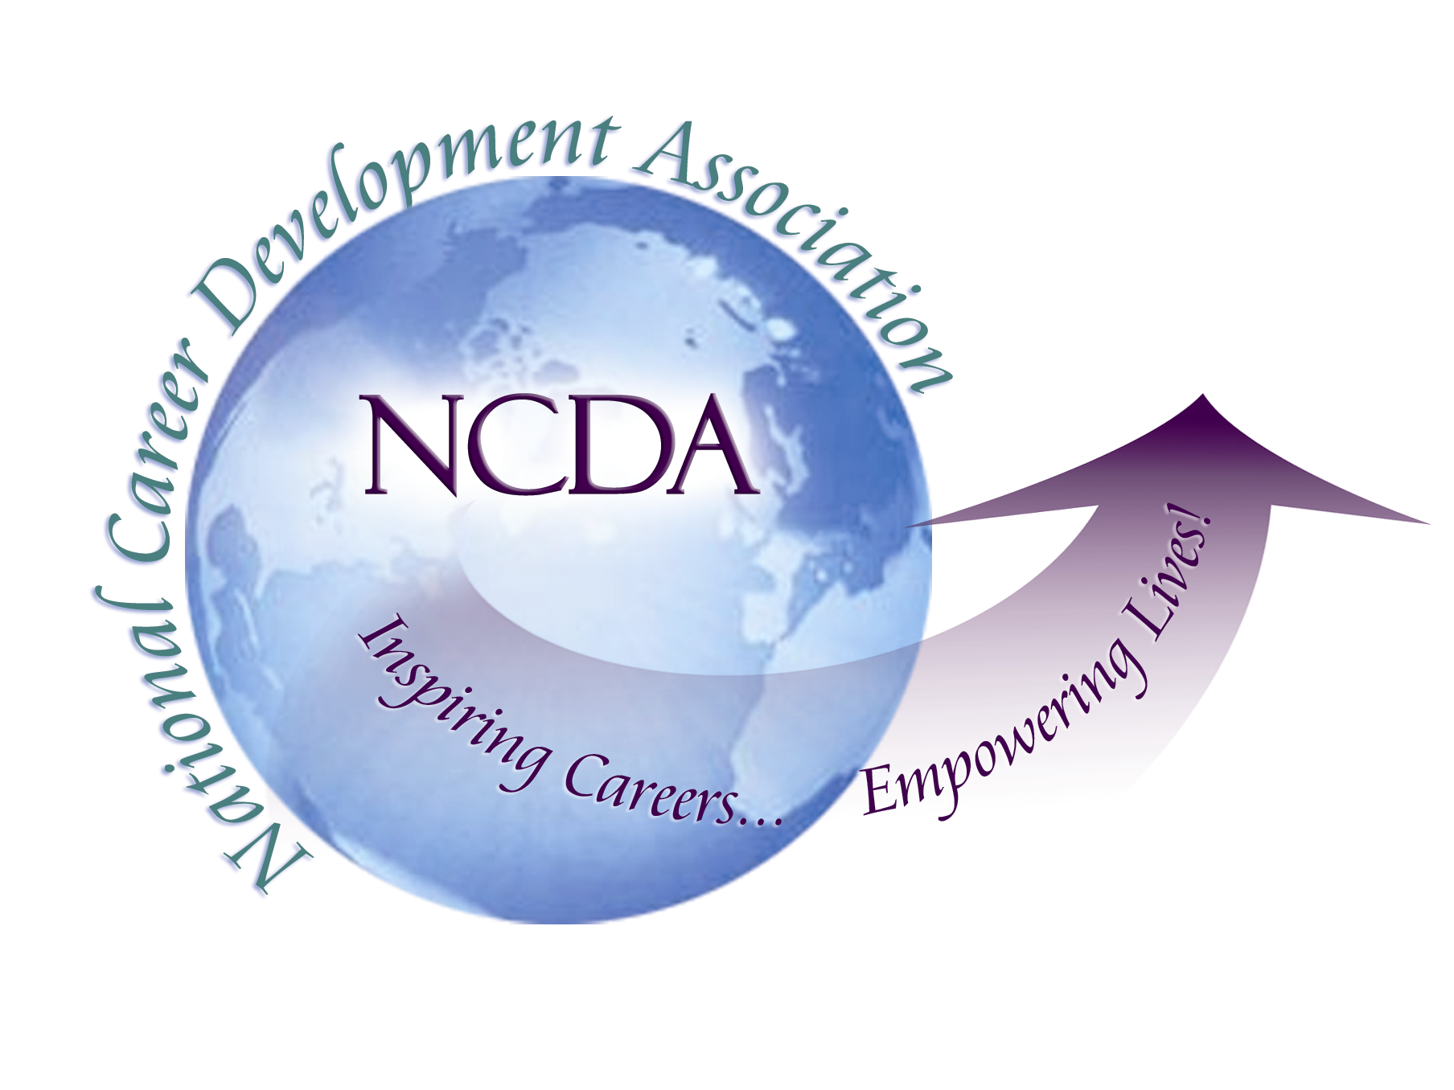
305 N. Beech Circle
Broken Arrow, OK 74012
918/663-7060
Fax: 918/663-7058
www.ncda.org

National Career Development Association
Leadership Academy
Project Summary

Participant(s): Lourdes M. Rivera
Lee Covington Rush

Board Mentor: Brian Taber

Leadership Academy Class: LA III, 2008-2009

Project Title: Reaffirming the Importance of Career Development in the Preparation of Professional Counselors: Strengthening the Linkages Between ACES and NCDA

Project Description:

The ACES/NCDA position paper, Preparing Counselors for Career Development in the New Millennium (2000), provided a clarion call for the reemergence of the historical connections between ACES and NCDA in counselor preparation, program initiatives, and counseling pedagogy, as related to training in career counseling. Most significantly this ACES/NCDA Commission report articulated the two associations joint commitment in “finding ways to assist counseling professionals to better meet client needs through a renewed vision of career development in counselor education”, (ACES/NCDA Commission, 2000, p. 1). The Commission report further highlighted the urgent need for these collaborative efforts given the rapid cultural, social and economic changes taking place in the US and the consequent differing and/or expanding client needs in this New Millennium.

The propositions of the Commission clearly identified re-conceptualized visions and goals in the training of counselors’ for effective career interventions. Yet as we approach the end of the first decade of the 21 Century, questions remain in terms of the implementation of the Commission’s proposals, vis-à-vis, counselor education training. For example, McGlothlin and Davis (2004) in a study assessing attitudes related to the benefits of CACREP core standards, reported that, “Counselor educators perceived Career Development… and Assessment…as the least beneficial CACREP (2001) core curriculum standards” (pp. 278-279). Indeed collectively, mental health professionals, school counseling professionals, as well as counselor educators, in this study, all ranked Career Development as the least beneficial CACREP standard.

Further, the ACES/NCDA Commission maintained that the dearth of research on career development in the ACES journal, Counselor Education and Supervision, was evidence of the lack of leadership by the organization in terms of career related research. In considering this concern by the Commission, the authors of this proposal did a cursory literature review of the Counselor Education and Supervision journal. Between the years of 2000-2008, we found only one article in the journal related to career development.

Thus, the rationale for undertaking this project for the NCDA Leadership Academy III, is that of articulating and identifying means and methods by which the linkages between ACES and NCDA might be renewed, for the enhancement of counselor training, and most importantly, for increased efficacy in client career counseling and interventions. Specifically, this project seeks to 1) increase counselor educators’ awareness and appreciation of the significance of career development as a corner stone in the preparation of counselors; and, 2) encourage an increased focus on career development and career counseling within counselor education programs.

In this effort we have undertaken a multi-pronged approach which included:

- Surveying the ACES membership on their perceptions and attitudes related to career development and counseling as an important component in the preparation of professional counselors
- Increasing communication and connections between ACES and NCDA leadership in order to dialogue on how ACES can integrate career development more prominently in their vision and mission
- Establish a Career Interest Network within ACES as a forum for dialoguing with counselor educators about the importance of career development in the training of professional counselors and provide support and resources for counselor educators committed to addressing career development training in their counselor preparation programs
- Increase the number of career development related presentations at national and regional counseling related conferences with a focus on the training of professional counselors.

References

ACES/NCDA Position Paper. (2000). Preparing counselors for career development in the
new millennium. ACES/NCDA Commission, Hanson, S. Chair and Principal Author.

McGlothlin, J. & Davis, T. (2004). Perceived benefits of cacrep (2001) core curriculum
standards. Counselor Education & Supervision, 43, 274-286.

Summary/Conclusion:

Though we see our efforts related to this project as an ongoing endeavor, we believe that over the past ten months we have been able to make significant progress in achieving our objectives. Below is a summary of what has been accomplished to date for each of the initiatives identified above.

Survey of Counselor Educators
We developed a 34 item survey to assess the perceptions of counselor educators as relates to the significance of career development/counseling training in the preparation of professional counselors. Working with the ACES leadership, we were able to obtain access to the ACES membership list and send the survey out to all ACES members. To date, we have received 421 responses. We will complete data collection within the next two weeks at which time we will begin to analyze the results of the survey.

Increasing Connections Between ACES and NCDA Leadership
As relates to the goal of increasing communication and networking between ACES and NCDA, we have reached out to the President and President-Elect of ACES to begin a dialogue around issues of career development as an important component in the preparation of professional counselors. Both the President and President-Elect have been very responsive and have expressed a desire to continue dialogue around focusing on career development issues as an organization. They also provided support in our efforts related to the dissemination of the aforementioned survey on the ACES lit-server and in the establishment of the ACES Career Interest Network as indications of their continued commitment.

ACES Career Interest Network
The ACES Career Interest Network was formally established and the first meeting of the Network was held at the 2009 ACA conference in Charlotte, NC. Information about the network has been included on the ACES webpage and we have been working on creating a list of interested professionals. The goal of this network is to increase dialogue among varied professionals regarding career development/counseling, the needs of professionals in the field, and the preparation of professional counselors as relates to career development training. To date, the list of interested professionals numbers roughly 18. As we continue to present at national conferences, we will continue to recruit members.

National and Regional Presentations
Since beginning work on this project, we have provided two refereed presentations on the importance of career development as a key component in the preparation of professional counselors. Both these presentations were at the NARACES conference in Portland, ME in 2008. In addition, we have two other referred presentations accepted and scheduled in 2009. The first presentation is; Why We Love Teaching Career Counseling, at the NCDA International Conference in St. Louis, July 09. The second presentation is; Rethinking the Intersection of Personal and Career Counseling: A Holistic-Relational Perspective for 21st Century Counseling Pedagogy, at the ACES Conference in San Diego, October 09.

Results/Recommendations:

Our presentation at the NCDA Leadership III Academy will follow as indicated:

- We will review and highlight the initiatives that have begun in terms of the continuing dialogue between the ACES leadership and ourselves.
- We will provide an overview of where we are with the ACES Career Interest Network.
- We will provide précis on the two refereed presentations in 08 as well as the two 09 presentations.
- The results / findings of our research study and data collection on Counselor Educators Attitudes Towards Career Counseling in the Preparation of Professional Counselors will be discussed. This discussion will include in depth analyses of findings, the implications of the findings, as well as recommendations that might emerge from the findings. Of particular importance in these discussions, will be the degree to which our study provides any additional knowledge, awareness, and insight as we work towards, Reaffirming the Importance of Career Development in the Preparation of Professional Counselors: Strengthening the Linkages Between ACES and NCDA.

