National Career Development Association
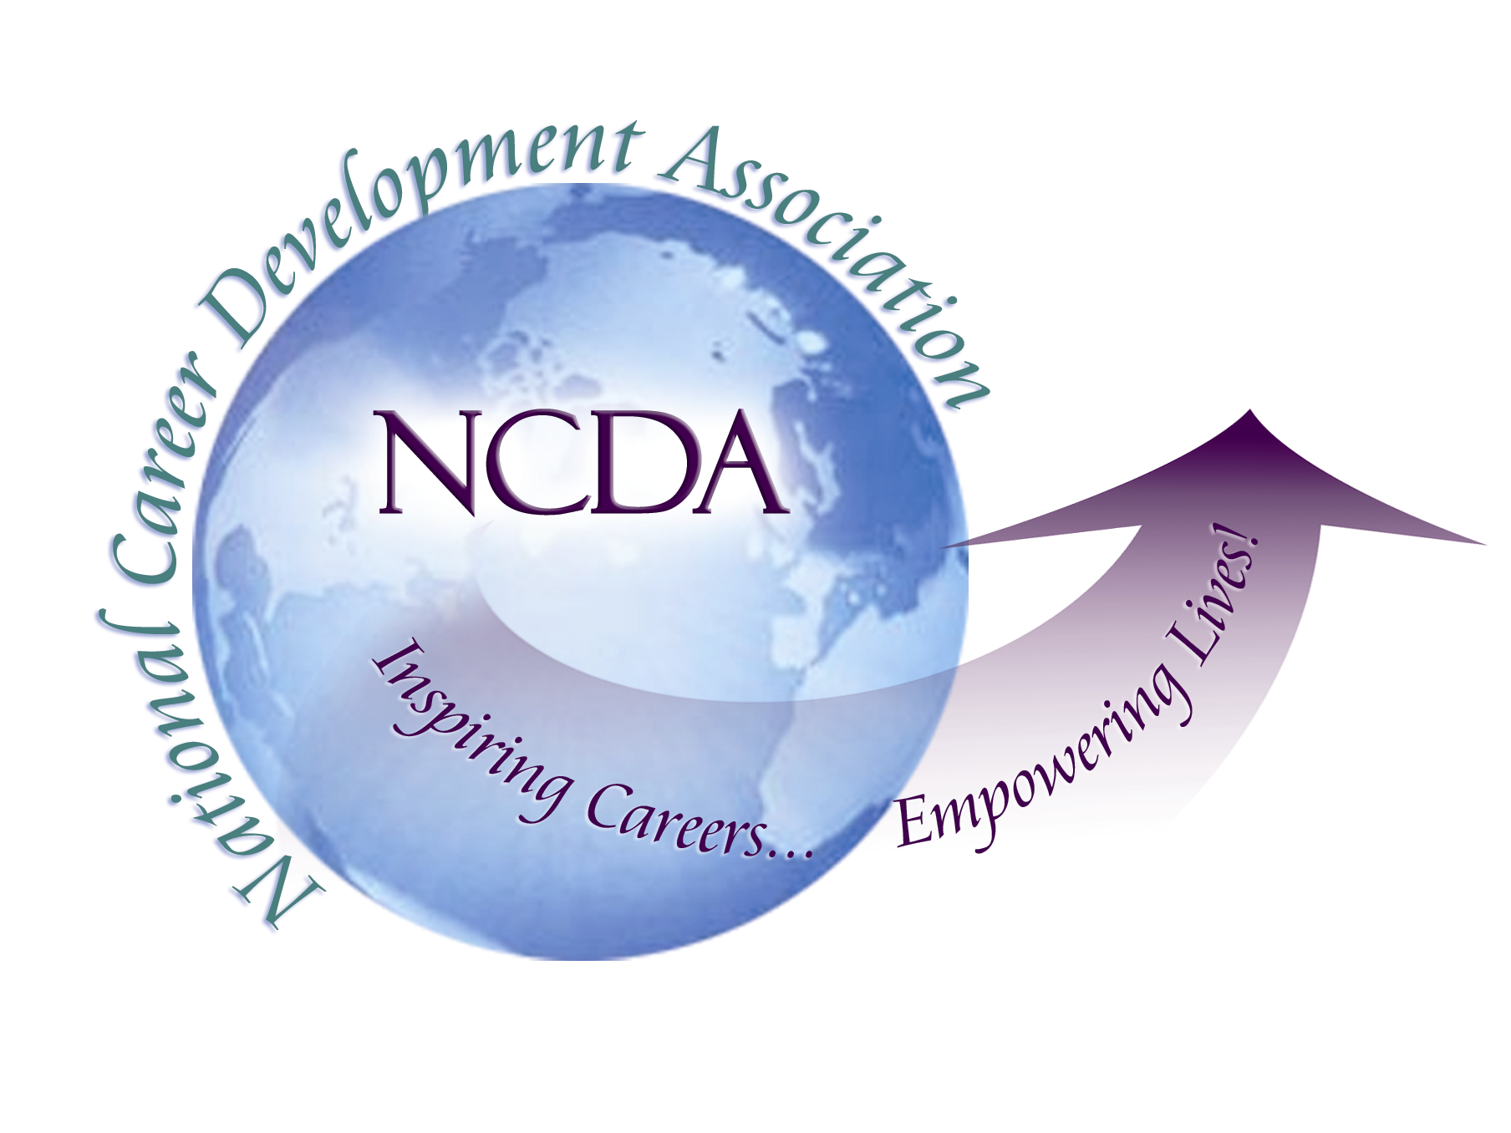
305 N. Beech Circle
Broken Arrow, OK 74012
918/663-7060
Fax: 918/663-7058
www.ncda.org

National Career Development Association
Leadership Academy
Project Summary

Participant(s): Brian Hutchison and Laura Coleman

Board Mentor: Dr. Spencer G. Niles

Leadership Academy Class: LA III, 2008-2009

Project Title: Revitalizing the Pennsylvania Career Development Association

Project Description: The Pennsylvania Career Development Association (PCDA) had been dormant for approximately one decade when we began our project in the Summer of 2008. Our primary goal was to explore the possibility of creating a new PCDA with elected officers by the 2009 NCDA Conference. In pursuit of that goal, we outlined the following action steps:

- Create, field, and analyze the results of a needs assessment conducted with NCDA members living in Pennsylvania.
- Hold a conference call with NCDA members identified from the needs assessment who wished to contribute to the new organization in some way.
- Create a revitalization committee from interested parties as determined from the conference call.
- Create an on-line “Google Group” so that potential PCDA members could communicate with one another and the revitalization committee could identify potential leaders.
- Publish a PCDA newsletter.
- Create a web site.
- Hold elections of officers by July 1, 2009.

Summary/Conclusion: We have taken the following steps towards realizing our goals:

- An electronic needs assessment survey was sent to all NCDA members residing in Pennsylvania in August of 2008. The 72 participants represented a 47% response rate. The results of the needs assessment were analyzed and below is a list of the key findings:
    - The highest item of importance was a PCDA state-wide conference
    - The next level items of interest were:
      - State-wide career development newsletter
      - Directory of PCDA members
      - State networking at the annual NCDA conference
      - Conference calls on specific topics
      - PCDA list-serv
      - State networking at PSCA
      - State networking at PCA
c) Items of interest mentioned:
1. Continuing ed workshops
2. Local city meetings, mentoring program like NCDA,
3. Catalogue of career education resources available

- Twenty-four NCDA members were identified from the needs assessment as interested in participating at a leadership level. These participants were invited to attend an organizational conference call. The call was held on September 12, 2008 at 11:00 am. Ten people participated. One of the ten participants expressed interest in moving forward in a leadership capacity at that time (in addition to the two Leadership Academy members).

- The three interested parties led the original revitalization committee. Since then, Dr. Tristana Harvey, the new state-wide contact, has joined.

- The on-line Google Group invitations were sent out in December of 2008 to 154 NCDA members living in Pennsylvania. Committee members periodically posted during the first month of the group to create energy and exchange on the discussion board. To date, there are 32 members of the discussion board.

- A draft of the first PCDA newsletter has been forwarded to the new state contact person and revitalization committee member, Dr. Tristana Harvey.

- Currently, the Google Group page is acting as a website for posting materials and messages for members only. We do not yet have a traditional web site that is accessible through Internet searches by non-members.

- Due to low activity and lack of interest from current message board members, there is still no plan to hold elections. Dr. Harvey has agreed to continue our efforts along with Laura Coleman. Brian Hutchison will be leaving Pennsylvania in May for a new job in Missouri.

Results/Recommendations:

There has been some positive feedback from NCDA members throughout the state but little interest in taking a leadership role at this point. Most conversations have included an expression of unfulfilled needs such as CEU’s or a conference and/or a desire to attend events or use resources such as newsletters and discussion board posts.

Our suggestion is that a small revitalization committee continue to plan low overhead initiatives that create a PCDA presence in the state. Each of these should include a means of identifying potential leaders/contributors who can be recruited to the effort. Current plans include a newsletter, meeting of PA career professionals at NCDA in Saint Louis, and the development of a website. There has been some discussion of offering an on-line seminar that would provide CEU’s to participants. Finally, relationships with other state-wide organizations might merit further investigation in hopes of collaborating.

