National Career Development Association
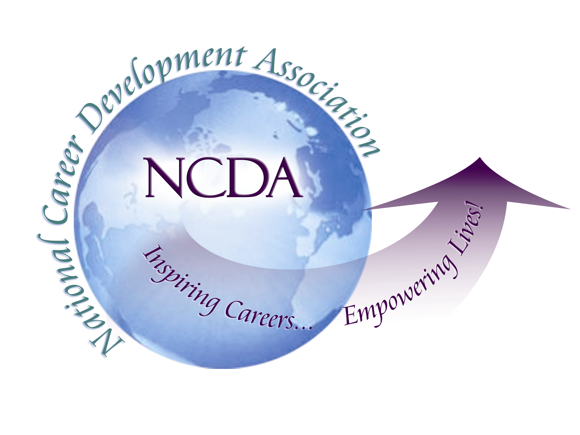
305 N. Beech Circle
Broken Arrow, OK 74012
918/663-7060
Fax: 918/663-7058
www.ncda.org

National Career Development Association
Leadership Academy
Project Summary

Participant(s): Lourdes M. Rivera
Lee Covington Rush

Board Mentor: Brian Taber

Leadership Academy Class: LA III, 2008-2009

Project Title: Reaffirming the Importance of Career Development in the Preparation of Professional Counselors: Strengthening the Linkages Between ACES and NCDA

Project Description:

The ACES/NCDA position paper, Preparing Counselors for Career Development in the New Millennium (2000), provided a clarion call for the reemergence of the historical connections between ACES and NCDA in counselor preparation, program initiatives, and counseling pedagogy, as related to training in career counseling. Most significantly this ACES/NCDA Commission report articulated the two associations joint commitment in “finding ways to assist counseling professionals to better meet client needs through a renewed vision of career development in counselor education”, (ACES/NCDA Commission, 2000, p. 1). The Commission report further highlighted the urgent need for these collaborative efforts given the rapid cultural, social and economic changes taking place in the US and the consequent differing and/or expanding client needs in this New Millennium.

The propositions of the Commission clearly identified re-conceptualized visions and goals in the training of counselors’ for effective career interventions. Yet as we approach the end of the first decade of the 21 Century, questions remain in terms of the implementation of the Commission’s proposals, vis-à-vis, counselor education training. For example, McGlothlin and Davis (2004) in a study assessing attitudes related to the benefits of CACREP core standards, reported that, “Counselor educators perceived Career Development… and Assessment…as the least beneficial CACREP (2001) core curriculum standards” (pp. 278-279). Indeed collectively, mental health professionals, school counseling professionals, as well as counselor educators, in this study, all ranked Career Development as the least beneficial CACREP standard.

Further, the ACES/NCDA Commission maintained that the dearth of research on career development in the ACES journal, Counselor Education and Supervision, was evidence of the lack of leadership by the organization in terms of career related research. In considering this concern by the Commission, the authors of this proposal did a cursory literature review of the Counselor Education and Supervision journal. Between the years of 2000-2008, we found only one article in the journal related to career development.

Thus, the rationale for undertaking this project for the NCDA Leadership Academy III is that of articulating and identifying means and methods by which the linkages between ACES and NCDA might be renewed, for the enhancement of counselor training, and most importantly, for increased efficacy in client career counseling and interventions. Specifically, this project seeks to 1) increase counselor educators’ awareness and appreciation of the significance of career development as a corner stone in the preparation of counselors; and, 2) encourage an increased focus on career development and career counseling within counselor education programs.

In this effort we have undertaken a multi-pronged approach which included:

- Surveying the ACES membership on their perceptions and attitudes related to career development and counseling as an important component in the preparation of professional counselors
- Increasing communication and connections between ACES and NCDA leadership in order to dialogue on how ACES can integrate career development more prominently in their vision and mission
- Establish a Career Interest Network within ACES as a forum for dialoguing with counselor educators about the importance of career development in the training of professional counselors and provide support and resources for counselor educators committed to addressing career development training in their counselor preparation programs
- Increase the number of career development related presentations at national and regional counseling related conferences with a focus on the training of professional counselors.

References

ACES/NCDA Position Paper. (2000). Preparing counselors for career development in the
new millennium. ACES/NCDA Commission, Hanson, S. Chair and Principal Author.

McGlothlin, J. & Davis, T. (2004). Perceived benefits of cacrep (2001) core curriculum
standards. Counselor Education & Supervision, 43, 274-286.

Summary/Conclusion:

Though we see our efforts related to this project as an ongoing endeavor, we believe that over the past year we have been able to make significant progress in achieving our objectives. Below is a summary of what has been accomplished to date for each of the initiatives identified above.

Survey of Counselor Educators
We developed a 34 item survey to assess the perceptions of counselor educators as relates to the significance of career development/counseling training in the preparation of professional counselors. Working with the ACES leadership, we were able to obtain access to the ACES membership list and send the survey out to all ACES members. We received 421 responses. Implications and recommendations based on the data collected in included at the end of this document.

Increasing Connections Between ACES and NCDA Leadership
As relates to the goal of increasing communication and networking between ACES and NCDA, we have reached out to the President and President-Elect of ACES to begin a dialogue around issues of career development as an important component in the preparation of professional counselors. Both the President and President-Elect have been very responsive and have expressed a desire to continue dialogue around focusing on career development issues as an organization. They also provided support in our efforts related to the dissemination of the aforementioned survey on the ACES listserver and in the establishment of the ACES Career Interest Network as indications of their continued commitment.

ACES Career Interest Network
The ACES Career Interest Network was formally established and the first meeting of the Network was held at the 2009 ACA conference in Charlotte, NC. Information about the network has been included on the ACES webpage and we have been working on creating a list of interested professionals. The goal of this network is to increase dialogue among varied professionals regarding career development/counseling, the needs of professionals in the field, and the preparation of professional counselors as relates to career development training. As we continue to present at national conferences, we will continue to recruit members.

National and Regional Presentations
Since beginning work on this project, we have provided two refereed presentations on the importance of career development as a key component in the preparation of professional counselors. Both these presentations were at the NARACES conference in Portland, ME in 2008. In addition, two other referred presentations were accepted and scheduled in 2009. The first presentation is; Why We Love Teaching Career Counseling, at the NCDA International Conference in St. Louis, July 09. The second presentation is; Rethinking the Intersection of Personal and Career Counseling: A Holistic-Relational Perspective for 21st Century Counseling Pedagogy, at the ACES Conference in San Diego, October 2009.

Summary of Survey Results:

Members of ACES were invited to complete a 34 item survey designed to assess the perceptions of counselor educators as relates to the significance of career development/counseling training in the preparation of professional counselors. The survey contained two subscales with items which specifically focused on career-related tasks and items which focused on more general counseling related tasks. Respondents were asked to indicate the importance of addressing these tasks in the preparation of professional counselors. In addition, respondents were asked to rank order the eight CAREP core areas based on how important they perceived each to be in the training of professional counselors.

The survey was sent to all ACES members through the organization’s membership list. Of the 424 ACES members who responded to our survey, 247 (58%) were female, 133 male (31%), and 44 (10%) did not indicate gender. The majority of respondents were Caucasian (71%). The rest of the sample consisted of African American (7%), Hispanic/Latina/o (4%), Asian American (3%), Native American/Alaskan Native (.5%), and fifteen percent of respondents did not answer this question.

As relates to the teaching of career related courses, 125 (30%) of respondents indicated that they currently teach career counseling courses, with 154 (36%) indicating that they have never taught a career course, and 78 (18%) responding that they have taught career courses in the past. Of those individuals currently teaching career courses, 83 were tenured or on a tenure track line (34% and 33% respectively), the rest were on non-tenure track lines (e.g., subsititute or adjunct).

A comparison of the mean scores for each subscale indicated that a significant difference emerged between the two subscales (t = 18.38, df = 423, < .001), with the general counseling tasks (M = 4.44, SD = .58) rated as more important in the training of professional counselors than the career related tasks (M = 4.08, SD = .41). An examination of the ranking of the eight CACREP core areas indicated that Career development was ranked as the least important in the training of professional counselors.

Implications:

Based on the results of this survey, it seems evident that career development continues to be viewed as the least significant area in the preparation of professional counselors. Given the importance of work in peoples’ lives and the increasing need to prepare young people for the world of work, greater efforts need to be made to highlight the importance of career development and counseling in the training of new counseling professionals. This need will become even more critical as our society continues to grow more diverse and the world of work continues to change and evolve.

Recommendations:

Below are some recommendations for how NCDA, in collaboration with ACES, can continue to work on promoting the significance of career development as an integral component of the training of professional counselors.

- Provide training and professional opportunities to increase counselors’ and counselor educators’ understanding and appreciation of the significance of work in peoples’ lives and the inseparability of personal and career counseling
- Provide continued outreach to counselor educators on teaching career development
- Use the Career Interest Network to provide support, resources, and a sharing venue for counselor educators
- Continue to foster a closer working relationship between the NCDA and ACES leadership in order to promote career development content as a key component in the preparation of professional counselors
- Both ACES and NCDA need to provide support for professionals to conduct research and publish in the area of career development and training.
- Both ACES and NCDA need to provide venues for professionals to share effective practices and relevant written and media materials that could be used for experiential presentations and activities in counselor preparation classes
- Develop presentations for ACES conferences of general interest to all counselor educators that use career cases as illustrations (e.g., case studies)

