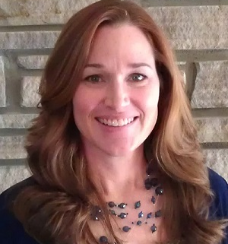
NCDA Speakers’ Bureau
Cheryl P. Wolf, PhD, NCC, LPCA, PHR, CHt
Western Kentucky University
Bowling Green, KY 42101

(270) 745-4484
cheryl.wolf@wku.edu
www.cherylpencewolf.com

Brief Bio: Cheryl is an Assistant Professor of counseling and Career and Workforce Development trainer at Western Kentucky University. More than 20 years of leadership, research, teaching, career counseling, and professional experience have strengthened Cheryl's passion for helping people find meaningful careers that are aligned with their values, provide a deep sense of satisfaction, and contribute to their overall personal wellness and work performance. From naval officer to counselor and professor, Cheryl's professional career experiences span across military, government, public-sector, private-sector, and academic arenas. Her education includes a B.S. in economics from the U.S. Naval Academy in Annapolis, Maryland; M.S. in human resource management from Troy State University; and her M.Ed., Ed.S., and Ph.D. in counselor education from the University of Florida. She maintains certifications as a Professional in Human Resource Management (PHR), Nationally Certified Counselor (NCC), Licensed Professional Counseling Associate (LPCA), and Certified Clinical Hypnotherapist (CHt). Cheryl has written several professional journal articles, book chapters, and more. She been a presenter at numerous state, regional, national, and international counseling association conferences as well as conducted training and consulting with many organizations on a variety of career-related topics.

Presentation Titles: Advocate for yourself: Negotiating your next academic job offer; Finding a dream job in counseling: Tips for exploring, negotiating, and securing your next position; Factors of career meaning: An analysis of U.S. Naval Academy graduates.

Fee: On site fee-Negotiable depending on the proximity, availability, audience, cost to participants, sponsoring agency, etc. Fee does not include travel, accommodations, and honorarium.

Format: Lecture, group activities, role plays, and individual presentations

Length of Session: From 1 hour to 1day; more time as negotiated.

Availability: One-month notice for scheduling, more advanced planning is preferred.

Follow-up: Yes-Available for consultation with participants or organizers after the event as needed.

