Ohio Dominican University
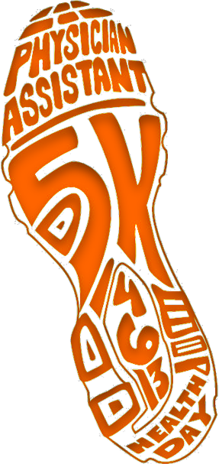 | 
 | 
Run and Fitness Walk • Yoga • Zumba • Nutrition and more!
April 6 • 8:30am • Greenswell.com to register

