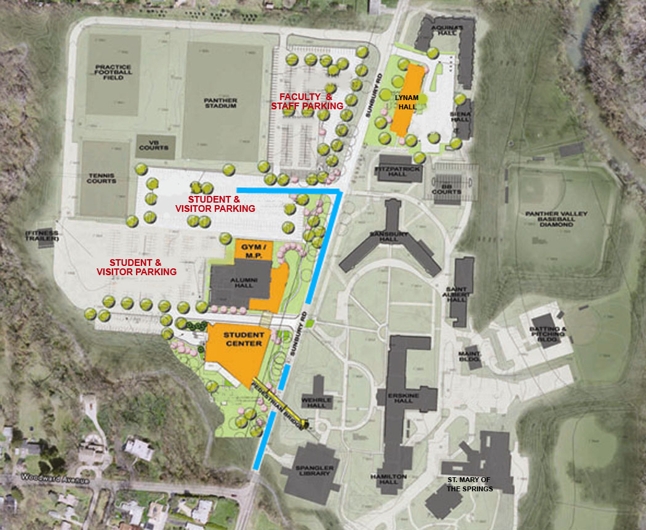

Parking questions:

Safety & Security Office
251-4700

