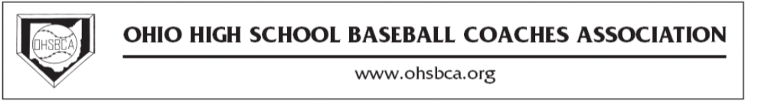

Dear Coach:

The highlight of our annual clinic is the Hall of Fame luncheon at noon on Friday. At this luncheon any coach who has attained a victory or membership milestone is recognized in the banquet program. In addition, certificates denoting the achievement are distributed at our district meeting. Membership awards go to coaches who have been members of the association for 15+ years. Victory awards go to coaches who have won their 100th, 200th, 300th, etc. high school varsity games during the preceding year.

If you qualify in either or both of these categories, please complete the information sheet below and return to the address below.

VICTORY AND SERVICE AWARD FORM

NAME________________________________________________________________

SCHOOL______________________________________________________________

EMAIL________________________________________________________________

DIVISION I II III IV

DISTRICT C E NE NW SE SW

NUMBER OF HIGH SCHOOL VICTORIES achieved during the past season:

100 200 300 400 500 _________

Please circle

NUMBER OF YEARS AS OHSBCA MEMBER achieved during the past season:

15 20 25 30 35 40 ________

Please circle

Deadline: Dec. 20, 2015

Members submitting forms after the deadline will not receive their award or be recognized at the state convention. Awards will be given to your district rep for distribution at a later date.
You may also e-mail this form by clicking on the hyperlink and saving as an attachment

benj33@aol.com

Mail forms to:
Ray Benjamin
332 Pagoda Court
Pickerington, Ohio 43147

