John Bakalar
President NEOBCA
Head Coach
Crestwood
216-408-0449
jbakalar@crestwoodschools.org
Dear Athletic Director/Head Baseball Coach:

The NEOBCA (Northeast Ohio Baseball Coaches Association) under the direction of the Board of Directors has elected a new Executive Board for the 2015-2016 season.

President: John Bakalar (Crestwood) Secretary: John Ellis (Benedictine)
Vice President: Dennis Markiewicz (Holy Name) Treasurer: Luke Smrdel (Kirkland)
All-Star Game Chairman: Bill Gamble (Jackson) Hall of Fame/Scholarship: Brian Sliwinski (Retired)

We are very excited to be representing this organization and our goal is to reestablish NEO (which is the largest district in the state) and bring some continuity and stability to the NEOBCA. We would like to thank long-time member Jeff Keck (Vermillion) for all his work on behalf of the Northeast District as a State Representative and All-Star Game Chairman and wish him the best of luck in the Northwest District.

For District information please visit our website under www.ohsbca.org, click Districts then Northeast. You can also subscribe to updates on Twitter @NEOBCA.

NEOBCA Benefits:
- Membership includes:
  - Nominate and Participate in NEOBCA All Star Game held in June
  - Nominate player(s) for NEOBCA 2016 All District Team including Player of the Year, Coach of the Year, Assistant Coach of the Year and Field of the Year.
  - Nominate/Selection for NEOBCA Hall of Fame
  - Nominate/Selection for NEOBCA Scholarship Program
- Annual dues are $20.00 – Must be received by March 15, 2016
  - If you are a member of the GCBCA, you may pay the NEOBCA dues at the GCBCA meetings and will have your membership information forwarded to the NEOBCA.

OHSBCA Benefits ($25 due February 15th):
- Nominate and Participate in Mizuno All-Ohio Senior All-Star Series
- Nominate Team in Coaches’ Poll
- Nominate Player(s) for All-Ohio Poll Team
- Nominate Player(s) for Academic All-Ohio
- Nominate Coaches for Hall of Fame and Scholarship opportunities
- www.ohsbca.org All forms and contact information

These organizations, the OHSBCA, NEOBCA, Lake County Coaches Association, Lorain County Coaches, and GCBCA (Greater Cleveland), allow coaches and students to be recognized for their excellence. Join these organizations (if they apply to your location) to ensure maximizing the visibility of your program and your student-athletes. Please feel free to pass along this information and accompanying materials to the head baseball coach.

Yours in Baseball,

President: John Bakalar (Crestwood) Secretary: John Ellis (Benedictine)
Vice President: Dennis Markiewicz (Holy Name) Treasurer: Luke Smrdel (Kirkland)
All-Star Game Director: Bill Gamble (Jackson) Hall of Fame/Scholarship: Brian Sliwinski (Retired)

NEOBCA was well represented in 2015!

Division I Aurora Final Four Coach Michael Brancazio

Saint Ignatius Final Four Coach Brad Ganor

OHSBCA Hall of Fame Inductee Coach Chris Kaczmar Walsh Jesuit

19 players on the All-Ohio Poll Team
Division II Poland Seminary State Runner-Up Coach Rich Murray

14 players on the All-Ohio Poll Team

Division III Canton Central Catholic State Champions Coach Doug Miller

14 players on the All-Ohio Poll Team

Division IV Berlin Center Western Reserve State Runner-Up Coach Ed Anthony

6 players on the All-Ohio Poll Team

Congratulations to Coach Ken Ciolek (Lakewood)
2016 OHSBCA Hall of Fame Inductee

Important Dates: OHSBCA State Clinic January 21-23, 2016
NEOBCA/OHSBCA All-Ohio/All-District
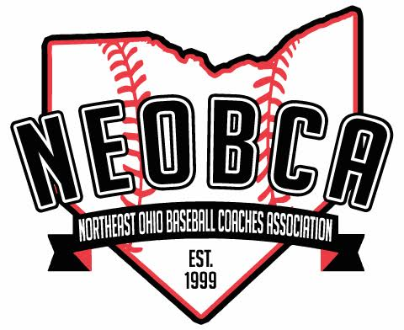
Meeting Hudson HS 2:00PM May 15, 2016

