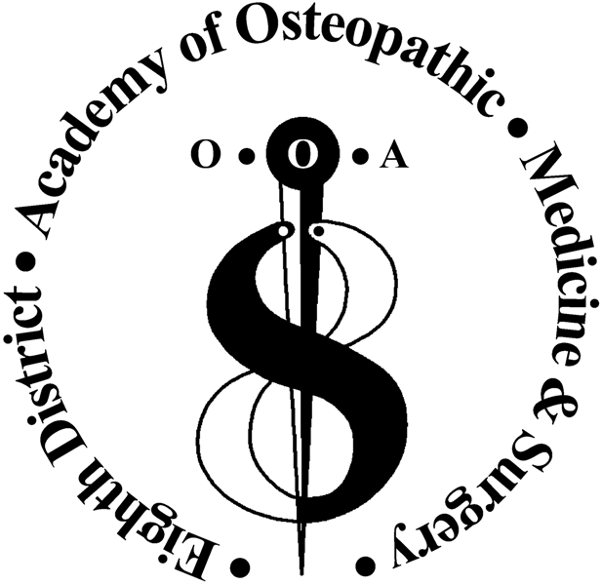

8th District Academy of Osteopathic Medicine & Surgery

Akron-Canton
8th District Academy
2014 Calendar of Events

2014 SAVE THE DATES! Please visit www.ooanet.org and http://district8do.org/
for updates and venue selections

May 21, 2014  CME Program: 3-4 AOA Cat 1A | Resident Paper Presentations @ Prime 93 http://prime93.com/
April 23-27, 2014 (CME  OOA Event) | OOA Symposium – Hilton @ Easton, Columbus, OH [refer to OOA www.ooanet.org]  http://www.ooanet.org/aws/OOSA/pt/sp/symposium
April 25-26, 2014 (OOA House of Delegates – OOA Event)
September 10, 2014 TENTATIVE | Academy Program or OOA Family Night/Tentative Date – NOT YET SCHEDULED
October 11-12, 2014  CME Program: 16 AOA Cat 1A | Touchdown to CME! @ Pro Football Hall of Fame, Canton, OH http://www.profootballhof.com/default.aspx

★ 8th District Academy of Osteopathic Medicine & Surgery’s 2014-2015 Slate of Officers and OOA State Officers:
Gabriele Bryant, Executive Director

Executive Committee Members:
Douglas W. Harley DO, President
Mark Tereletsky, DO, Vice President
Kevin Zacour, DO, Secretary
Sandy Wikas, DO, Treasurer
James Pritchard DO, At-Large Member

Paul T. Scheatzle DO, OOA President/At-Large Member
Charles D. Milligan, DO, OOA State Trustee
Douglas Harley, DO, OOA Alternate State Trustee

T.J. Wolski, DO – Resident Member
Jacqueline Zuponcic – Student Member

497 Thayer Place, Wadsworth OH 44281 District8DO@gmail.com
Phone: 330.608.7647 Fax: 888.268.6773
http://district8do.org/

