

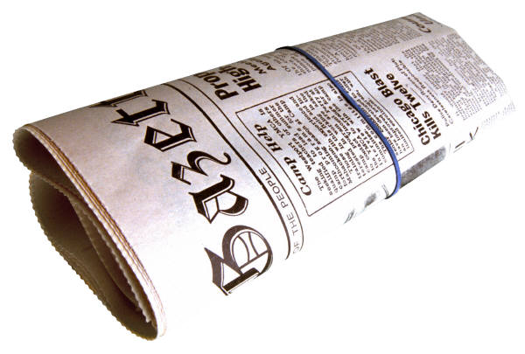
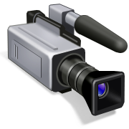
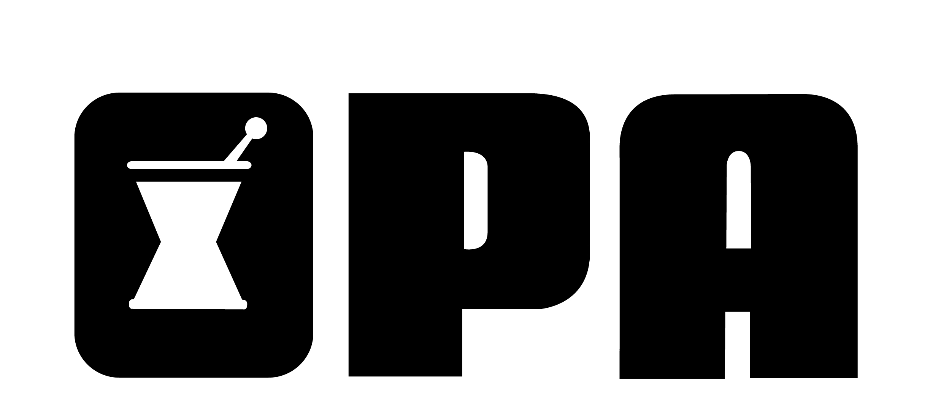
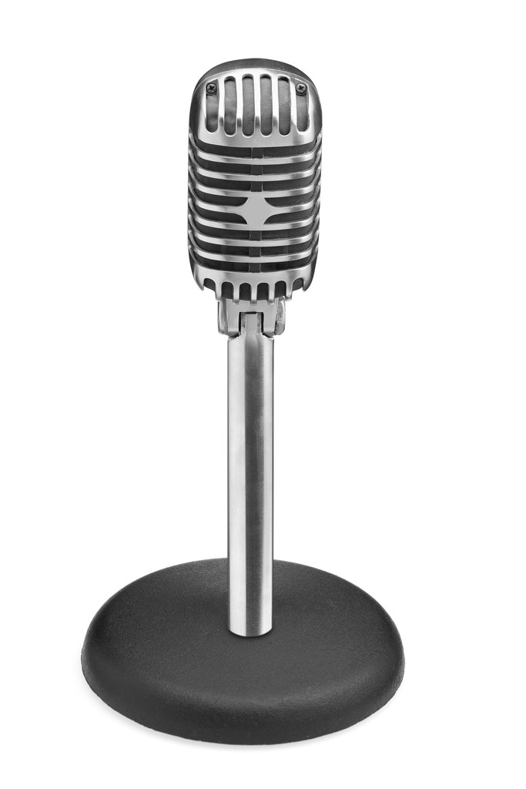
HELP OPA GET THE WORD OUT!
Do you have an interest in...
- educating the public about the value of pharmacists,
- writing editorials or articles for local newspapers or magazines,
- being on television and radio,
- utilizing social media,
- talking to local groups or schools, or
- locating pharmacist resources in your area when the media contacts you?

The OPA Public Relations Committee is looking for members and students across the state to become a part of our new PR Pharmacy Network. Help educate the public on topics that showcase the value of pharmacists in improving healthcare. Just fill out the form below and send to OPA for more information.

Ohio Pharmacists Association ~ 2674 Federated Boulevard, Columbus, OH 43235
phone: 614-389-3236 ~ fax: 614-389-4582 ~ info@ohiopharmacists.org

Name: ___________________________________________________
Address: _________________________________________________
City: ____________________________ State: ___ Zip: ________
Email: ___________________________________________________
Willing to travel within Ohio?  Yes  No
Topics that interest you: ____________________________________
__________________________________________________________
Please select all that interest you:
- Television interviews
- Radio interviews
- Writing editorials/articles
- Social Media
- Presentations to local groups
- Other:___________________________

