Worship Bulletin
For
May 1, 2011
Remembering World Malaria Day (April 25)
And
The ELCA Malaria Campaign

Introduction:
The Southern Ohio Synod is a pilot synod in the ELCA Malaria Campaign. The ELCA is part of a worldwide effort to eliminate deaths from malaria. In 2008, there were 247 million cases of malaria and nearly one million deaths – mostly among children living in Africa; in Africa a child dies every 45 seconds of malaria. Malaria is a disease of poverty, but we have the tools to prevent and treat it. This worship service is a special focus on our call as
the Body of Christ to hear and reach out to ‘the least’ in need.

Prelude

Welcome

The assembly stands

Confession and Forgiveness
Blessed be the holy Trinity, + one God,
who gives us a new birth into a living hope,
who raises us with Christ from death,
who fills us with the Holy Spirit.
Amen.
Let us repent of our sin and claim the promise of God.
Silence is kept for reflection.
Living God,
we confess before you and one another our futile ways,
our pursuit of perishable things, our own part in crucifying the Lord Jesus. Forgive us, O God; renew the face of the earth; and give us the assurance that you have rescued us
from the power of sin and made us alive in the Spirit forever.
Amen.
Christ suffered for sins once for all in order to bring you to God.
1
Lord's Prayer
Our Father, who art in heaven, hallowed be thy name,
thy kingdom come, thy will be done,
on earth as it is in heaven.
Give us this day our daily bread; and forgive us our trespasses, as we forgive those who trespass against us;
and lead us not into temptation,
but deliver us from evil.
For thine is the kingdom, and the power, and the glory,
forever and ever. Amen.

COMMUNION

COMMUNION HYMNS; insert as desired

POST-COMMUNION PRAYER
Let us pray.

O God, we give yoy thanks that you have set before us this feast, the body and blood of your Son. By your Spirit strengthen us to serve all in need and to give ourselves away as bread for the hungry, through Jesus Christ our Lord.
Amen.

Blessing
May the Christ who walks with wounded feet
teach you to follow in his path.
May the Christ who serves with wounded hands
teach you how to serve.
May you see the face of Christ in all who you meet and
May all whom you meet, see the face of Christ in you.
Amen.

Sending Song: see attached list for suggestions

Dismissal
Go in peace. Share the good news.
Thanks be to God. Alleluia, alleluia!

Postlude

10
Now you are God's people; now you have received mercy.
In the name of the risen + Lord Jesus, I declare to you t
hat your sins are forgiven. Lay aside guilt, put away shame,
for you are chosen and precious in God's sight.
Live in the marvelous light of Christ.
Amen.

Gathering Song: see attached list for suggestions
Greeting
Alleluia! Christ is risen!
Christ is risen indeed. Alleluia!
The grace of our Lord Jesus Christ, the love of God,
and the communion of the Holy Spirit be with you all.
And also with you.
Gathering Litany
God comes to us in the waters of baptism, rushing to fill our lives with the Spirit.
Refresh us, O Lord.

God comes to us in the words of the prophets, the language of the gospels.
Speak to us, O Lord.

God comes to us in the clamoring voices of children, the needs of the world.
Slow us down, O Lord.

God comes to us in the midst of disease, healing our bodies and souls,
Comfort us, O Lord.

God comes to us in the bread and wine of the table, signs of mercy and grace for all.
Feed us, O Lord.

2
Canticle of Praise
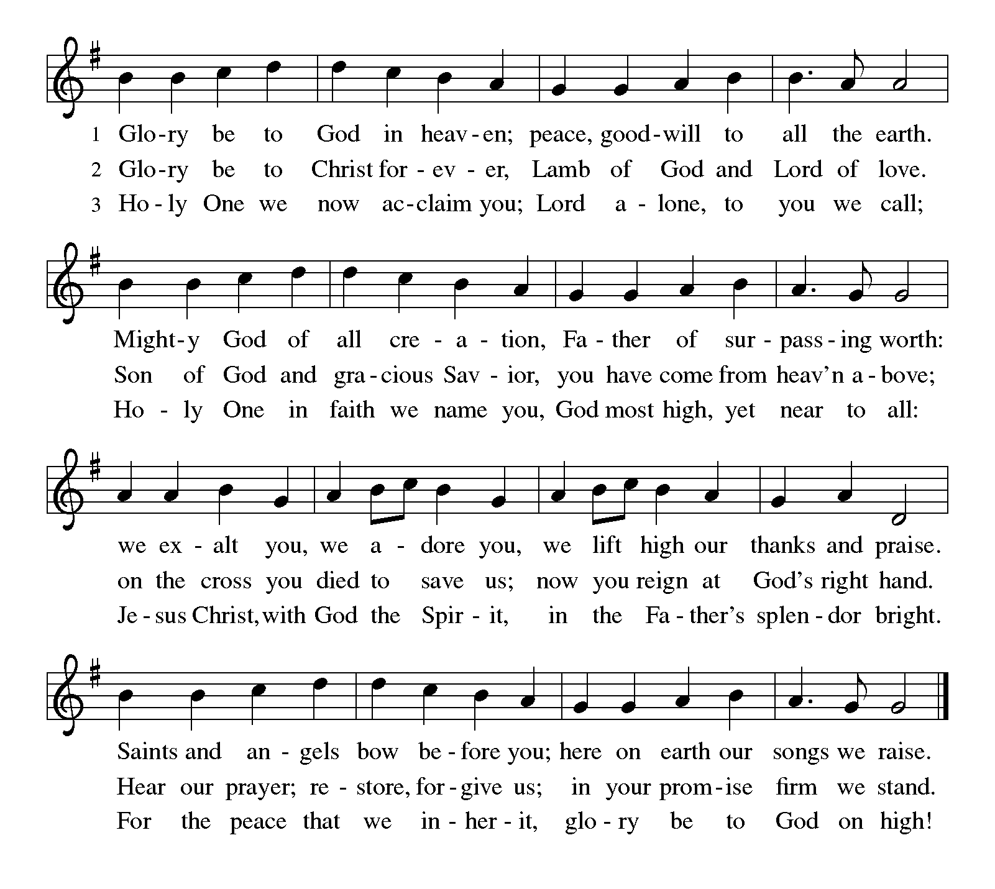
Prayer of the Day
Almighty God, with joy we celebrate the festival of our Lord's resurrection. Graciously help us to show the power of the resurrection in all that we say and do; through your Son, Jesus Christ our Lord, who lives and reigns with you and the Holy Spirit, one God, now and forever.

First Reading
A reading from Isaiah 55:1, 10-11
Ho, everyone who thirsts, come to the waters; and you that have no money, come, buy and eat! Come, buy wine and milk without money and without price. For as the rain and the snow come down from heaven, and do not return there until they have watered the earth, making it bring forth and sprout, giving seed to the sower and bread to the eater, so shall my word be that goes out from my mouth; it shall not return to me empty, but it shall
3
accomplish that which I purpose, and succeed in the thing for which I sent it.
The word of the Lord. Thanks be to God.

Psalm 103:1-6
¹ Bless the Lord, O my soul,
and all that is within me,
bless his holy name.
² Bless the Lord, O my soul,
and do not forget all his benefits—
³ who forgives all your iniquity,
who heals all your diseases,
⁴ who redeems your life from the Pit,
who crowns you with steadfast love and mercy,
⁵ who satisfies you with good as long as you live
so that your youth is renewed like the eagle’s.
⁶ The Lord works vindication
and justice for all who are oppressed.

Second Reading
A reading from 1 Corinthians 12:12-26
For just as the body is one and has many members, and all the members of the body, though many, are one body, so it is with Christ. For in the one Spirit we were all baptized into one body—Jews or Greeks, slaves or free—and we were all made to drink of one Spirit. Indeed, the body does not consist of one member but of many. If the foot would say, “Because I am not a hand, I do not belong to the body,” that would not make it any less a part of the body. And if the ear would say, “Because I am not an eye, I do not belong to the body,” that would not make it any less a part of the body. If the whole body were an eye, where would the hearing be? If the whole body were hearing, where would the sense of smell be? But as it is, God arranged the members in the body, each one of them, as he chose. If all were a single member, where would the body be? As it is, there are many members, yet one body. The eye cannot say to the hand, “I have no need of you,” nor again the head to the feet, “I have no need of you.” On the contrary, the members of the body that seem to be weaker are indispensable, and those members of the body that we think less honorable we clothe with greater honor, and our less respectable members are treated with greater respect; whereas our more respectable members do not need this. But God has so arranged the body, giving the greater honor to the inferior member, that there may be
4
no dissension within the body, but the members may have the same care for one another. If one member suffers, all suffer together with
it; if one member is honored, all rejoice together with it.

The word of the Lord. Thanks be to God.

The assembly stands

Gospel Acclamation

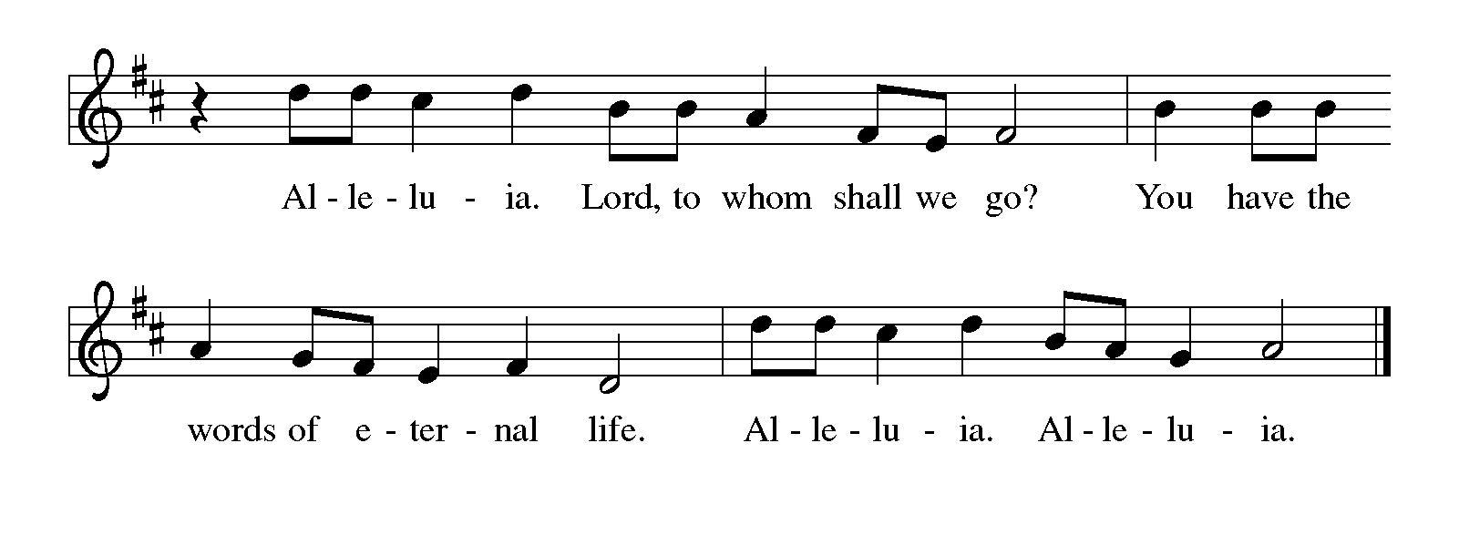
Gospel:
The holy gospel according to St. Matthew.
Glory to you, O Lord.
Matthew 25:34-40
I was hungry and you gave me food, I was thirsty and you gave me something to drink, I was a stranger and you welcomed me, I was naked and you gave me clothing, I was sick and you took care of me, I was in prison and you visited me.’ Then the righteous will answer him, ‘Lord, when was it that we saw you hungry and gave you food, or thirsty and gave you something to drink? And when was it that we saw you a stranger and welcomed you, or naked and gave you clothing? And when was it that we saw you sick or in prison and visited you?’ And the king will answer them, ‘Truly I tell you, just as you did it to one of the least of these who are members of my family, you did it to me
The gospel of the Lord.
Praise to you, O Christ.

CHILDREN’S SERMON: see attached sermon for children
SERMON: see attached sermon and/or sermon starter
5
HYMN OF THE DAY: see attached list for suggestions

Creed
We believe in one God,
the Father, the Almighty,
maker of heaven and earth,
of all that is, seen and unseen.
We believe in one Lord, Jesus Christ,
the only Son of God,
eternally begotten of the Father,
God from God, Light from Light,
true God from true God,
begotten, not made,
of one Being with the Father;
through him all things were made.
For us and for our salvation
he came down from heaven,
was incarnate of the Holy Spirit and the virgin
Mary
and became truly human.
For our sake he was crucified under Pontius
Pilate;
he suffered death and was buried.
On the third day he rose again
in accordance with the scriptures;
he ascended into heaven
and is seated at the right hand of the Father.
He will come again in glory to judge the living
and the dead,
and his kingdom will have no end.
We believe in the Holy Spirit, the Lord, the giver of life,
who proceeds from the Father and the Son,*
who with the Father and the Son is worshiped and
glorified,
who has spoken through the prophets.
We believe in one holy catholic and apostolic church.
We acknowledge one baptism for the forgiveness of
sins.
We look for the resurrection of the dead,
and the life of the world to come. Amen.

6
Prayers of Intercession
In this season of resurrection, we lift up to God all those in need in the church and throughout the world.
A brief silence.
Alleluia! We thank you for your church and its mission. Give us courage to take good news into a world that does not know you. Hear us, O God.
Your mercy is great.
Alleluia! We thank you for your creation. Challenge us to use its resources wisely, generously, and respectfully. Hear us, O God.
Your mercy is great.

Alleluia! Awaken us to the promise of new and renewed life that accompanies our Lord’s resurrection. Stir up hope in all who suffer with malaria, and renew the zeal of those who research cures and treatments, that through their lives and work the world might behold the promise of Christ’s resurrection for today.

Your mercy is great.

Alleluia! We thank you for all the good things you have given us. Transform our thanks into compassion for those who are poor in body, mind, or spirit (especially). Hear us, O God.
Your mercy is great.
Alleluia! We thank you for this congregation, its pastor/s and lay leaders. Equip us with a sense of purpose in this place to serve our neighbors (especially those fighting the disease of malaria). Hear us, O God.
Your mercy is great.
Alleluia! We thank you for the resurrection we have been promised through Jesus' death and resurrection. Bring us together again one day with all the saints Hear us, O God.
Your mercy is great.
Into your care, O God, we place ourselves and all our prayers, trusting your promise of new life in Jesus Christ, our risen Savior.
Amen.

7
peace
The peace of Christ be with you always.
And also with you.

The assembly is seated
Offering

The assembly stands

Offertory Hymn: Create in Me a Clean Heart (ELW 186)
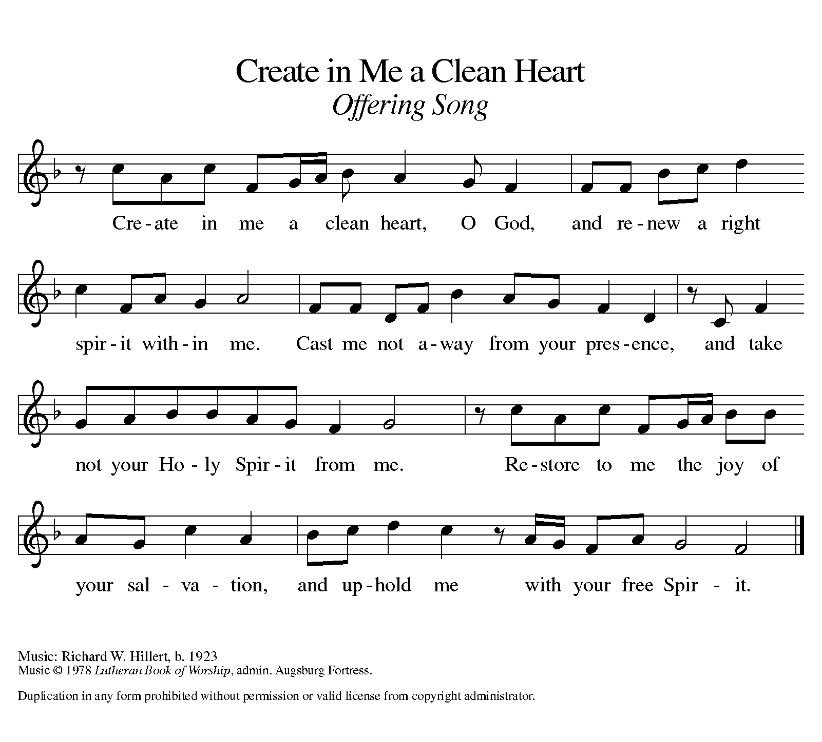

offering prayer
Let us pray.

Holy God, gracious and merciful, you bring forth food from the earth and nourish your whole creation. Turn our hearts toward those who hunger in any way, that all may know your care; and prepare us now to feast on the bread of life, Jesus Christ, our Savior and Lord.
Amen.
8
Great thanksgiving through Words of Institution:
Insert preferred setting

9

