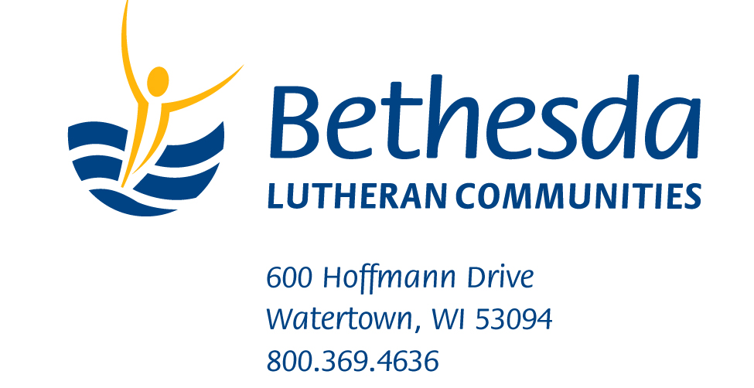

December 2, 2013
Media Contact: Nicholas L. Honeck
920-206-4445|
Student Volunteers Needed for Bethesda Lutheran Communities Summer Camps
Watertown, Wis. — More than 750 student volunteers are needed for four Bethesda Lutheran Communities camp programs in Wisconsin, Indiana, Colorado and Texas this summer.
Bethesda, a national provider services for people with intellectual and developmental disabilities, has offered camp and retreat ministry opportunities since 1969.
Bethesda camps are designed to engage volunteers (ages 14 and older) as one-to-one companions with people who have developmental disabilities. Activities—including worship, arts and crafts, and outdoor recreation—foster spiritual growth and the development of meaningful friendships. Adults are also needed to serve as cabin leaders and in other capacities.
Camps, which last six days and five nights, are ideal for youth and adult groups and families looking for mission trip and service opportunities. Volunteers receive training on topics related to developmental disabilities, including etiquette, personal care and communication.
Camps are SonRise, Anderson, Ind.; Camp Matz, Watertown, Wis.; Camp Bethesda, Tomball, Texas; and Bethesda Mountain Builders, Woodland Park, Colo.
Registration fees cover meals and lodging. To learn more, visit BethesdaLutheranCommunities.org/camps.
The 2014 camp offerings are:
- SonRise, Anderson, Ind., 45 minutes northeast of Indianapolis. Features air-conditioned, 25,000-square-foot retreat facility set on 14-wooded-acres. Eight sessions are scheduled from June to August. No session the week of July 4. Email SonRise@mailblc.org.
-more-
Bethesda Retreats
Add 1

- Camp Matz, Watertown, Wis., located between Milwaukee and Madison. Features an outdoor chapel and a large, accessible tree house. Eight sessions are scheduled from June to August. No session the week of July 4. Email CampMatz@mailblc.org.
- Camp Bethesda, Tomball, Texas, hosted at the Kaiserhof Retreat Center, 45 minutes north of Houston. Features a spacious outdoor pavilion overlooking a pond and a pool. Three sessions: June 23-28, July 7-12 and July 14-19. Email CampBethesdaTexas@mailblc.org.
- Bethesda Mountain Builders, Woodland Park, Colo., hosted at Lutheran Valley Retreat (LVR). Features a wilderness camp setting, arts and crafts and recreational activities. Three sessions: June 8-14 and July 13-19 and Aug. 4-11. Email BethesdaMountainBuilders@mailblc.org.
-30-
Bethesda Lutheran Communities is a leading provider of person-centered and community-based services that enhance the lives of people who have intellectual and developmental disabilities around the country and throughout the world. Bethesda offers residential and supported-living services, faith and ministry supports, education and training resources, and employment assistance.

