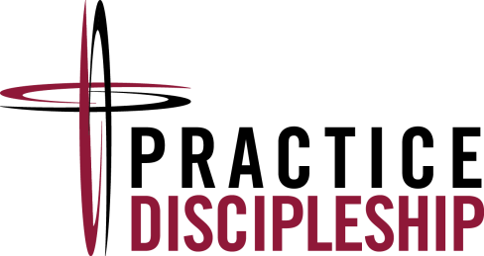
June 7, 2014

Dear Faithful Leaders,

May the joy and peace of God be with you! As we gear up for youth and young adult ministries this summer and continue to prepare, in many congregations, for the 2014 ELCA Youth Gathering in Detroit, thank you for all the ways you value young people and journey with them by faith. Christ is at work in and through you – you make a difference!

This letter is an invitation for leaders involved in youth and young adult ministries serving in your congregation… and really for anyone in the congregation who cares deeply about accompanying young people on their journey of faith. We’d like to offer an opportunity to take a “time-out” and huddle in the spirit of faithful fellowship, teamwork and learning together!

Leaders involved in youth and young adult ministry from Northeastern, Northwestern and Southern Ohio Synods are coming together on August 9th for worship, workshops, and mutual conversation regarding the landscape of youth and young adult ministry today and how we can grow in serving. Sometimes, leaders might feel alone, lost or confused in this vital calling. Our prayer is that this event would be a time to renew, grow, and build relationships between one another.

Here are the particulars:

When ? Saturday, August 9th from 10am to 5pm. (Meals provided: Lunch and optional BBQ dinner with fellowship time starting at 5pm)

Where? All Shepherds Lutheran Church
6580 Columbus Pike
Lewis Center, OH 43035

Who is planning this event? Practice Discipleship Coaches and corresponding Teams/Leadership from Southern Ohio, Northwestern Ohio and Northeastern Ohio Synods involved in the ELCA Youth Ministry Network

How do I register? RSVP by August 1 by visiting one of the following websites:

+ neos-elca.org (For Northeastern Ohio Synod)
+ nwosydn.org (For Northwestern Ohio Synod)
+ pastorbeth64@gmail.com (For Southern Ohio Synod)

How much does this cost? There is NO COST to attend this event. We’d like to offer this to you as a ‘thank offering’ for your faithful leadership and commitment.

If you have any further questions about this event, you are more than welcome to contact one of us:

Pastor Matt Wheeler (NWOS) (419)560-1826 or pastor@galionfirstlutheran.org
Pastor Beth Westphal (SOS) (614)837-7041 or pastorbeth64@gmail.com
Mary Ann Sima (NEOS) (440)655-0983 or maryasima@aol.com

With joy and gratitude for you,

Pastor Matt Wheeler

