Association of Community Health Nursing Educators
Teaching Strategy Submission Form

Directions and Cover Page

Directions for Submitters:

Thank you for sharing your innovative teaching strategies. Please complete this cover page and the attached submission form. The personal information will be removed and the submission will be sent out for a blind review. The reviewers may request you make some changes for the purposes of consistency and clarity. Following approval, the strategy will be posted on the ACHNE website in the members-only section. We are also establishing a process for keeping the website current and will contact you to annually review your submission for currency and broken links.

Please use the following format for the name of the document:
abbreviatedtitle_date
For example: assessment_01312010

Please submit the cover page and submission form to the Editor of the Innovative Teaching Strategies: Christine Vandenhouten at: vandenhc@uwgb.edu

Name: Sarah Cloud
Title: BSN Faculty
Credentials: DNP, RN, APHN-BC
Co-Authors:
Organization: State College of Florida
Email Address: clouds@scf.edu
Office Phone: 941-363-7258
Address: 7131 Professional Pkwy. E.
City: Sarasota
State: FL
Zip: 34240

Title of Teaching Plan/Strategy: Discovery Cafe
Association of Community Health Nursing Educators
Teaching Strategy Submission Form

Directions: Please complete each of the following questions by using the lists in the appendix. The use of bulleted points is encouraged.

1. Title of Teaching Plan/Strategy: DiscoveryCafe_04102013

2. Date of Submission: April 10, 2013 (Revised May 14, 2013)

3. Relevance to Public Health Nursing competencies – select the Main competencies from the appendix and rank the top three competencies in order of importance.

- ACHNE Public Health Nursing Core Knowledge and Basic Competencies
  - Human Diversity (#1)
- QUAD Council and Council of Linkages Competencies
  - Cultural Competency (#2)
  - Communication Skills (#3)

4. Topical Area (select one from the list): Cultural Diversity in Public Health Nursing Practice

5. Learner Level(s) (select all that apply from the list): Undergraduate; RN to BSN; Graduate Students; Staff Development
6. Learner Setting(s) (select all that apply from the list): Classroom
7. Strategy Type (select all that apply from the list): Simulation Exercises (Experiential)
8. Learning Goals/Objectives: The objectives for the Discovery Café are:
- Students will communicate in a culturally responsive and relevant manner.
- Students will explain factors contributing to cultural diversity.
- Students will demonstrate culturally appropriate nursing practice with individuals, groups and community members.
- Students will adapt nursing care to individuals, families and groups based on cultural needs and differences.

9. Estimated time for the student to complete the activity: 120 minutes
  - Timeline:
Activity Duration
Mingling/Food and I AM Activity 15 min
Introduction, Ground Rules 15 min
1st Question 20 min
Change 5 min
2nd Question 20 min
Change 5 min
3rd Question 20 min
Final Question/Insights 15 min
Closing (one word) 2 min

The optional PowerPoint presentation and classroom discussion may be presented prior to activity (in earlier class session). Presentation estimated time 60-90 minutes.

10. Strategy Overview—provide detailed steps for the strategy: (if student directions are available, please include at the end)

Based on the World Café approach (Brown & Isaacs, 2005), The Discovery Café is a practical approach for catalyzing conversations around complex yet important questions aimed at broadening students’ understanding of cultural concepts and issues. The increasing diversity of patient populations prompts the focus on cultural competency in the nursing curriculum, yet nursing educators are challenged to develop new and effective curricula that emphasize understanding and sensitivity toward the variety of patients, vulnerable populations and people of all backgrounds and life experiences. Expansion of cultural competency into the nursing curriculum is further enhanced by introducing concepts of social and cultural factors that affect nursing and healthcare, disparities in health and healthcare, and resources for continuous cultural competence development. The process of competence in cross-cultural encounters begins with self-awareness. Before addressing the multi-cultural background and unique perspectives of others, nurses must first address their own personal and professional knowledge, values, attitudes and life experiences that make up their own unique and individual culture.

The Discovery Café offers students the opportunity to practice cultural competencies within the context of a safe and welcoming environment. Classroom lecture/discussion on Culture and Heritage may be provided prior to this activity. (Attachment A: Culture and Heritage PowerPoint presentation with speaking notes)

To create the Discovery Café experience for students:

- Create a Hospitable Space (Setting up)
Select a setting (classroom or gathering place) which can be transformed into a “mini-café” with tables of four, arranged with tablecloths, flowers and electric candles. Encourage students and faculty to bring food to share with the group—especially something that was special to their family. Group size may vary depending on the size of the room—smaller groups of 20-28 students works well.
  - Optional Activity: With blank post-it notes, spell out the phrase “I AM” on the wall or a whiteboard. As students arrive into the space, instruct them to select four words that describe their own unique culture, and to write each word on one blank Post-It note. Encourage students to be creative in their description of their culture in terms of their role (Mom, Sister, Brother), their ethnic background (Cuban, Indonesian), personal characteristics (shy, honest, caring), and affiliations (Christian, Future Nurse). (See instruction poster and photo below).
  - 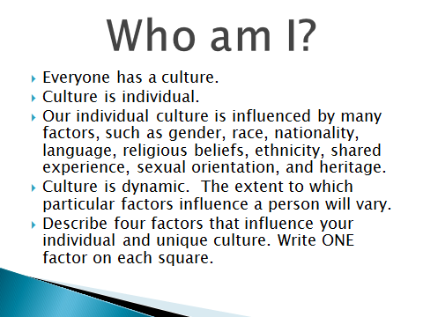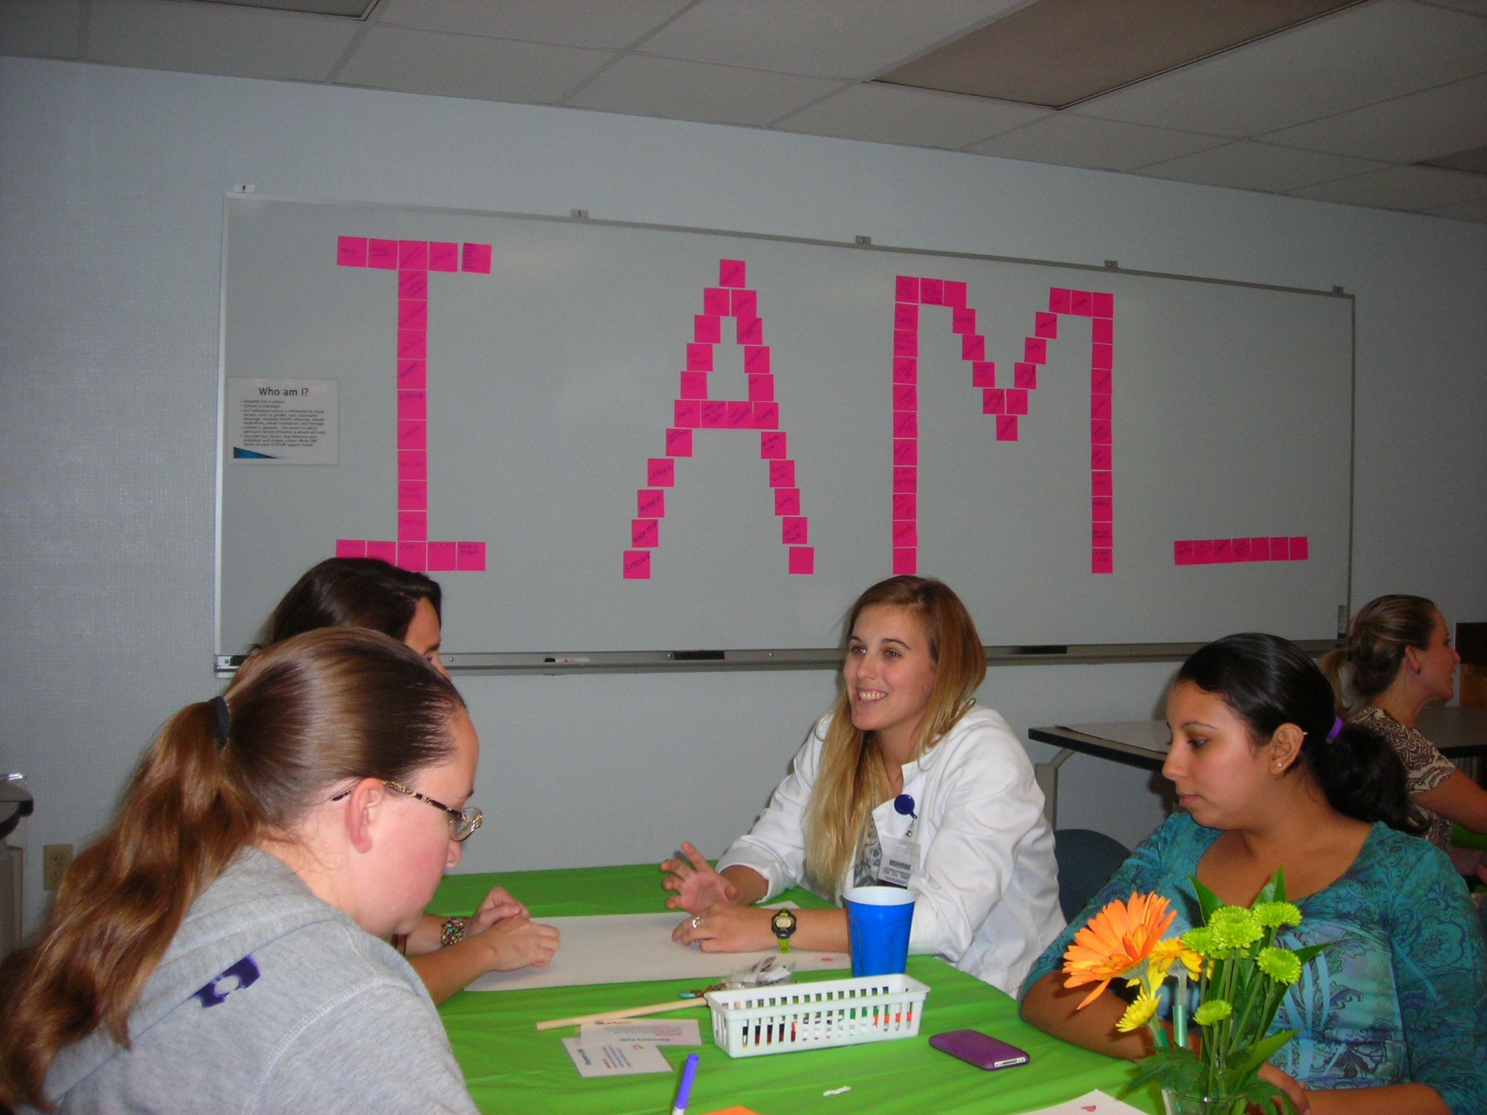

B. Welcome Students and Introduce Discovery Café Guidelines
Begin with a warm welcome and introduce the Discovery Café process, set the context for the event, and review the Discovery Café etiquette and guidelines (Attachment B). Place a replica of a Native American “talking stick” at each table, to encourage student participation, both in speaking and active listening. Read the guidelines for the talking stick (Attachment C). The goal of the welcome is to put participants at ease. Post inspirational posters (Attachment D) around the room to set the stage for sharing. Place poster board and markers on each table, to encourage students to jot down insights, or to draw/doodle key ideas. Reinforce that this activity is not graded, and there are no “right or wrong” answers to the questions posed.

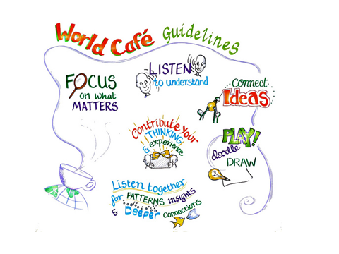

C. Pose Questions that Matter and Encourage Everyone’s contribution
Next, pose a series of four questions to create a logical progression of discovery through several rounds of dialogue. Students discuss the first question as a small group, followed by larger group reflection. To encourage active participation in discussion, ask students to move between tables after each question, creating new group combinations and exchanges for each subsequent question. Allow students to freely share their insights on the questions and their experiences within each round of small group conversation, without faculty interruption or input into the groups.

The Café is built on the assumption that people already have within them the wisdom and creativity to confront even the most difficult challenges. According to Vogt, Brown & Isaacs (2003), a powerful question is simple and clear, is thought provoking, generates energy, focuses inquiry, surfaces unconscious assumptions and opens new possibilities. Print Discovery Café Question Cards (Attachment E) and distribute to each group (one per question round).

Questions:
- Of the four cultural descriptors you posted on the wall, think about the factors you MOST identify with. How does this identity impact your life?
- Although we each have our own unique cultural differences, in what ways are we already connected?
- How can we develop a deeper understanding of individuals and groups that differ from us?
- How might the discoveries and insights gained today impact your role as a culturally competent nurse serving a diverse population?

D. Connect Diverse Perspectives; Listen for Insights and Share Discoveries
At the end of each 15-20 minute “round,” facilitate an open classroom conversation, giving students the opportunity to connect overall themes and insights. Encourage students to post these insights on the “Discovery Zone” posters on the wall. Upon conclusion of the fourth round and post-round insight discussion, guide all participants to form one large circle. Ask each participant to state one word that describes their experience at that moment. Conclude the event with statement of appreciation for the students’ honest and open connections with one another. (PowerPoint file of photos from recent Discovery Café events is provided in Attachment F).

11. Resources Needed
- Classroom setting: Arrange tables to seat four students facing one another
- Tablecloths (optional)
- Candles (non-burning)
- Flowers in small vase (not to block vision)
- “Talking Stick” or “Talking Rock”
- Poster board for tables and wall
- Markers
- Post-it notes
- Posters of diversity quotes (post on wall around room)
- Question cards for each table (four questions, provided one at a time)
12. File(s): (please describe any attachments (e.g., PowerPoint, grading rubric) that you are including)
- Attachment A: PowerPoint presentation on Culture and Heritage with Speaking Notes
- Attachment B: Discovery Café Etiquette and Guidelines
- Attachment C: Native American Talking Stick Description
- Attachment D: Inspirational Quote Posters
- Attachment E: Discovery Café Question Cards
- Attachment F: Photos from Café
- Attachment G: Appendix B: Cultural Influences on Health and Health-Related Behaviors (Clark, 2008)
- Attachment H: Student Evaluation Form

13. Website Links (Please provide a description of the website and directions for learning experience on the website. Note the length of time needed if appropriate –i.e video)

- The World Café website: http://www.theworldcafe.com provides a wealth of information and ideas about using the World Café approach to hosting large group dialogue.
- Additional websites included in PowerPoint presentation (see slide below)

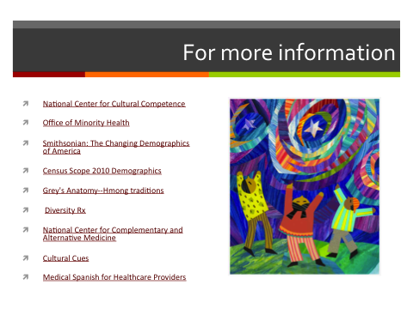
14. Methods for evaluating student learning (i.e., papers, projects, quiz, clinical conference discussion, evaluation tool to rate experience)

Following the Discovery Café experience, ask students to complete the Student Evaluation (attached), using paper or online survey methods. Evaluate the effectiveness of the strategy in achieving stated objectives, and encourage students to share insights and comments. While students may be able to evaluate their own achievement of objectives #1 and #2 following the Discovery Café experience, faculty may be best able to assess student achievement of objectives #3 and #4 in the clinical setting.

Discovery Café Student Learning Objectives
- Students will communicate in a culturally responsive and relevant manner.
- Students will explain factors contributing to cultural diversity.
- Students will demonstrate culturally appropriate nursing practice with individuals, groups and community members.
- Students will adapt nursing care to individuals, families and groups based on cultural needs and differences.

15. Please comment on overall success of this teaching strategy.
Over the course of three semesters of Discovery Café events, undergraduate nursing students freely shared their insights on the questions and their experiences within each round of small group conversation. Open conversations gave the group an opportunity to connect the overall themes and insights. Students were encouraged to post these insights on the “Discovery Zone” posters on the wall.

At the conclusion of the workshop, students were asked to complete an online survey to evaluate the effectiveness of the Discovery Café in meeting the intended objectives, and to share their insights on the value of the activity on their learning about cultural competency. The results of the survey over three semesters demonstrated that the activity completely met or exceeded the intended objectives, and the students greatly valued the experience. Faculty incorporated student suggestions for improvement in subsequent workshops. A few of the student comments are listed below:

“Diversity is more than just ethnicity or culture; it is the understanding that we are all individuals regardless of our external factors. With this in mind, the activity was a good way to explore respect and appreciation for other’s thoughts.”

“While diversity and culture are widely studied, this activity helped put a personal face to what other people might practice or believe.”

“This activity was valuable and exceeded my expectations. The relaxed environment and sharing of food encouraged a feeling of community; we were able to interact honestly without fear of judgment. I really did become aware of new insights regarding cultural sensitivity, especially how to broach questions regarding someone’s origin and customs.”

“This experience put me in several situations where I had to apply patience, listening, acceptance of others’ view. Instead of just learning about what we should or should not do in a situation, we actually experienced it. It was wonderful and I feel closer with my class!”

“It was a great learning experience and really helped me compare my values, views and opinions with others of different ethnicities and cultures, which helped expand my cultural sensitivity.”

16. References (Be specific noting chapters, pages etc)

Brown, J. & Isaacs, D. (2005). The World Café: Shaping our Futures through Conversations that Matter. San Francisco: Berrett-Koehler Publishers, Inc.

Clark, M. J. (2008). Community Health Nursing: Advocacy for Population Health (Appendix B: Cultural Influences on Health and Health-Related Behaviors). Upper Saddle River, NJ: Pearson Prentice Hall.
Fadiman, A. (1997). The Spirit Catches You and You Fall Down: A Hmong Child, her American Doctors, and the Collision of Two Cultures. New York: Farrar, Straus and Giroux.
Vogt, E. E., Brown, J., & Isaacs, D. (2003). The Art of Powerful Questions. Waltham, MA: Pegasus Communications, Inc. Retrieved from http://www.theworldcafe.com.

Appendix: List of Criteria for Questions 2- 6)

2. Relevance to PHN Competencies and Standards (select the Main competencies - list the top three in order of importance):

ACHNE Public Health Nursing Core Knowledge and Basic Competencies
- Communication
- Epidemiology and biostatistics
- Community/population assessment
- Community/population planning
- Policy development
- Assurance
- Health promotion and risk reduction
- Illness and disease management
- Information and health care technology
- Environmental health
- Global health
- Human diversity
- Ethics and social justice

ANA PHN Scope and Standards of Practice:
Competency/Content Area
1. Assessment
2. Population Diagnosis and Priorities
3. Outcomes Identification
4. Planning
5a. Implementation
5b. Coordination
5c. Health Education and Health Promotion
5c. Consultation
5d. Regulatory Activities
6. Evaluation
Standards of Professional Practice
7. Quality of Practice
8. Education
9. Professional Practice Evaluation
10. Collegiality and Professional Relationships
11. Collaboration
12. Ethics
13. Research
14. Resource Utilization
15. Leadership
16. Advocacy

QUAD Council and Council of Linkages Competencies
1. Analytic Assessment Skills
2. Policy Development/ Program Planning Skills
3. Financial Planning and Management Skills
4. Leadership and Systems Thinking
5. Communication Skills
6. Cultural Competence
7. Community Dimensions of Practice
8. Public Health Sciences

3. Topical Areas (select the main topical area)

Community Assessment & Diagnosis
Community as Partner

Community-based Care: Practice Settings
Local, State and National Levels
Home Health Care Nursing
Hospice Nursing
Parish Nursing
School Health Nursing

Communicable Diseases
Surveillance and Outbreak Investigation
Vaccine Preventable Diseases

Cultural Diversity in Public Health Nursing Practice

Disaster Nursing/Bioterrorism

Economics of Health Care Delivery

Environmental Health

Epidemiology
Natural History of Disease (Primary/Secondary/Tertiary Prevention)

Ethics in Public Health Nursing Practice

Global Health
Emerging Pandemic Diseases
International Public Health Nursing

Health Behavior Change

Health Care Systems (Public and Primary Care)

Health Policy
National Health Objectives
National/State Health Care Reimbursement

Health Promotion Across the Lifespan
Teaching/Learning Principles

History of Public Health Nursing

Interventions for Public Health Nurses
Intervention Wheel

Program Planning & Evaluation
Goals & Objectives
Outcome Measures

Public Health Nursing
Core Competencies

Public Health Foundations
Population-Focused Practice
Essential Public Health Services

Quality Management in Public Health Nursing

Vulnerable Populations
Homeless
Migrant Workers
Prison/Incarcerated
Rural Health
Teen Pregnancy

4. Learner Level
RN to BSN
Undergraduate
Graduate students
Staff development
Continuing education

5. Learning Setting (In what setting(s) would this strategy be appropriate?)
Clinical settings
Skills or simulation laboratories
Online or web-based modules
Classroom
Independent study

6. Strategy Type (What descriptor best fits this strategy?)

Course syllabus
Individual Lesson Plans
Simulation Exercises
Case studies, problem-based learning, assignments, reflective practice, exercises
Audiovisual aids
Paper assignments
Test/evaluation/assessment strategies
Webinar/Audio-video conferencing
Other

