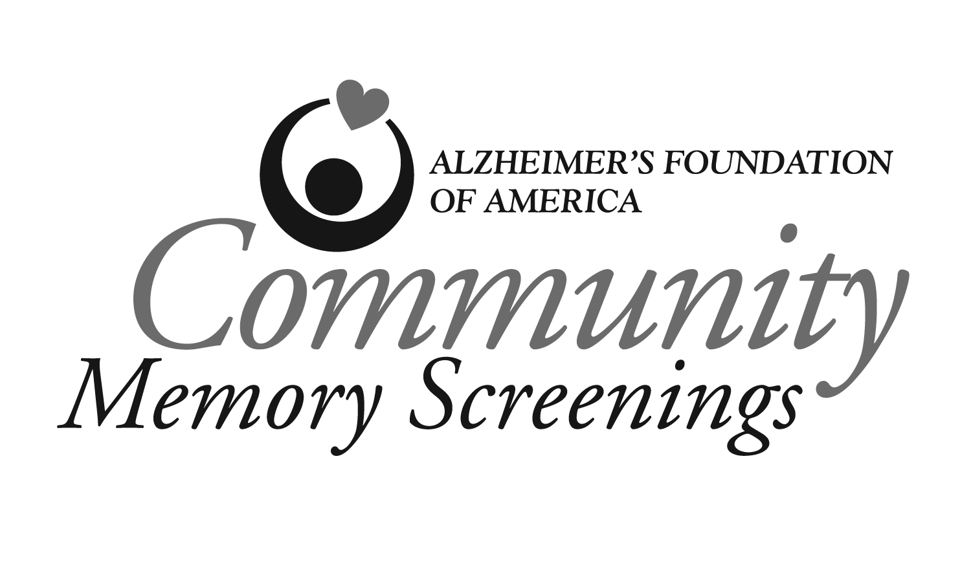

ATT: Healthcare Professional

On _______________, ___________________________________________________
(date) (print first name, last name)

participated in a memory screening at________________________________________
(name of organization)

as part of the Alzheimer’s Foundation of America’s Community Memory Screening initiative.

The test used during this screening was the ___________________________________.
(name of screening tool)

This individual scored ______ out of ______ on the exam.
(number) (number)

Score/ range of scores on this screening tool that indicates a need for further assessment: __________________.
We advised the client that a memory screening is not used to diagnose any illness and does not replace consultation with a physician or other qualified healthcare professional.
If you have any questions regarding this exam or a related matter, please contact the person below or the Alzheimer’s Foundation of America at (866) 232-8484.

Examiner:______________________________________________________________
(print first name, last name)

Telephone: ______________________________________________________________
(area code-phone number)

