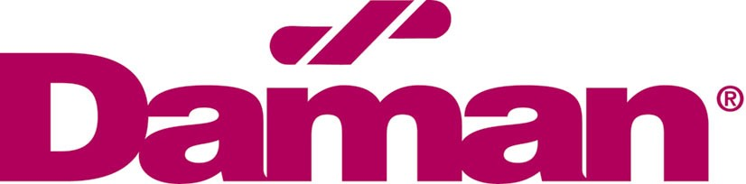

FOR IMMEDIATE RELEASE
December 2, 2014
CONTACT: Krysten Shoulders, HR Manager Larry Davis, President 800.959.7841

7th and 8th Grade Students Dive into Mechanical and Hydraulic Engineering Concepts
MISHAWAKA -­‐ Local seventh and eighth grade students from South Bend Community Schools, South Bend Career Academy, and John Young Middle School of Mishawaka are participating in the 2014 Fluid Power Challenge hosted by Daman Products Company, a manifold manufacturing facility based in Mishawaka, Indiana. The final competition event is being held at the Ivy Tech Community College in South Bend on Friday, December 5 from 9 am to 2 pm. The winners for each category will be announced at Friday’s event.

"The Challenge offers area middle school students the opportunity to experience a hands-­‐on education concerning fluid power and mechanical engineering concepts," says Larry Davis, president of Daman. "Students are required to demonstrate teamwork in the midst of material constraints, a required division of labor, clear planning practices and the ability to work toward a common goal."

The program also gives support and resources to teachers for a science and technology curriculum in a learning environment where math and science are fun. All students use the same tools and an identical kit of supplies to recreate their unique mechanisms, which they use in the competition to pick up weighted objects and place them on a platform.

Students Prepared in October Workshop Days Held at Daman Products
October 1-­‐2, 2014, middle school students from South Bend Community Schools, South Bend Career Academy, and John Young Middle School of Mishawaka attended onsite Workshop Days at Daman. Students started the workshops with a breakfast and hydraulic assessment which tested their current understanding about fluid power. Davis facilitated two sessions presenting how to build a pneumatic lifter and the basic fundamentals about fluid power.

Afterward, the Fluid Power Challenge assignment was given: design and build a machine that will rotate, lift and grip per the Challenge guidelines, along with the judging criteria, thus launching the teams to create their solutions for Challenge Day on December 5. Student teams will be graded in a number of areas, including portfolio ideas, design, hydraulic and mechanical knowledge gained and teamwork.

National Fluid Power Association Partnership
Since 2008, the NFPA (National Fluid Power Association) Fluid Power Challenge has offered middle school students the opportunity to experience a hands-­‐on education concerning fluid power and mechanical engineering concepts. Through the Challenge, NFPA hopes to encourage students to select more mathematics and science courses in their high school curricula and to keep their options open for technology-­‐based, post-­‐secondary studies.

For more information about attending this year’s Fluid Power Challenge Day competition or about sponsoring next year’s NFPA Fluid Power Challenge, contact Krysten Shoulders or Matt Giloth at Daman Products at 800.959.7841.

About Daman Products -­‐ Driving Exceptional Performance
Daman Products Company, Inc. was founded in 1976 by Mishawaka native Jack D. Davis to design and manufacture hydraulic valve manifolds and related products. Daman Products was recognized as an Inc. Magazine's Top 5,000 fastest-­‐growing private companies in 2013, a Growth 100 company in 1998, 1999 and 2004, in addition to being named St. Joseph County Small Business of the Year 2004. Larry Davis, president, was named Indiana Small Business Person of the Year in 2005.

# # #

