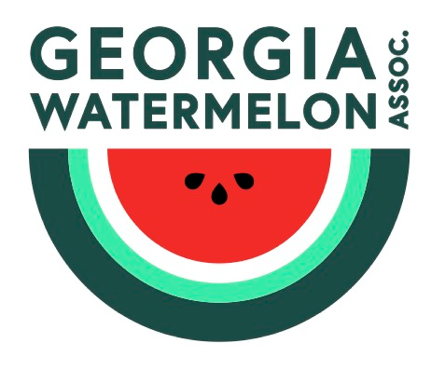
GEORGIA WATERMELON ASSOCIATION, INC.
P.O. Box 1109
LaGrange, GA 30241
706-845-8575 - Main
706-883-8215 - Fax

GWA Membership Application
Support Your Industry and Join Today

New Member Renewal Member

NAME: COMPANY:

ADDRESS: CITY/STATE:

TELEPHONE: ZIP:

OTHER: FAX:

WEB SITE: EMAIL:

REFERRED BY:
WATERMELONS GROWN | ACREAGE – (ESTIMATED AVERAGE)
This information is for internal purposes only; your information is respected and kept confidentially

ANNUAL MEMBERSHIP DUES
$100 Shipper
FREE Grower
$50 Associate
$100 Allied (persons who are in the Seed, Chemical, Containers, etc. industry)

If Allied, what is the nature of your business (products, etc)?

TOTAL DUE: $

Make check payable to and mail to:

GWA
P.O. Box 1109
LaGrange, GA 30241

706-845-8575
706-883-8215 (fax)
clollis@asginfo.net
Credit Card payment is also accepted:

TYPE OF CARD: MC Visa Disc AmEx
CARD NUMBER: EXPIRATION DATE:
SECURITY CODE: (3 digit number on back of card)
NAME ON CARD: SIGNATURE:

P.O. Box 1109 LaGrange, GA 30241 706-845-8575 Fax-706-883-8215

