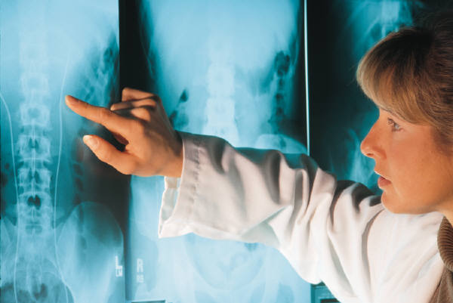
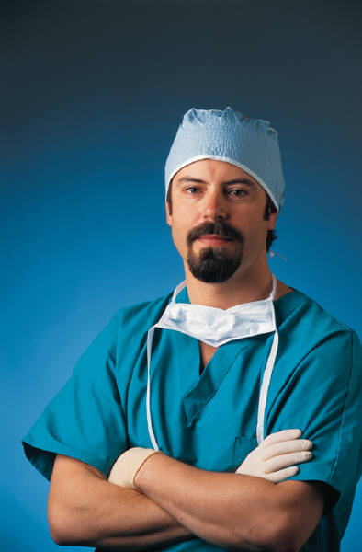



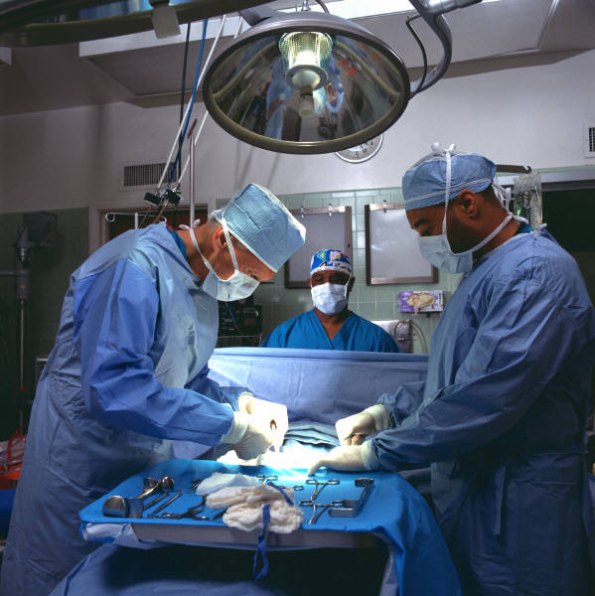

Iowa Association
of Ambulatory Surgery Centers

Iowa Association of Ambulatory Surgery Centers
Saturday April 7, 2018

Coralville Marriott

300 E. 9th Street

Coralville, IA

Exhibitor Contract

Exhibit Space Agreement: The Exhibitor agrees to pay IAASC for each exhibit space requested. Your payment is required with your completed form. Exhibit space includes one 8 foot skirted table/2 chairs/lunch for up to two. Exhibitor commits to maintain booth space from 7:00 am to 12:00 pm Saturday April 7. (Set up may begin as early as
6:00am on Saturday.)

Contact Person: ______________________ Affiliation: _______________________
Address: ___________________ City: __________________ State: _________ Zip: _____
Phone: ( ) _______________ Fax: ( ) ____________ E-mail: ____________________
Product/Service to be displayed: _____________________________________________
Do you need Electricity? ___ yes ___ no. Number needing lunch __________

Auxiliary Membership (includes exhibit) $500 _____
Exhibitor Only $175 _____

Make checks payable to Iowa Association of Ambulatory Surgery Centers Tax ID
36-4584912

Payment must be received by Friday, March 16, 2018

Checks should be mailed to:
Scott Kallemeyn, MHA, FACHE
Surgery Center Cedar Rapids
1075 1st Avenue SE
Cedar Rapids, IA 52402
T (319) 558-4801

Questions may be directed to
Natalie Coubrough @ ncoubrough@westlakessurgery.com

