Creating a Culture of Teamwork: The Power of One
2019 IAASC Annual Conference
Eric Suter, MBA
Program Manager – Organizational Development
UnityPoint Health – St. Luke’s Hospital - Cedar Rapids

Session Objectives
- Explain the negative impact of poor teamwork and why teams are beneficial to individuals and organizations.
- Describe the characteristics of high-performing teams and the stages of growth that teams transition through over time.
- Describe the conditions that support and promote the development of a Culture of Teamwork and its impact on performance.
- Identify next steps participants can take to create and/or improve the culture of teamwork within their organization.

Never doubt that a small group of thoughtful committed people can change the world; indeed, it's the only thing that ever has.
~Margaret Mead

Why?

The Seven Crucial Conversations

- ________ _______
- __________
- Lack of __________
- _____________
- Poor ___________
- ____________
- __________________

The Seven Crucial Conversations –
#5 Poor ___________

The study reveals that ____% of clinical-care providers have one or more teammates who gossip or is part of a clique that divides the team…and ____% have a teammate who tries to look good at others’ expense.

Nurses and Other Clinical Care Providers’ Concerns about Poor Teamwork
_____% are concerned about a peer’s poor teamwork. | This peer does something that undercuts the team at least once a month. | ____%
 | The problem with this peer has gone on for a year or more. | ____%
____% have spoken with this peer and shared their full concerns. | Because of this teamwork issue, the respondent can’t trust that patients in their area are receiving the right level of care. | ____%
 | Because of this teamwork issue, the respondent is seriously considering leaving the unit or the hospital. | ____%

Benefits of Teams
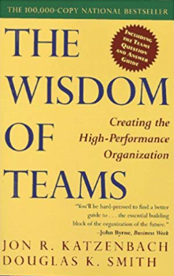
- Teams bring together complementary ______ and ________________ that, by definition exceed those of any ____________ on the team.
- Teams establish _______________ that support real-time problem solving and initiative.
- Teams provide a unique _________ dimension that enhances the economic and administrative aspects of work.
- Teams have more ______.

What?

‘Team’ Defined
- A team is a small number of people with _______________ skills who are ____________ to a common __________, performance ________, and ____________ for which they hold themselves mutually _______________.

Characteristics of High-Performing Teams
- Ingredients for a Successful Team
  - Clarity in team ________
  - A plan for ______________
  - Clearly defined ________
  - Clear _________________
  - ___________ team behaviors
  - Well-defined ________ procedures
  - ___________ participation
  - Established __________ _________
  - Awareness of the group __________
  - Use of the ___________ method
Characteristics of High-Performing Teams
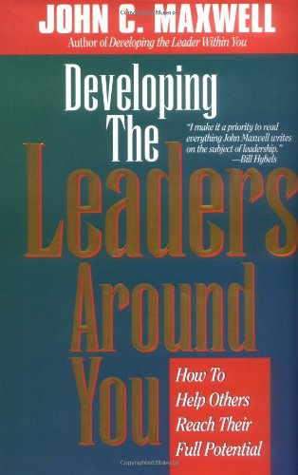
- Qualities of a Dream Team
  - Team members __________ for one another
  - Team members know what is ______________
  - Team members _____________ with one another
  - Team members _________ together
  - There is a team ________
  - Team members place their _____________ rights ___________ the best interest of the team
  - Each team member plays a _____________ role
  - An effective team has a _______ __________
  - Team members know exactly where the team ____________
  - Team members are _____________ to pay the price
An Integrated Description of Team
Complementary Skills
- Clearly defined roles
- Each team member plays a special role
- There is a team fit
- Balanced participation
- Team members grow together
- An effective team has a good bench

Committed
- Beneficial team behaviors
- Team members care for one another
- Team members place their individual rights beneath the best interest of the team
- Team members are willing to pay the price

Common Purpose
- Team members know what is important

Common Performance Goals
- Clarity in Team Goals

Common Approach
- A plan for improvement
- Clear communication
- Well-defined decision procedures
- Established ground rules
- Awareness of the group process
- Use of the scientific method

Mutually Accountable
- Team members communicate with one another
- Team members know exactly where the team stands
Stages of Team Growth

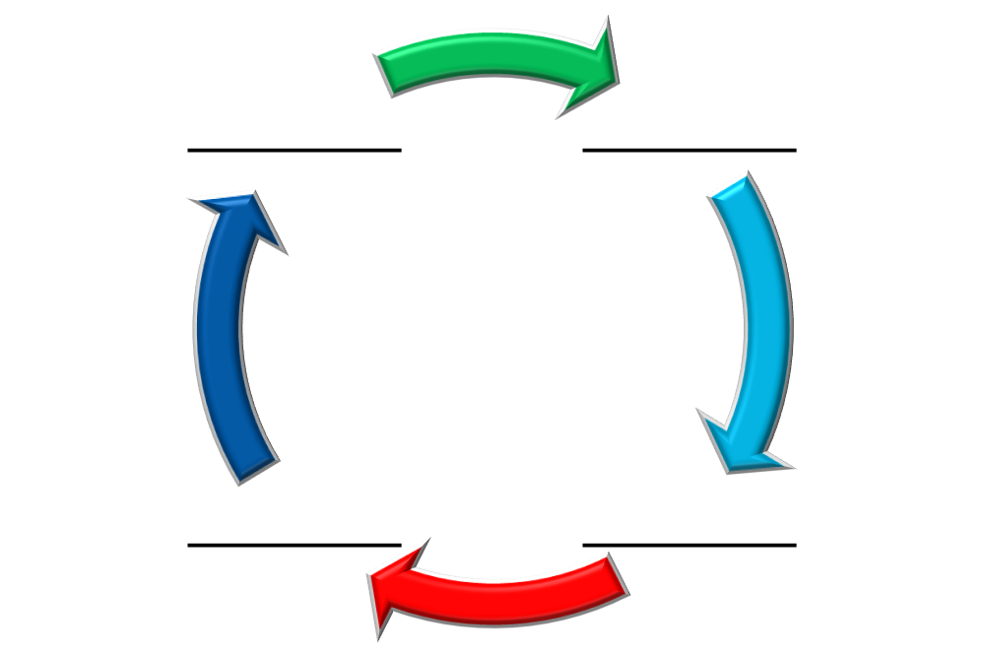

Stages of Team Growth
____________
- Characteristics
  - Members often feel ____________ and _______________
  - People don’t know each other _______ yet
  - ________ aren’t clear
  - ________ aren’t clear
  - ____________ aren’t clear
  - __________ may be noticed
  - People don’t understand the leader’s ______ or _______

- Strategies to Move to the Next Stage
  - Get to know each other and build _______________
  - Understand the ___________, ____________ and _____________ of team members
  - Clarify team’s ____________, ___________ and _________
  - Focus all efforts on ___________ goals
  - Clarify _________
  - Establish or clarify team operating ____________

Stages of Team Growth
____________
- Characteristics
  - False ____________ emerge (misunderstanding/misinterpretation)
  - _____________ conflicts – procedural or situational factors
  - _____________ conflicts – Simple disagreements that lead to more fundamental differences of opinion
  - General ________________ voiced during meetings and afterward
  - Heightened levels of __________
  - Less _________________ than the team wants or needs
- Strategies to Move to the Next Stage
  - Surface and recognize the value of _________________ on the team
  - Discuss the ____________, its source and possible solutions
  - View ____________ as a useful and valid part of teamwork
  - Address disagreements and spend time for appropriate ___________
  - Get _________________ involved in these discussions
  - Address other issues that are causing challenges or reduce _________________

Stages of Team Growth
____________
- Characteristics
  - Conflict is replaced by a feeling of _________________
  - A sense of unity or team ___________ develops
  - Members are __________ involved
  - Members are more ____________ with the team and its progress
  - Stress and anxiety are ____________
  - Cooperation and __________________ begin to replace conflict as the prevalent features of team interactions

- Strategies to Move to the Next Stage
  - Develop or continue to ____________ a specific project management plan with detailed _______________
  - Establish methods for ___________ problems and ________ conflicts
  - Build in feedback and ___________ mechanisms (individual and team performance)
  - Establish or reinforce ___________ or expectations for how the team works _____________

Stages of Team Growth
_____________
- Characteristics
  - There is ________ focus on team goals and outputs than on process
  - Members understand and are _________ to each other and the team
  - Members play to each other’s ________________
  - Members are ________ on their roles but are willing to assist ______
  - Members are _______________ to each other
  - High-quality work gets __________________
  - More ___________ tasks can be managed

- Strategies to Maintain this Level Teamwork
  - Push for ____________________
  - Evaluate _________ and make adjustments
  - Learn from ________________: what’s working and what isn’t
  - Evaluate efficiency and strive for continuous ________________
  - Celebrate team ______________

How?
Culture Eats Strategy for Lunch

Quint Studer Observations
- We Need to Be Balanced
We cannot accept 2/3rd performance.

Clinical  Skills | Patient  Skills | Team  Skills | Do We  Keep?

Wisdom of Teams: Lessons Learned
- Significant performance challenges _____________ teams
  - No team arises without a performance challenge that is ___________ to those involved.
- Leaders can foster team __________ best by building a strong performance ethic rather than by establishing a team-promoting environment alone
  - Teams do not become teams just because we call them teams or send them to ______-__________ workshops. They form when leaders make clear performance demands.
- Biases toward individualism exist but need not get in the way of team performance
  - Teams are not antithetical to individual performance. Real teams always find ways for each individual to ___________ and thereby gain distinction.
- ____________ both within the team and across the organization creates the conditions for team performance
  - Groups become teams through disciplined ___________.

Wisdom of Teams: Performance Curve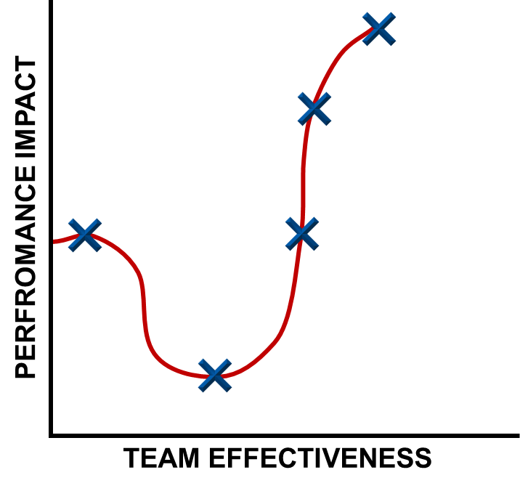
- Work _________
  - No significant, incremental performance need
  - Members interact to improve individual performance within his/her area of responsibility
- _________ Team
  - There is a significant, incremental performance need
  - No focus on collective performance
- _________ Team
  - There is a significant, incremental performance need
  - Effort is made to improve its performance impact

Wisdom of Teams: Performance Curve
- ______ Team
  - A small number of people with complementary skills who are equally committed to a common purpose, goals, and working approach for which they hold themselves mutually accountable
- _______ _______________ Team
  - Same as above with members who are also deeply committed to one another’s personal growth and success.

Now What?

Control, Influence, and Everything Else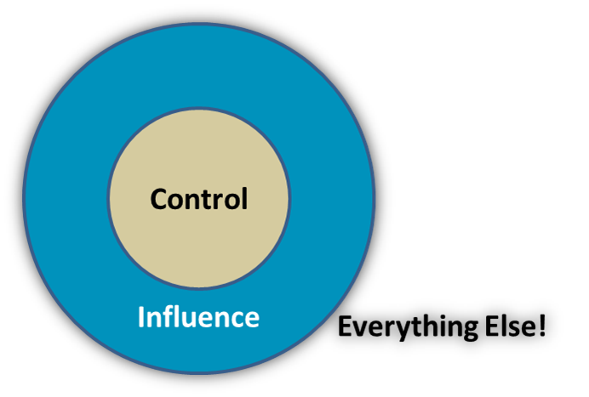
- You can influence other people. You cannot control them.
- Control _______ you can.
- Influence _______ you can.

It’s All About Getting _________
When you can’t control what’s happening, challenge yourself to control the way you respond to what’s happening. That’s where your power is.

3 Levels of Success
- Become the Best Team Member
  - Success is about self-mastery
- Develop the Best Work Team
  - Understand the power of one
- Advocate for a Culture of Teamwork
  - Expand your circle of influence
Commit to One Thing… in the Next 30 Days
Change is inevitable. Growth is optional.
3 Levels of Success
  - Become the Best Team Member
  - Develop the Best Work Team
  - Advocate for a Culture of Teamwork

Thank You
Eric Suter, MBA
Program Manager – Organizational Development
UnityPoint Health – St. Luke’s Hospital - Cedar Rapids
Contact Information:
Email Address: Eric.Suter@unitypoint.org
Office Phone #: 319.369.3896

References
Eikenberry, Kevin, and Guy Harris. From Bud to Boss: Transition to Remarkable Leadership. Jossey-Bass, 2011.
Katzenbach, Jon R., and Douglas K. Smith. The Wisdom of Teams::Creating the High-Performance Organization. Harvard Business School Press, 1993.
Maxwell, John C. Developing the Leaders around You. Nelson Business, 1995.
McRaven, William H. Make Your Bed: Little Things That Can Change Your Life-- and Maybe the World. Thorndike Press, a Part of Gale, a Cengage Company, 2017.
Scholtes, Peter R., et al. The Team Handbook. Oriel, 2003.
Silence Kills: The Seven Crucial Conversations for Healthcare. VitalSmarts, 2005, Silence Kills: The Seven Crucial Conversations for Healthcare.

