MASa 2024 Annual fall conference
Wednesday, November 6th, 2024 from 7:30-4
Ann Plapp, MS, RN, CASC  Preparing for your AAAHC Accreditation Survey  Rubin Garcia, CHFM, CFPS, CLSS-HC  Common Life Safety Codes and Physical Environment Deficiencies in ASCs  Christopher Endres  BioMed 201  William Miller, Esq.  The Anatomy of a Deposition, Welcome to the Hotseat  John Karwoski, RPh, MBA Narcotic Diversion, Risk Assessment and Prevention | 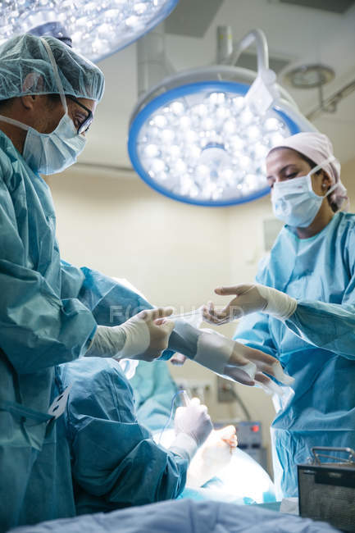

Turf Valley Resort  2700 Turf Valley Road  410-465-1500  Hotel Rooms Available | MASA members $225 Each additional $175  Non-Members $275 Each additional $225  Continental Breakfast & Lunch included
Please register online at www.mdasc.org
This program is approved for up to 5.0 hours of AEUs by BASC Provider # 8813


