

Funeral Directors’ Handbook:
Essential Death Certificate Procedures and Related
Guidelines

August 24, 2026

The Funeral Home’s Role In Death Registration – A Letter From The State Registrar

Dear Michigan Funeral Service Professionals:
When a loved one dies, families across Michigan turn to their trusted local funeral home for help in those critical days after death—help with final disposition, planning memorial services, publishing obituaries, and obtaining a death certificate. I think most people would be amazed, however, to know that for most deaths, you--funeral directors and staff--are singularly responsible for every step of the process, from collecting demographic information to verifying the social security number, chasing down a medical certifier to obtain a valid cause of death, then filing the certificate and getting copies at the local registrar. Without your efforts, death certificates as we know them simply would not exist. The fact that within days of the loss of a loved one, Michigan families can have in their hands copies of accurate and complete death certificates is a testament to your dedication, professionalism, and commitment to the people you serve. The fact that accurate, actionable information from death certificates is promptly available for use by public health professionals is a reflection of your role in public health response.
On behalf of the Michigan Division of Vital Records and Health Statistics, thanks for your efforts.
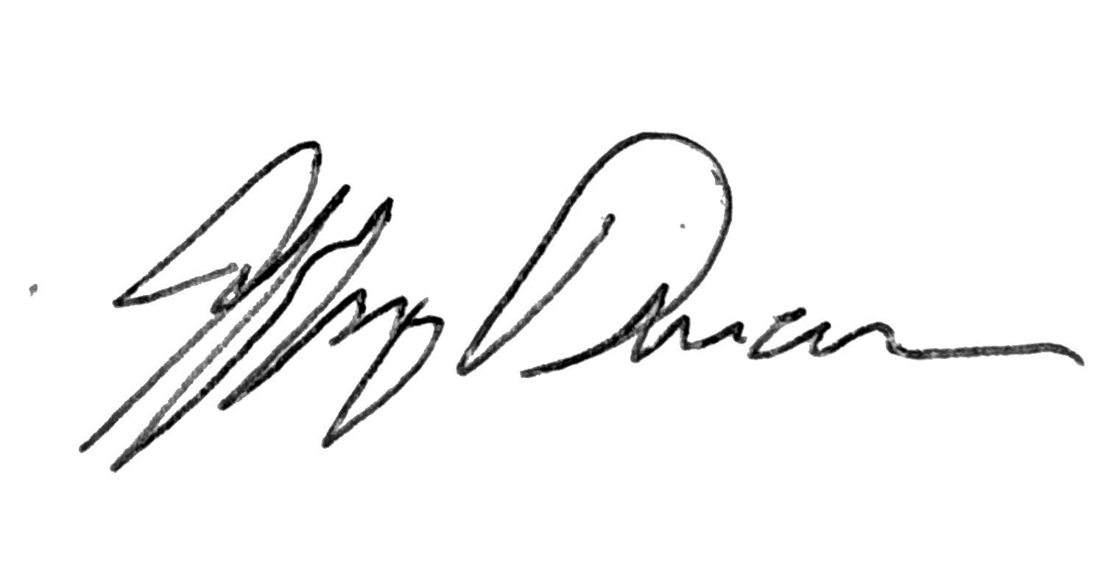
Jeffery Duncan, PhD, State Registrar

Contents
The Funeral Home’s Role In Death Registration – A Letter From The State Registrar 2
Abbreviations 6
Definitions 6
The Registration Process Vital Statistics Registration System In Michigan 7
Responsibility For Registration And Reporting Of Death Certificates 7
The Role Of The Funeral Director (FD) 7
The Role Of The Informant 7
The Role Of The Physician 8
The Role Of The Hospital Or Institution 8
The Role Of The Medical Examiner 8
The Role Of The Local Registrar 9
The Role Of The State Registrar 9
Determining Responsibility For The Medical Portion Of The Death Certificate 10
Natural Manner Of Death – Death Occurs At A Medical Facility 11
Natural Manner Of Death – Death Occurs In Home Hospice Care 11
Natural Manner Of Death – Death Occurs Outside Of A Medical Facility 11
Non-Natural Cause Or Manner Of Death 11
General Instructions For Death Certificates 12
Responsibilities Of The Funeral Director In Death Registration 13
Specific Instructions For Completing The Personal Portion Of The Death Certificate 14
Decedent’s Name And Demographics 14
Residence Of Decedent 15
Place And Location Of Pronounced Death 16
Family Members 16
Informant 16
Disposition 17
Decedent’s Attributes 17
Date Of Death 18
Attesting To Medical Portion Of The Death Certificate 19
Completion Of The Medical Statement Of Death (MSOD), Aka Medical Certificate Of Death, By Certifying Physician Or Medical Examiner 20
Important Terms To Understand Before Completing The Medical Statement Of Death 21
Terminal Event 21
Cause Of Death (COD) 21
Manner Of Death (MOD) 21
Other Significant Conditions 21
Specific Instruction On The Completion Of Individual Items 22
Section 1: Name Of Decedent And Other Decedent Information Fields 22
Section 2: Medical Certification Fields 22
Cause Of Death (COD) 24
COD Part I 24
Part 2 - Other Significant Conditions 24
Did Tobacco Use Contribute To Death? 25
If Female 25
Manner of Death (MOD) 25
Was An Autopsy Performed? 25
Injury Information 25
Certifier Checkboxes, Signature And Date Signed 26
Medical Statement of Death (MSOD) Sample 27
Reporting Pending Cases 28
Supplemental Report 28
Resources For Death Certificate Completion 30
Burial Transit Permits 31
Transporting Dead Bodies 31
Trade Calls 31
Cremation And Cremation Permit 33
Other Situations 35
Disinterment And Reinterment Of Human Remains 35
Authorization For Delayed Interment 35
Anatomical Donation 39
Unclaimed Body 39
Presumptive Death 39
Infectious Agents 39
Induced Termination Of Pregnancy 40
Guidelines For Issuance Of A Permit For Final Disposition Of A Fetus Or Stillbirth 40
Safekeeping Of Blank Birth And Death Forms 42
Correction Of Death Certificate 43
Where To Find Forms And FAQS 44
Delayed Registration Of Death 45
Relevant Michigan Laws 46
Public Health Code Act 368 of 1978 46
Public Health Code Act 368 Of 1978 Part 28 (Vital Records) 46
Unclaimed Body Law 46
Public Health Code Act 368 Of 1978 Part 26 (Data, Information and Research) 46
Presumptive Death MCLs 46
Determination Of Death Act 90 Of 1992 46
County Medical Examiners Act 181 Of 1953 46
Occupational Code Act 299 Of 1980 Article 18 (Mortuary Science Laws) 46
Cemetery Regulation Act 46
Revised Uniform Anatomical Gift Law 46
Relevant Administrative Rules 46
Additional Resources 47
Sample Certificate Of Death 48

Abbreviations
COD Cause of Death
CP Certifying Physician
DOB Date of Birth
DOD Date of Death
DC Death Certificate
DVRHS Division of Vital Records and Health Statistics
EDRS Electronic Death Registry System
FD Funeral Director
FDR Fetal Death Report
MDHHS Michigan Department of Health and Human Services
ME Medical Examiner
MOD Manner of Death
MSOD Medical Statement of Death (Form DCH-0483M)
VERA Vital Events Reporting Application
VBR VERA Birth Registry
VDR VERA Death Registry
VFDR VERA Fetal Death Registry

Definitions
EDRS, or the Electronic Death Registry System, is the state software application used to report deaths. As of 5/10/2026, it is a software application that can be accessed directly through MiLogin for Business. The EDRS will eventually be accessed through VERA and will be referred to as VDR (VERA Death Registry).
Medical Statement of Death (MSOD) was previously referred to as the medical certificate of death (MCOD) or the medical portion of the death certificate. The MSOD is the form (Form DCH-0483M) that should be used by the certifying physician or Medical Examiner (ME).
- It is also used when a Funeral Director is attesting to the information provided on the form.
- When a funeral director “attests” to the cause of death, it means they are formally certifying or confirming that the cause of death has been determined and is accurate for the purposes of the death certificate and related legal or administrative processes. The cause of death is determined by a physician or medical examiner. This determination is then recorded on the MSOD which is supplied to the Funeral Director when the physician does not have access to the EDRS. The funeral director enters the information in the EDRS and indicates within the system that they are attesting to the information provided.
It may also be used when the facility has people who enter the data in the EDRS before the doctor certifies the record in the system.

The Registration Process Vital Statistics Registration System In Michigan
The vital statistics system in Michigan is the collection, compilation, amendment, coordination and preservation of vital records including the tabulation, analysis and publication of vital statistics. Inherent to the vital statistics system is the registration of vital events. The recording of vital events is a state and local function.
By law, the Michigan Department of Health and Human Services (MDHHS), Division of Vital Records and Health Statistics (DVRHS), has the responsibility for the supervision of the registration of vital events in the state. The law also provides for local county and city registrars to assist the state in the registration process.
The registration of vital events requires the conscientious efforts of the informants, physicians, hospital personnel, funeral directors, medical examiners, local registrars, court clerks, attorneys and others who are responsible for preparing or certifying to the information required for proper completion of vital records.

Responsibility For Registration And Reporting Of Death Certificates

The Role Of The Funeral Director (FD)
The role of FD is to report the occurrence of a death; see to the overall completion of the death certificate; obtain the physician's or medical examiner's certification of death; secure all necessary signatures on the certificate; notify the medical examiner of any death falling within the jurisdiction of the medical examiner; file the death certificate within 72 hours after death; and obtain the necessary permit for final disposition of a dead body. The FD must review the death certificate (DC) for legibility, completeness and accuracy.
When a death occurs in this state, the responsibility to report the death rests with the FD who first takes possession of the body. For information about trade calls, please see Trade Calls.
A certificate of death must be prepared and filed for each individual that dies within the state as well as for individuals whose place of death is not known but the body is found and pronounced dead in this state.
By exercising care in completing the DC, its intended purposes can be fulfilled: providing accurate mortality data for the people of Michigan and serving as a permanent legal record of the death. The immediate family of the deceased derives the most direct benefit from the death certificate. Certified copies of the filed document are often essential for processing pension and insurance claims, probating the estate, and initiating or terminating Social Security benefits.
The FD is also responsible for properly completing the Final Disposition of a Stillborn (DCH-0490) when the parents authorize the FD to assume responsibility for the final disposition of a dead fetus. The funeral director must retain the completed permit for a minimum of seven years.

The Role Of The Informant
The role of the informant is to provide accurate personal information that is used in the completion of vital records and related documents. The informant is the person that provides the personal information about the deceased. Examples of the relationship to the deceased may be a spouse, a family member, a legal guardian, a medical examiner investigator, the funeral director, or others. It will occasionally be the deceased if the information is provided to the FD prior to their death. The informant field documents who supplied the information and does not confer legal authority related to the estate, inheritance, or next-of-kin status. This designation cannot be changed to another person who did not participate in providing the information.

The Role Of The Physician
The role of the physician is to provide concise and accurate information regarding deaths:
Deaths Inside Of A Facility
- If appropriate, notify the county medical examiner of the death for investigation.
- When a death occurs in Michigan, the attending physician is to complete the medical certification section and sign the death certificate within 48 hours after death, certifying to the time, date, place and cause(s) and manner of death. If manner of death is other than natural, contact the ME.
- In the absence of an attending physician, then one of the following: a physician acting as an authorized representative, the chief medical officer of the institution in which the death occurred, or a pathologist.
Deaths Outside Of A Facility
- If appropriate, notify the county medical examiner of the death for investigation.
- When a natural death occurs in Michigan, and the death was attended, the hospice or treating physician is to complete the medical certification section and sign the death certificate within 48 hours after death, certifying to the time, date, place and cause(s) and manner.
- A death is considered attended when the individual dies with medical attendance by a physician within the 1 year immediately preceding the time of death, or the individual dies while under home hospice care with medical attendance by a physician or a registered nurse within the 48 hours immediately preceding the time of death.
- If death was unattended or not natural, a referral must be made to the ME.
- Please see section below titled, “Non-Natural Cause or Manner of Death” for additional reasons to refer to the ME.
Disposition of Dead Fetuses - Physicians must certify that a fetus was born dead on a form entitled Final Disposition of a Stillbirth (DCH-0490) to permit proper disposition. Physicians should not use this form when there has been a live birth and subsequent death.

The Role Of The Hospital Or Institution
The role of the individual in charge of the institution, or their designated representative, is to obtain vital records information, prepare and submit certificates and reports to the proper agency.
When a death occurs in an institution and it does not fall within the jurisdiction of the ME, institution personnel authorized by the individual in charge of the institution may initiate the preparation of the death certificate either in EDRS or by entering the required information on the MSOD (DCH-0483M).
- Upon completion of the preceding information, the partially completed certificate should be presented to the FD or person acting as such.

The Role Of The Medical Examiner
The role of the ME is to investigate and certify to the date, cause, time, place and manner of death for all deaths falling within their jurisdiction and to sign a death certificate within 48 hours after taking charge of each case. If cause of death (COD) or manner of death (MOD) is pending, MEs can initially enter pending in those fields and later update the cause of death by submitting a Supplemental Report to Amend a Pending Certificate of Death (DCH-0483 SR).
The ME must authorize the cremation of any human body or fetus prior to cremation.

The Role Of The Local Registrar
The role of the local registrar is to examine each birth or death certificate for accuracy, legibility, and completeness before accepting it for filing. If a record is incomplete or unsatisfactory, the local registrar shall require the submission of additional information necessary to complete the record or request that a new record be prepared before accepting it for filing. The local registrar is also responsible for ensuring that certificates are filed on time, assigning a local file number to each certificate, affixing their signature and the filing date to each vital record, and retaining a copy of each certificate filed in their office.

The Role Of The State Registrar
The role of the state registrar is to administer and control the only system of vital statistics for the state of Michigan. The state registrar is responsible for ensuring proper registration and reporting of vital events, for issuing instructions for the administration of the vital statistics system and conducting training programs to promote the uniformity of policies and procedures throughout the state in matters pertaining to the vital statistics system. The state registrar is also responsible for prescribing, furnishing and distributing forms for reporting vital events, and prescribing procedures for transmitting records of vital events and statistics.

Determining Responsibility For The Medical Portion Of The Death Certificate
Manner of death refers to how the death came about. A natural manner of death is one resulting solely from disease and/or age. In Michigan, non-natural manners of death are categorized by accident, suicide, homicide and undetermined. Manner of death determines if the certifying physician or medical examiner (ME) completes the medical statement of death.
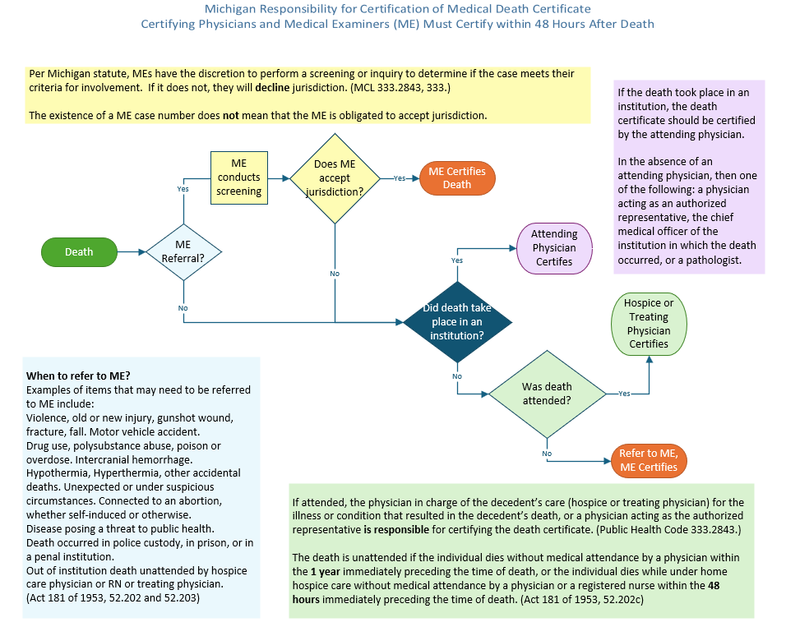 The ME may become involved with a case following a referral from a number of individuals and agencies including police agencies, hospital personnel, emergency medical personnel, a decedent’s physician, a FD, a local or state registrar. If the ME determines that the case does not require their certification, it is not necessary for the ME to be involved in the completion of the death certificate. If the ME does certify, it is their responsibility to complete the medical portion of the death certificate and should file within 48 hours.

Natural Manner Of Death – Death Occurs At A Medical Facility
When the death occurred or was pronounced within a medical facility, the certification of the death becomes the responsibility of the attending physician. In the absence of the attending physician, certification of the death becomes the responsibility of:
- A physician acting as the authorized representative of the physician.
- The chief medical officer of the institution.
- A pathologist.

Natural Manner Of Death – Death Occurs In Home Hospice Care
If the decedent was under the care of a home hospice physician and/or registered nurse within 48 hours of the decedent’s time and date of death, then the home hospice physician shall certify the death certificate. The home hospice physician is considered the attending physician and is responsible for completing the death certificate unless there is a ME referral and ME accepts jurisdiction.

Natural Manner Of Death – Death Occurs Outside Of A Medical Facility
If MEs decline jurisdiction for attended deaths outside of the medical facility, the personal physician of the decedent is most knowledgeable about the health and history of the decedent. The physician who was in charge of the decedent’s care for the illness or condition that resulted in the decedent’s death is considered the attending physician and are legally responsible for completing the medical certification of the death certificate.
When personal physician is not available, any physician who attended to the patient around the time of death, or within a year of their death, may certify as the attendant.
Unattended deaths outside of the medical facility are the duty of the ME to investigate.

Non-Natural Cause Or Manner Of Death
When the manner of death is not natural, a ME with jurisdiction in the county where the death occurred must provide and certify the cause and manner of death. An attending physician has the primary responsibility to identify deaths that should be investigated by the ME.
Specific statutes that define ME cases are MCL - Section 52.202 and MCL - Section 333.2844.
In addition to deaths that occur outside of institutions not attended by a home hospice doctor or hospice registered nurse within the 48 hours immediately preceding the time of death, MEs should be contacted whenever:
- The death is violent or accidental. Note: When an injury includes a historic injury, and the injury contributed to the cause of death, the ME may investigate. Consult with the ME in your county for clarification or in relation to a specific case.
- The death was unexpected.
- The cause of death is unknown to the attendant.
- The individual dies as the result of an abortion.
- The death occurs while a prisoner is incarcerated.

General Instructions For Death Certificates
- Death registration is required for each individual who dies in this state.
- Funeral Directors must use DVRHS’ EDRS to report death certificates.
- Complete all items on the death certificate unless the item instructions indicate that the item can or should be blank. Similarly, “unknown” or an entry of similar meaning is not an acceptable entry unless otherwise indicated in the specific instructions for that item.
- The legal names of the individuals recorded on the document, including the decedent, spouse, and parents, must be entered in the EDRS using English alphabetic characters. Surname suffixes may be entered using either Roman or Arabic numerals.
- Do not use abbreviations.
- The location of death is the specific place where the person was officially pronounced dead.
- The place where the body is found shall be shown as the place of death.
- If the place of death is unknown, but the body is found in this state, the death certificate shall show this fact and shall be completed and filed in this state.
- When death occurs in a moving conveyance in the United States and the body is first removed from the conveyance in this state, the death certificate shall show this fact and the place where the body is first removed from the conveyance shall be shown as the place of death.
- When the death occurs in a moving conveyance while in international waters, air space, or a foreign country, and the body is first removed from the conveyance in this state, the death shall be registered in this state, but the certificate shall show the actual place the death occurred insofar as the place can be determined.

Responsibilities Of The Funeral Director In Death Registration
The FD is the driving force behind organizing all of the required information for death record registration. The FD should be familiar with the laws, rules and regulations governing the handling of death certificates and related permits.
The FD or their authorized agent is responsible for the preparation and filing of the death certificate. In general, the duties of the FD are:
- Obtaining the personal data on the deceased and certifying the death certificate for filing within 72 hours of death.
- Obtaining the physician’s or MEs certification of death.
  - Note: The medical certification must be completed and signed no later than 48 hours after death by the certifying physician (CP) or within 48 hours after taking charge of the case by the ME.
- Securing all necessary signatures on the certificate:
  - If electronic, then the record should be certified by the physician within the EDRS.
  - If attesting in the EDRS, the physician’s ink or electronic signature must be on the paper MSOD.
- Notifying the ME of any death that is believed to fall within the MEs jurisdiction. Cooperating with MEs in all cases involving postmortem examinations. See Act 181 of 1953 Section 52.202.
- Obtaining and recording information on final disposition.
- Reviewing the certificate for completeness and accuracy. Call the local registrar office or state office of DVRHS for advice and assistance when necessary.
  - The registration unit call center number is 517-335-6506 and email is MDHHS-VR-Registration@michigan.gov.
- Using EDRS to file the completed death certificate with the appropriate local registrar within 72 hours after death.
  - The information on the personal portion of the DC should be gathered from the informant as soon as possible. Once the FD has physical possession of the dead body, the information should be entered in the EDRS. MCL 333.2843 (1)
- Obtaining all necessary permits.

Specific Instructions For Completing The Personal Portion Of The Death Certificate

Decedent’s Name And Demographics
Legal Name
The name is the most important item on the death certificate for legal and personal use by the family. There are alternate spellings to many names, and it is critical for the family to have the name spelled correctly.
- Enter the name as provided by the informant and have the informant check the spelling and order of names before entering the name on the certificate. The name must consist of English alphabetic characters and punctuation marks, except that surname suffixes may be entered using either Roman or Arabic numerals.
  - Diacritics, or special characters, are not permitted.
- If the CP or ME has a different name, do not enter this name as the legal name. It can be entered in the field indicated for name at birth and/or other names used for personal business.
- If a name such a “Baby Boy Johnson” is obtained from medical records for the death of a newborn, check with the parents or other informant to see if the child had a given name. If the child had not been named, enter only the surname.
- If the ME cannot determine the name of a found body, enter “Unknown” in the first name field and “Person” in the last name field.
- Do not enter titles such as Doctor or Esquire in the legal name fields.
Name At Birth And/Or Other Name Used For Personal Business
This item is intended to assist in accurately documenting the decedent and to facilitate handling the affairs of the decedent. Use this item to record alias names or other name variations that are considered important to document. This item may be left blank.
- For people who were married, enter their name before they were first married.
- Enter the decedent’s name at birth and/or other names the decedent used, or was known as, in their lifetime. Alias names should be listed if it is substantially different from the decedent’s legal name. Examples:
  - Virginia Jones also used the name Ginny Jones.
  - Jonathan Richard Smith also used the name JR Smith or Ricky Smith.
Date Of Birth (DOB)
- Enter the exact date of the decedent’s birth in the sequence of month, day and four-digit year.
- If the DOB is unknown, call the DVRHS registration unit at 517-335-6506.
Sex
Enter male or female based on observation. Unknown may be entered only if certified by a ME.
Age
- Last Birthday - Enter the age of the decedent in years as of the last birthday. If decedent was under one year, leave this space blank.
- Under 1 Year - Enter the age of the infant at the time of death in months or days. If the infant was between 1 and 11 months of age, enter the age in completed months.
  - If the infant was over one year old or less than one day of age, leave this item blank.
- Under 1 Day - If the infant was less than 1 month old, enter the age in days. Enter the number of hours or minutes the infant lived. If the infant was between 1 and 23 hours old, enter the age in completed hours. If the infant was less than 1 hour old, enter the age in minutes.
  - If the infant was more than 1 day old, leave this item blank.
Social Security Number (SSN)
- Enter the social security number of the decedent. If the social security number is unknown, enter “unknown.” If the decedent never obtained a social security number, enter “none.”
- In EDRS, verify the SSN after confirming correct name, date of birth, date of death, and county of death. After the SSN is verified, the system will lock those fields.
Birth Place (City And State Or Foreign Country)
If the decedent was born in the United States, enter the name of the city and state.
- If the decedent was born in the United States but the city or state is unknown, enter the information that is known.
- If the decedent was not born in the United States, enter the name of the country of birth whether or not the decedent was a U.S. citizen at the time of death.
- If the decedent was born in a foreign country but the country is unknown, enter “unknown.”
- If no information is available regarding place of birth, enter “unknown.”
Was Decedent Ever In U.S. Armed Forces?
If the decedent was ever in any branch of the United States military service, enter “yes.” If not, select “no” or “unknown.”

Residence Of Decedent
The residence of the decedent is the place where they actually resided. The actual residence is not necessarily the same as “home state,” “voting residence,” or “legal residence.” If the decedent has more than one residence, enter the residence lived in most of the year.
- The residence cannot be a PO Box.
- Never enter a temporary residence such as one used during a visit, business trip or a vacation.
- Place of residence during a tour of military duty or attendance at college is not considered temporary and is to be considered as place of residence.
- Decedents who at the time of death are living in institutions where persons stay for long periods of time such as prisons, nursing homes, and assisted living facilities, are considered residents of the institution for the purpose of completing these items. These places should not be considered temporary for the individual.
- If the decedent was experiencing homelessness, enter as much of the address as is known. For example, the minimum known may be city and county where the decedent’s body was found, or the city and county of the facility in which they died.
- If the decedent is a minor child, the residence is the same as that of the parent(s), legal guardian, custodian or parent of custody, unless the child is a resident of a long-term institution or a boarding school.
  - If an infant never resided at home, the place of residence is that of the mother or legal guardian. Do not use the hospital or NICU as place of residence.
- “Unknown” may be entered for these items, if the place of residence for the decedent is unknown.
Current Residence: Locality- Select city or village of, inside township of, or unincorporated place, to describe the locality where the decedent resided. Reference list of incorporated places or consult local clerk if in doubt regarding the status of a locality. Michigan Municipalities & Unincorporated Places is a great resource for determining locality.

Place And Location Of Pronounced Death
Place
Enter the name of the hospital or institution (hospice, nursing home, extended care facility) where the decedent was officially pronounced dead.
- If the decedent was pronounced dead en route to or on arrival at a hospital or institution, enter the name of the hospital or institution.
- If the decedent was not pronounced dead in a hospital or other institution, enter the number, street and zip code of the locality where the decedent was pronounced dead.
- If the number, street, and zip code is not known, enter an intersection, the closest mile marker sign on the highway, or GPS coordinates. Specificity is important. Do not use a vague description such as “wooded area.”
Location – City, Village Or Township And County Of Death
Enter the name of the city, village, or township where death was officially pronounced.

Family Members
Marital Status
Enter the marital status of the decedent at the time of death. Specify one of the following: married, separated, never married, widowed, or divorced.
- If a married couple dies simultaneously, or if a determination of which partner died first is not made by the CP, the marital status of each should be listed as “married.”
- If the marital status of the decedent cannot be determined enter “unknown.”
Surviving Spouse
- If the decedent was married at the time of death, enter the name of the surviving spouse. A person is legally married even if separated.
- If a married couple dies simultaneously, or if the order of their deaths is not determined by the CP or the ME, the spouse should be recorded as the surviving spouse.
- If the decedent is married and the name of the surviving spouse is unknown, enter unknown.
- If the surviving spouse changed their name after marriage, enter their full name prior to first marriage.
- Leave blank if marital status is never married, widowed, divorced, or unknown.
Parent Names
Enter the first, middle and last name of the decedent’s parents. Enter the names of the parents before they were first married. Unknown may be entered if the name of the parent(s) are not known.

Informant
Enter the name of the person who supplied the personal facts about the decedent and their family. This field documents who supplied the information and does not confer legal authority related to the estate, inheritance, or next-of-kin status. This designation cannot be changed to another person who did not participate in providing the information.
Informant’s Relationship To Decedent – Enter the relationship to the decedent of the person who supplied the personal facts about the decedent and their family.
Mailing Address – Enter the complete mailing address of the informant. This may be a PO Box but should not be unknown.

Disposition
Method Of Disposition
Enter the method of disposition as burial, cremation, entombment, removal, storage or donation or other. If other, then specify.
Place Of Disposition
Enter the name of the cemetery, crematory, or other place of disposition.
- If the body is removed from the state, specify the name of the cemetery, crematory, or other place of disposition to which the body is removed.
- If the body is to be used by a hospital or a medical or mortuary school for scientific or educational purposes, give the name of that institution.
Location Of Disposition
Enter the name of the city, village or township and state where the place of disposition is located.
- If the place of disposition is not in the United States, enter country name and any other information available.
- If the body of the decedent is to be used by a hospital, or a medical or mortuary school for scientific or educational purposes, enter the name of the city, town, or village and state where the institution is located.
Mortuary Science Licensee
The FD or other person authorized by law to act as a FD may certify. To sign a certificate of death, a FD must be a holder of a Michigan license. Holding a license from another state is not sufficient to assume responsibility for the death certificate.
License Number – Enter the personal state license number of the mortuary science licensee.
Name And Address Of Facility – Enter the name and complete address of the facility handling the body prior to burial or other disposition.

Decedent’s Attributes
Education
Enter the highest level of regular schooling completed or highest educational degree awarded to the decedent such as 8th grade, high school graduate, some college, B.A., M.S., M.D., etc.
Ancestry
Enter the ancestry of the decedent as obtained from the informant. Ancestry refers to the nationality, lineage, or country in which the person’s ancestors were born.
- If ancestry information is not available, enter unknown.
- If the decedent is an American Indian or Native American or Alaskan Native, enter the decedent’s principal tribe(s).
- If a religious group is reported - such as, Jewish, Muslem, or Protestant - ask for the country of origin or nationality. An entry of “Black” or “White” should never be recorded in the ancestry item.
Was the Decedent Of Hispanic Origin?
In the current EDRS, this is a yes, no, or unknown question that can be best reported by an informant. Hispanic commonly refers to people whose origins are from Spain, Mexico, or Spanish-speaking islands or countries of Central or South America.
Race
Enter the race or races of the decedent as obtained from the informant. Entry of multiple races is appropriate when applicable.
- The entry for many groups other than White, Black and American Indian are determined by their national origins. For these groups, enter the national origin of the decedent such as Chinese, Japanese, Korean, Filipino or Hawaiian, etc.
- If the race or national origin is unknown, enter unknown.
Occupation
Enter the usual occupation of the decedent. “Usual occupation” is the kind of work the decedent did during most of their working life, such as claim adjuster, farm hand, coal miner, janitor, store manager, research chemist, civil engineer, college professor, teacher, etc.
- If the decedent was never employed, enter “never employed.”
- If the usual occupation of the decedent is unknown, enter “unknown.”
- If the decedent was a homemaker at the time of death but had worked outside the household during their working life, enter that occupation. If the decedent was a homemaker during most of their working life, and never worked outside the household, enter “Homemaker.” Enter “own home” for business/industry.
- All death certificates for persons 14 years of age or older should have entries for both “decedent’s usual occupation” and “kind of business/industry.” Enter “Student” if the decedent was a student at the time of death and was never regularly employed.
- For children not enrolled in school as a student, enter “infant” or “child.”
- Do not use “retired.” If the decedent had retired from their usual occupation, the “usual occupation” and “business/industry” of the decedent must be specified.
- “Self-employed” by itself is incomplete. The kind of work must be determined. The entry for business/industry should include both the proper business/industry and the entry “self-employed.”
- Avoid entering vague job types. Attempt to be as specific as possible. Example: for broker, specify stockbroker, real estate broker or livestock broker.
Kind of Business Or Industry
Enter the kind of business or industry to which the occupation was related, such as insurance, automobile, government, school, church, etc.
- DO NOT enter organization or firm names.
- If decedent was never employed, enter “never employed.”
- If this information is unknown, enter unknown.
- Items to check in filling out business/industry. For more information, view CDC Guidelines for Reporting Occupation and Industry on Death Certificates.

Date Of Death
Enter the actual, approximate or found date that death occurred in the sequence of month, day and year. The medical certifier must certify to the date of death.
- A death that occurred at 2400 or 0000 midnight belongs to the start of the new day. One minute after midnight is entered as 0001 of the new day.

Attesting To Medical Portion Of The Death Certificate
If providing the MSOD to the physician, type or legibly write the decedent’s name and date of birth, if available, before submitting the MSOD to the CP. If available, funeral homes should also write the location of death information, the sex, and the date of actual or presumed death under the decedent section.
- Funeral homes should not enter the actual or pronounced time of death on the MSOD.
- Funeral homes should not enter any information in the medical certification section of the MSOD.
- When MSOD is completed, signed, and returned to the funeral home, the FD must enter what is seen. Abbreviations are not recommended; however, if the CP used abbreviations, the FD must enter the information exactly as it appears on the signed MSOD.
- Attach signed MSOD to the record.
- Do not alter the signed MSOD. If revisions are needed, resubmit the MSOD to the CP. The CP can complete a new MSOD or may place a single line strike-through to correct the information and then initial and date the correction.
- Submit a referral to the appropriate ME Office, when necessary to do so.
  - Please see section above titled Non-Natural Cause or Manner Of Death and send a referral to the local ME office.

Completion Of The Medical Statement Of Death (MSOD), Aka Medical Certificate Of Death, By Certifying Physician Or Medical Examiner
Information about the proper completion of the MSOD is included in this handbook for the awareness of the FD and their staff.
The certificate of death that is completed and filed is retained in the state vital records repository as a permanent legal record of the event. The document will be available for the issuance of certified copies to permit establishing the facts of death in settling the affairs of the decedent and will serve as an historical record of interest to descendants into the future.
The report of death must be submitted using the web-based application system established by the Division of Vital Records and Health Statistics for the registration of deaths.
Great care should be taken in the preparation of these documents to ensure each is complete, accurate, and legible.
It is important to follow these simple rules:
- Complete all items that are the responsibility of the CP.
- Avoid medical shorthand and abbreviations.
- Unless specified below, do not leave any items blank.
- It is ok to use terms like “probable,” “possible,” “likely,” “presumed,” or “suspected” when unsure about a cause of death.
- If completing the MSOD on paper, type or legibly print in ink. Sign the certificate within 48 hours of death. This must be an original or electronic signature. Effective March 16, 2027, all physicians must use DVRHS’s death reporting software, for electronic death registration.
- When completing the medical portion of the death certificate electronically, care should be taken to verify that the information reported is correct before certifying the record.
- Minor changes or alterations on the MSOD can be made by the CP with a single line strike-through and their initials and date. Changes to the paper MSOD should not be made by funeral home staff.

Important Terms To Understand Before Completing The Medical Statement Of Death

Terminal Event
The How. The final physiological occurrence immediately before death. Do not enter a terminal event without showing the etiology.
Examples: Cardiac arrest, respiratory arrest, liver failure, exsanguination, cardiac arrhythmia, sepsis/septicemia, cerebral hypoxia.

Cause Of Death (COD)
The Why. The specific injury, disease or condition that directly leads to death.
Examples: Gunshot wound to chest, left lower lobe pneumonia, diabetes mellitus noninsulin dependent, hepatic cirrhosis, drowning, alcoholic cirrhosis, coronary artery atherosclerosis, complications of leukemia.

Manner Of Death (MOD)
The Category. Classification of circumstances surrounding the death.
Examples: Natural, Accident, Homicide, Suicide, Undetermined.

Other Significant Conditions
Diseases or conditions that contributed to cause of death but did not cause it.
Examples: Obesity, diabetes mellitus type 2, chronic obstructive pulmonary disease, smoking, hypertension, chronic kidney disease, Covid 19, coronary artery disease.

Specific Instruction On The Completion Of Individual Items
The FD is responsible for completing the personal section of the death certificate. When the medical and personal portions of the death certificate are certified in the EDRS, the record will be reviewed and placed on file by the local registrar office.

Section 1: Name Of Decedent And Other Decedent Information Fields
Name Of Decedent
The medical record of the decedent often contains a name that is not complete or is somehow different from the correct legal name. The funeral home, when consulting with the family, should be able to obtain the accurate legal name. Write the name of the decedent as it is known.
Date Of Death (DOD)
The CP or ME is responsible for accurate reporting of the DOD. The DOD can be described as actual, or on or about (approximate).
County And Location Pronounced Dead
Typically entered by the FD. Physician’s should review and verify. Include hospital or institution name, or if neither, give street number and name.
- If street number and name are not available, list latitudinal and longitudinal coordinates, or provide cross streets, mile marker on highway, intersection or GPS coordinates.
- Enter the name of the city, village, or township where the death occurred.
- The county where the body was located and first pronounced dead must be entered.

Section 2: Medical Certification Fields
Place Of Pronounced Death
The type, or category, of place where the person was pronounced dead. Examples include home, hospice, hospital, nursing home, highway, prison, body of water. This item should not be left blank.
If Place Of Pronounced Death Was Hospital
  - Indicate if Inpatient, Outpatient/Emergency Room, DOA or Other (Specify).
  - If patient was in the ICU or critical care units, labor and delivery, etc., they were an inpatient, and no further information should be provided in the other (specify) section.
  - If the decedent was pronounced in any place other than a hospital, this item must be left blank.
Actual or Presumed Time of Death
The actual or presumed time of death should appear here as AM, PM, military, or unknown, and described as actual or on or about (approximate).
- If the exact time is unknown, enter the approximate time and select the “on or about” modifier.
- If the time of death cannot be approximated, indicate as unknown.
Date Pronounced Dead
The month, date and year the decedent was pronounced dead (MM/DD/YYYY).
Time Pronounced Dead
The time the decedent was pronounced in hours and minutes as AM, PM or military. Note: Noon is 12:00 pm and Midnight is 12:00 am.
Was Medical Examiner Contacted?
"Yes" should be entered if the ME was contacted in regard to the case, otherwise "no" should be entered.
Examples Of Causes That May Need To Be Referred To The Medical Examiner
- Trauma, gunshot wound, criminal violence, fracture, fall, Motor Vehicle Accident (MVA).
- Drug use, polysubstance abuse, poison or overdose.
- Intercranial hemorrhage.
- Hypothermia, hyperthermia.
- Other Accidental deaths. Accidental deaths, regardless of interval from injury to death. If an injury causes or contributes to death, no matter how minor the contribution, the record must be referred to the medical examiner.
- Disease, injury or toxic agent resulting from employment.
- Disease posing a threat to public health.
- Deaths in police custody, in prison, or in a penal institution.
- Deaths connected to an abortion, whether self-induced or otherwise.
- Sudden death, when apparently in good health, including sleep-related infant deaths.
- If the death is unattended by a licensed medical professional or if the decedent dies outside of a facility and has not seen a doctor in more than ten days. The ME might be contacted regarding a case and determine that ME involvement is not necessary. If they determine the case does not fall within their jurisdiction, the ME shall refer the case back to the decedent’s physician within 24 hours for completion of the medical certificate.

ME Case Number
If known, include ME case number. If unknown, or there is no ME case number, leave blank.
Name of Attending Physician if Other than Certifier
If the certifier is the attending physician, no entry is required. If the attending physician was not the certifier, the name of the other physician should appear here.

Name Of Certifying Physician (CP) Or ME, License Number And Address
This section allows for the entry of the CP's information including their name, their license number and address. As of January 27, 2026, CPs include MDs, DOs and MEs.
- Resident MDs or DOs may also sign if they are licensed as such by the State of Michigan.
- At this time, nurse practitioners (NP) and physician assistants (PA) are not permitted by law to act as CPs on the medical portion of the death certificate. NPs and PAs may be listed as the attending physician.
License Number Enter the state license number of the CP or ME who signs the certificate as the certifier of the medical facts.

Note: In the EDRS, when the CP is entering the data, their name, license number and address will automatically populate when they have certified the medical portion of the death record. Physicians and MEs do not need to enter their names if they are entering the data in the EDRS.

Once the record is certified, then the name of the CP cannot be changed unless the ME takes over jurisdiction of the medical portion of the record.

Cause Of Death (COD)
The COD section of the MSOD is designed to elicit the best medical opinion of the certifier as to the immediate cause of death and the antecedent causes, as well as the contributing causes of death. It provides a story of why the patient died at this time and in this way.
- The cause of death section cannot be left blank. In addition, reporting “Unknown” or “Natural Causes” are not acceptable entries. The COD information should be your best medical opinion and the condition can be listed as “probable” or “suspected” even if it has not been definitively diagnosed.
- The cause cannot be reported as "pending" by an attending physician. Only the ME can report the COD as pending and certify as such.

COD Part I
The cause of death section cannot be left blank. In addition, reporting “Unknown” or “Natural causes” are not acceptable entries. The COD information should be your best medical opinion condition and can be listed as “probable” or “suspected” if it has not been definitively diagnosed.
Enter the chain of events (diseases, injuries, or complications) that directly caused the death.
- Do not enter terminal events such as cardiac arrest, respiratory arrest, natural causes or ventricular fibrillation without showing the etiology.
- Mechanisms of death are linked to the chain of events that lead to the terminal event (heart stops, breathing stops). A mechanism of death is the physiological or biochemical process that defines how the body ceased to function. Examples: Cardiac arrhythmia, exsanguination, respiratory failure. Do not enter mechanism of deaths without showing the etiology.
- If diabetes was an immediate, underlying or contributing cause of death, be sure to record diabetes in either Part I or Part 2 of the cause of death section.
- If dementia was an underlying or contributing cause of death, specify the type of dementia.
Line a – Immediate
What happened right before the patient died. Enter the immediate cause (final disease or condition resulting in death) first on Line a.
Line b-d – Intermediate And Underlying
What diseases or conditions caused the condition on Line a? Sequentially enter the underlying cause(s) (diseases or injuries that initiated the events resulting in death) on lines b-d.
- Only one cause is to be entered on each line.

Ask questions until you determine the condition that is not the result of another condition. This is known as the underlying cause, or the disease that caused life-threatening complications that required hospitalization or caused death.

Interval Between Onset And Death
The best estimate of the time interval between the onset of each condition and death. General terms like “minutes” or “days” or “years” are acceptable. If impossible to estimate, unknown is acceptable.

Part 2 - Other Significant Conditions
Part II is for reporting all other significant diseases, conditions, or injuries that contributed to death, but which did not result in the underlying cause of death given in Part I.
- If historical injuries are included in this section, a ME should be contacted.
- This item may be blank, if there are no other significant conditions to report.

Did Tobacco Use Contribute To Death?
- Yes, if in your opinion, any use of tobacco or tobacco exposure contributed to the death of the decedent. For example, tobacco use may contribute to deaths due to emphysema or lung cancer. Tobacco use should also be reported in deaths due to fires due to smoking.
- Probably, if tobacco use may have contributed to the death.
- No, the use of tobacco did not contribute to death.
- Unknown may be selected if the physician has no knowledge of tobacco exposure or use by the decedent.
- Do not leave this section blank.

If Female
If the decedent is a female, check the appropriate box:
- Not pregnant within the past year.
- Was pregnant at the time of death.
- Not pregnant, but pregnant within 42 days of death.
- Not pregnant, but pregnant 43 days to 1 year before death.
- Unknown if pregnant within the past year.
- Do not leave this section blank if decedent was female.

Manner of Death (MOD)
If MOD is other than natural, or for the reasons stated above in the ME section, the case should be referred to the ME.
- When MOD is known, the record should be updated to indicate natural, suicide, accidental or homicide.
- MEs are the only physicians permitted to indicate the MOD is pending.
- When MOD cannot be determined after thorough investigation, indeterminate should be indicated.

Was An Autopsy Performed?
- Yes, if a full autopsy was completed.
- Partial Autopsy, if a partial autopsy was completed.
- No, if an autopsy has not been completed at the time of certification.
- Do not leave this section blank.
- If the answer was no when the record was filed, and an autopsy or partial autopsy was completed later, care should be taken to update this information.
Were Autopsy Findings Available Prior To Completion Of MSOD?
- Yes, if autopsy findings were available prior to certification.
- No, if autopsy findings were not available at the time of certification.
- This field should not be left blank.

Injury Information
Section is completed by ME, if applicable. This will be completed if MOD is Accident, Suicide, Homicide or Indeterminate.
Time Of Injury
Enter exact time as AM, PM, military or unknown and describe as actual or on or about (approximate).
Describe How Injury Occurred
- Enter a concise statement such as, “Fell off ladder while painting house.”
- Enter unknown, if it cannot be determined.
Injury At Work
Options are yes, no and unknown. This item includes all motor vehicle or other transportation deaths.
Place Of Injury
General category describing where the injury occurred, i.e. home, farm, street, factory, office building, etc.
Transportation Injury
Specify role of decedent in the accident (i.e. driver/operator, passenger, pedestrian). This includes accidents involving other modes of transportation including bicycles.
- If Other (Specify), other applies to watercraft, aircraft, animals or people attached to outside of vehicles (i.e. water skiers) who are not bona fide passengers or drivers.
- Unknown is an acceptable response.

Location
The complete address (street or RFD number, city/village/township and state). A geographical description of the location may appear if the location can only be described geographically.

Certifier Checkboxes, Signature And Date Signed
Select appropriate check box.
- The CP or ME must sign the MSOD if completing on paper.
- ME office investigators or facility data entry staff may enter the data in the EDRS, but the certifiers are responsible for signing in ink or electronically.
- Date signed should be the date the MSOD was initially completed and signed.

Medical Statement of Death (MSOD) Sample
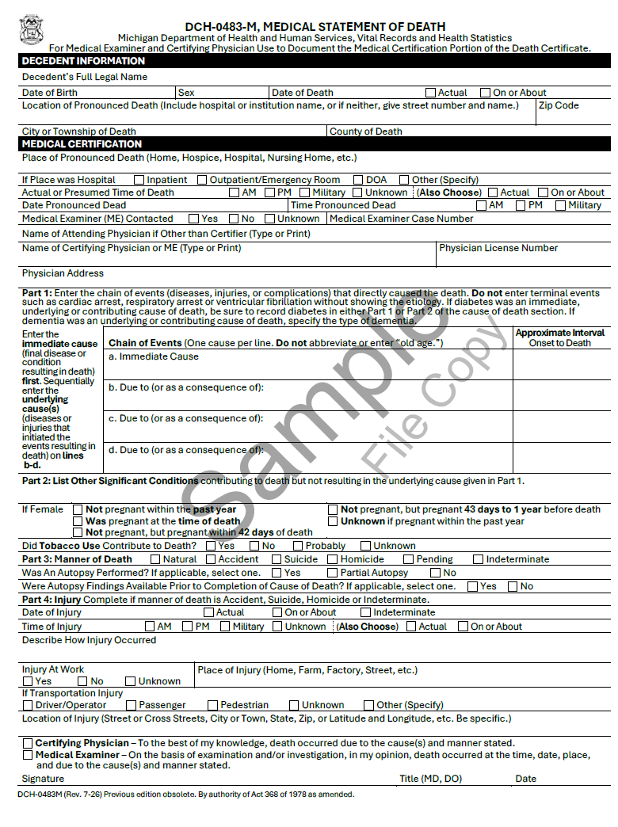

Reporting Pending Cases
MEs are the only physicians permitted to list “pending” as a COD or a MOD. The expeditious filing of pending records and the subsequent completion of those records eases the handling of the decedent's affairs while providing for an accurate accounting for the death.
The CDC defines the term ‘‘pending’’ as: intended to apply only to cases in which there is a reasonable expectation that an autopsy, other diagnostic procedure, or investigation may significantly change the diagnosis.
It is quite common that the COD for a decedent will not be finally determined until sometime after the death and long after it is necessary to prepare and file a certificate of death. This situation should only occur, however, when the death is under review by the ME. To permit a normal filing of the certificate, MEs are requested to certify to the death in such cases by entering the cause and/or the manner of death as "Pending." This permits the filing of a certificate and allows purchase of certified copies of the certificate so that handling some, if not all, of the affairs of the decedent can progress.
- If the ME enters the COD as pending, the FD must file the case. The FD shall not withhold filing until the COD is determined.

Supplemental Report
- This form is to be used by MEs ONLY when submitting supplemental information to AMEND a PENDING certificate of death. Decedent should be identified by name, DOD and County of Death.
- MEs may submit reports to update the record when new information is available. For example, if COD is known and MOD is pending, then a Supplemental Report (DCH-0483 SR ) may be submitted to update COD information and a second Supplemental Report may be submitted when MOD is known.
- Per administrative Rule R325.3210, a Supplemental Report should be completed within 60 days of when the date the death occurred (or the date the ME assumed jurisdiction). If a Supplemental Report is not submitted within 60 days, add a comment should be added to the record indicating why the record is not updated.

Resources For Death Certificate Completion
www.michiganedrs.org
MPHI website with resources, training, monthly minute videos and contact information.

www.michiganvera.org
MPHI website with resources, training, monthly minute videos and contact information.

- A CDC resource, view the Funeral Director’s Handbook on Death Registration and Fetal Death Reporting
- A CDC resource, view the Physician’s Handbook on Medical Certification of Death
- A CDC resource, view the Medical Examiners' and Coroners' Handbook on Death Registration and Fetal Death Reporting

- A CDC resource, view the two-page Instructions for Completing the Cause-of-Death Section of the Death Certificate
- A CDC resource, view the two-page Instructions for Completing the Cause-of-Death Section of the Death Certificate for Injury and Poisoning
- A CDC resource, view the guide for Identifying, Tracking, and Reporting Disaster-Related Deaths

Burial Transit Permits
A burial transit permit (Form DCH-0490B) is required to transport or to dispose of a dead body.

Before disposition, the death certificate must be certified. The burial transit permit should be issued from the EDRS.

The authorization for final disposition of a dead body must be issued on a form prescribed by the state registrar and signed by the local registrar or the state registrar. (Public Health Code MCL - Section 333.2848)

The permit must accompany the body to the place of disposition and be presented to the sexton or person in charge before interment or cremation. That person must sign the permit and record the disposition in their registry.

Note: If the EDRS is down, a licensed FD may issue a burial transit permit to themselves. This should be rare. Whenever possible, the permit should be issued from the EDRS.

Transporting Dead Bodies
A burial transit permit must accompany the body to the place of interment. When shipping by common carrier, the permit must be sealed in a strong envelope and attached securely to the outside of the shipping container.

A duplicate copy of the permit should be provided to the receiving FD—either delivered by the escort or mailed if the body is unescorted.

Burial transit permits issued by another state are valid for disposition in Michigan as long as the permit accompanies the body.

If a body must be transferred beyond the destination listed on the original permit, the FD, mortuary science licensee, or local registrar may issue a new permit showing both the original and new destinations.

Trade Calls
Burial transit permits may be used when a funeral home is acting as a representative of another funeral home in the State of Michigan. In these instances, the transferring and receiving funeral homes agree on the scope of the services. A common scenario would be when a decedent dies while visiting another region in Michigan and the receiving funeral homes requests that a local funeral home transfer the body.

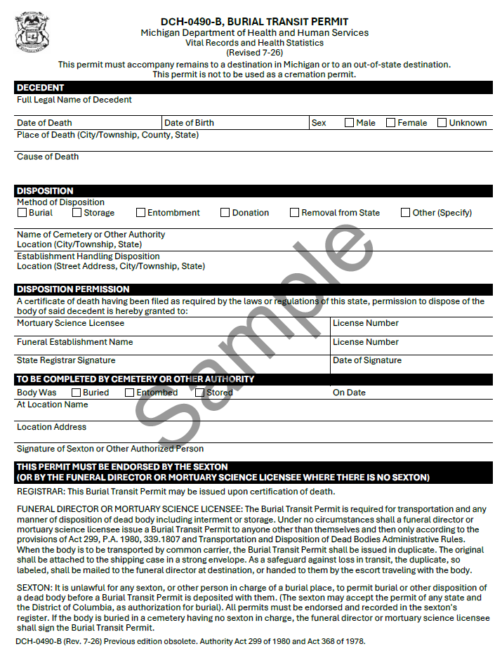

Cremation And Cremation Permit

When final disposition is by cremation, the ME of the county in which death occurred must review the certified medical portion of the death certificate and sign the Cremation Permit (Form DCH-0490C), or Final Disposition of a Stillbirth form (Form DCH-0490).

The authorization for final disposition of a dead body must be issued on a form prescribed by the state registrar and signed by the local registrar or the state registrar. (MCL Section 333.2848)

Before cremation the death certificate must be certified so the ME can review it before signing the cremation permit.
- The cremation permit should be issued from the EDRS.
- The signature on the cremation permit may be the signature of the ME or a deputy ME. (MCL - Section 52.210)
- The ME in the jurisdiction of death must sign the cremation permit for bodies being cremated in state or out of state.

The person in charge of the crematory must be presented with the signed cremation permit before they can dispose of the body or fetus.

Note: If the EDRS is down, a licensed funeral director may issue a cremation permit and have it signed by the ME on paper. This should be rare. Whenever possible, the permit should be issued and approved from the EDRS.

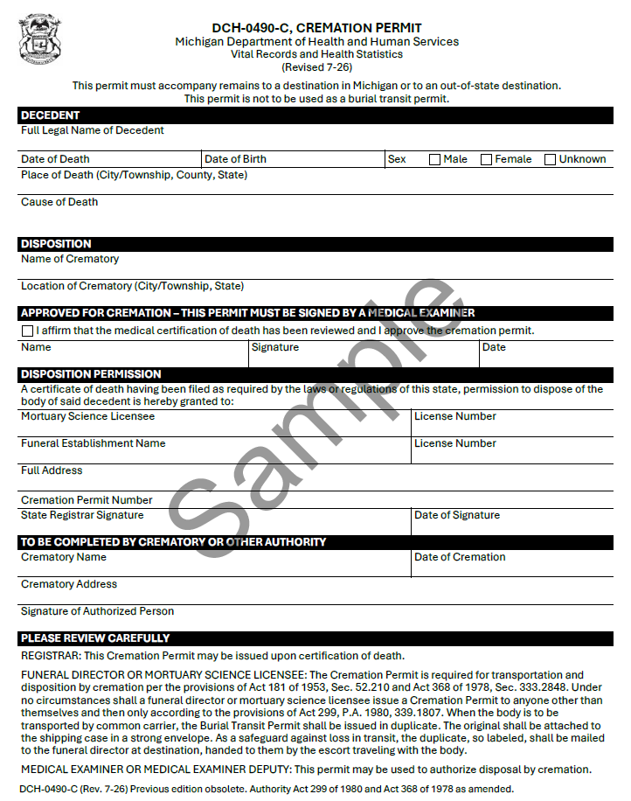

Other Situations

Disinterment And Reinterment Of Human Remains
Disinterment Definition
The exhumation of a body from a cemetery or place where a dead human body has been buried or otherwise interred. The body is then presumed to be reinterred at another site. This process of disinterment and reinterment, along with the pertinent form, must still be followed even for movement within the same cemetery, regardless of whether or not the remains are removed from the ground.
This process is not to be confused with the process of the opening and closing of a previously buried casket for the purpose of adding or removing articles. Refer to departmental form number DCH-0734.
Permit Requirements
A disinterment/reinterment permit is required any time human remains are disinterred. The permit must be obtained from the local health office where the remains are buried. To obtain it, a licensed FD or authorized representative must submit a completed Affidavit for Disinterment and Reinterment (Form DCH-0734A). The permit is issued to the FD, who must oversee both the disinterment and reinterment.
A permit is required even when moving or sliding a body to another gravesite within the same cemetery. No permit is required to move cremated remains or to open a casket solely to retrieve or place an article, like jewelry. (Administrative Rule 325.8055)
The health officer must retain the Affidavit for at least five years. The cemetery where the body is reinterred must permanently retain the permit, and a duplicate must be permanently kept by the cemetery of original interment.

Additional Resource Act 368 of 1978 Section 333.2458
MCL - Section 333.2458

Authorization For Delayed Interment
The Authorization for Delayed Interment departmental form, DCH-0734B, is required when a cemetery must store a decedent’s remains when weather or other conditions make an immediate burial impossible. This storage is not considered interment; therefore, to move the remains later, a disinterment and reinterment permit is not required.
In Michigan, this form is traditionally used for winter storage when the ground is too cold to bury the remains.

Additional Resource Act 368 of 1978 Section 333.2852
MCL - Section 333.2852
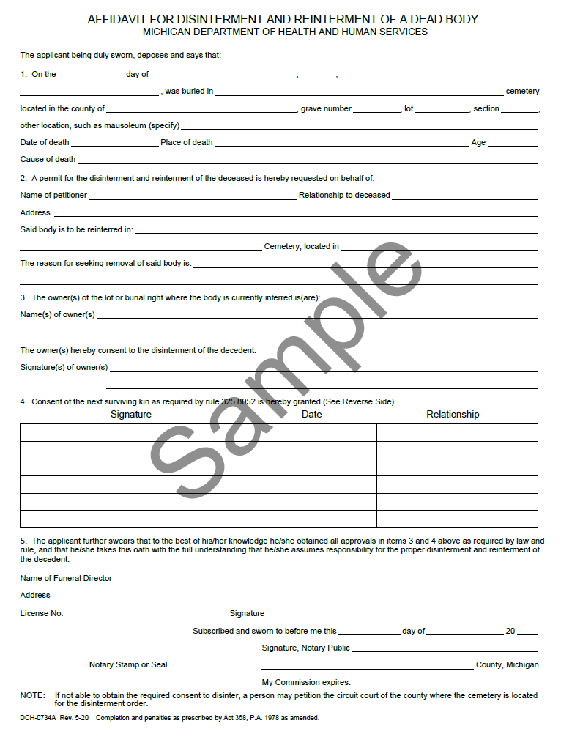
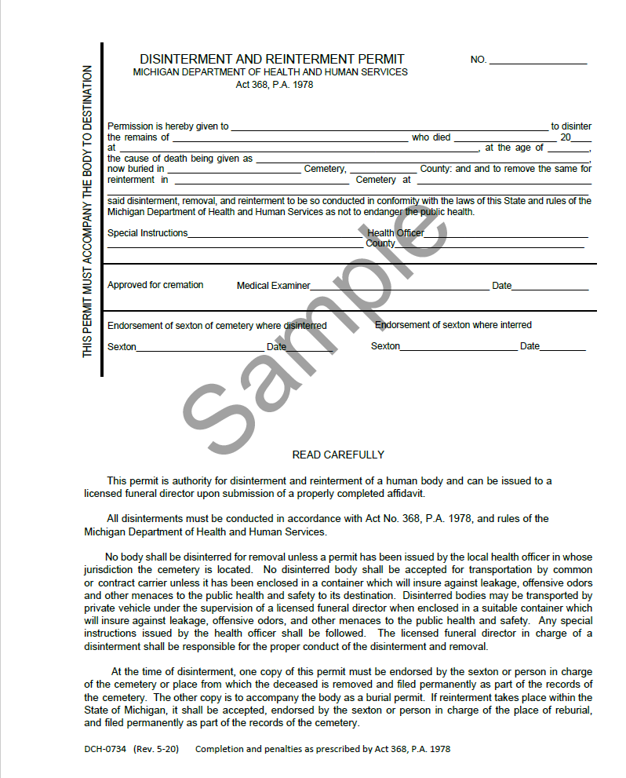
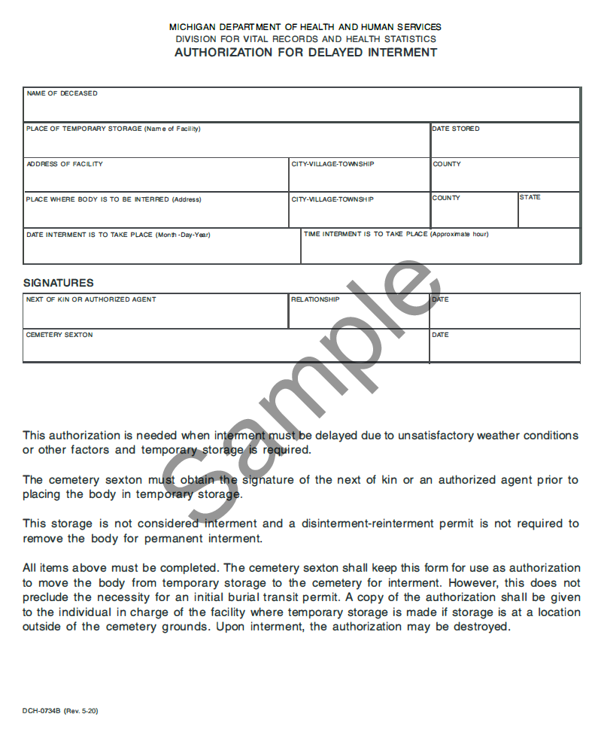

Anatomical Donation
Anatomical Gift Definition: The process by which an individual of sound mind and 18 years of age or more may give all or any physical part of the individual's body for any purpose specified in statute, (MCL - Section 333.10104), the gift to take effect upon death.
When a body is donated under the anatomical gifts law, a death certificate must be filed with the local registrar where the death occurred (or the body was found) within 72 hours. A Burial Transit Permit (DCH-0490B) must also be obtained and completed.
Responsibility for completing the death certificate and obtaining the burial transit permit falls to:
- The FD arranging services with the family, if only a portion of the body is donated.
- The mortuary science licensee of the institution receiving the donated body, if the entire body is donated.
Relevant law: Act 368, P.A. 1978, Sections 333.10101–10108. View MCL 368-1978-10.

Unclaimed Body
A dead human body for which the deceased has not provided a disposition, an estate or assets to defray costs of burial do not exist and the body is not claimed for burial by a person, relative or court appointed fiduciary who has the right to control disposition of the body. (MCL 333.2653(1))
MEs will contact FDs to handle final disposition. The medical portion of the death certificate will be handled by a CP or an ME. FDs should certify the personal portion of the death certificate within 48 hours of receipt of the remains. The informant in these instances may be the MEs office or FD.

Presumptive Death
The establishment of a death certificate in an instance where an accident or a disaster has claimed a life, but the body of the decedent cannot be found or is not identifiable. The ME completes a death certificate as completely as possible pursuant to an order of a court of competent jurisdiction. (MCL - Section 333.2845) Such certificates are marked "presumptive."
Funeral homes are not involved until or unless remains are found. If remains are found, the circuit court that established the order for the presumptive death must order Vital Records to void the original record before a new record can be submitted by the funeral home. Also see Act 386 of 1998 MCL - Section 700.1207 and MCL - Section 700.1208.

Infectious Agents
Physicians who are required to complete medical certifications for a deceased patient, and who have actual knowledge of the presence of “infectious agents” in a deceased individual, are required to report that information to the funeral director. (MCL - Section 333.2843b.)

To facilitate timely, ongoing updates to the definition of “infectious agent,” MDHHS is currently in the process of amending administrative Rule 325.9031. Once this change is completed, the list of infectious agents will be updated as necessary.

Identifying, Tracking, and Reporting Disaster-Related Deaths is a guide provided by the CDC that is useful when reporting disaster-related deaths, including deaths by infectious agents or during pandemics.
Documenting Disaster-Related Deaths is a helpful monthly minute video we created.

Induced Termination Of Pregnancy

Infant Born Alive
The death of an infant who was born alive following an attempted abortion and was surrendered to an emergency service provider under the safe delivery of newborns law should be reported in the same manner as any death. However, the deceased infant must be listed as “Baby Doe” and no information that would directly identify the deceased infant or the deceased infant’s parents shall be reported.
Fetus Delivered with No Signs of Life
If induced termination of pregnancy and no signs of life, neither a live birth nor a fetal death report nor a death certificate should be completed.

Guidelines For Issuance Of A Permit For Final Disposition Of A Fetus Or Stillbirth
A permit for final disposition of a stillbirth must be obtained prior to final disposition of a dead fetus. This form should only be completed if there was not a live birth and a subsequent death. If there was a live birth and a subsequent death, then a birth certificate and death certificate are filed.
Fetus Definition
For disposition purposes, a developing human organism irrespective of gestational age.
Process
Authorization for final disposition of a dead fetus must be given by both parents.
If the mother/birth parent is not married at the time of delivery authorization of only the mother/birth parent is required.
The parent(s) may authorize any of the following to handle disposition of the fetus.
- A funeral director.
- Director of the hospital or institution or their authorized representative where the delivery occurred.
- An institution or agency authorized to accept donated bodies of fetuses.
The person assuming responsibility for final disposition of a still birth is responsible for seeing to the proper completion of the disposition permit. The individual must also retain the permit for a minimum of seven years. If you are assuming responsibility for final disposition of a dead fetus, the burial transit permit should be completed.
After the parent(s) have signed the form, the parent(s) should be advised that they may have a copy of the form for personal use, if they wish. It should be explained that they can have the form as it now stands or receive the form after the mortuary science licensee or facility use part is completed.
If the parent(s) choose to have a FD dispose of the body or donate the body to an agency authorized to accept donated bodies, the FD or institution accepting the donated body will complete the bottom portion of the permit.

If disposition is by cremation, funeral home must obtain authorization for cremation from a ME.

A properly completed disposition permit must be displayed to the cemetery or crematory prior to disposition. If duplicates of the disposition permit are prepared, the original should remain in the possession of the person authorized to dispose of the dead fetus.

After disposition, the person authorized by the parent(s) to dispose of the dead fetus must retain the permit for a period of not less than seven years.

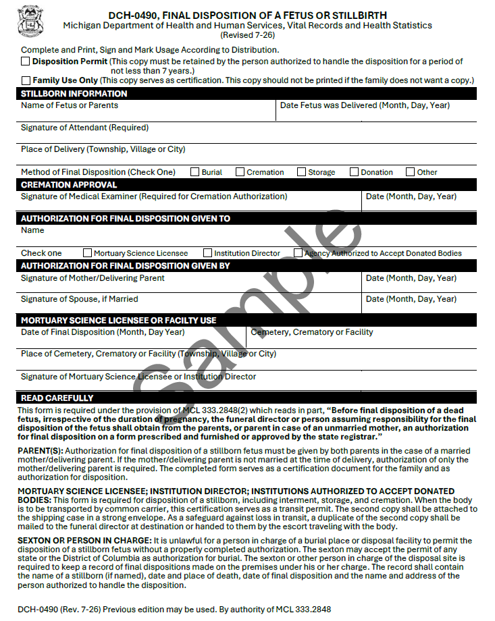

Safekeeping Of Blank Birth And Death Forms
Why It Matters
Blank forms can be misused to create false birth or death records. These forgeries can enable fraud, false benefits, or identity theft. Only forms issued or approved by the state registrar are authorized for use (Administrative Rule 325.3204 - 3205).

Storage Requirements
• Keep all the blank forms in a locked cabinet, drawer, or storeroom outside business hours.
• During business hours, only remove forms as needed.
• Forms must not be accessible to non–vital records staff.

Tracking And Use
• Maintain an inventory system (spreadsheet/database is preferred; paper log is acceptable).
- Record numeric serial numbers.
- Record who received forms.
- Record the number removed and returned.
- Use dual verification: two employees check amounts when forms are taken out and returned.
• Printers/copiers used with blank forms must be in restricted areas or forms must be retrieved immediately after use.

Missing Safety Paper Or Forms
Notify the state registrar immediately and file a report with the following details:
1. Date the forms were discovered missing.
2. Type of record (birth or death).
3. Number of missing forms.
4. Pre-printed serial numbers (if applicable).
5. Any other information that could help to recover them.
Send details to: VRFraudUnit@michigan.gov and/or call 517-335-6000.
Other Requirements
• All unused forms must be returned to the state registrar upon request.
• Local registrars may be asked to distribute instructions from the state registrar to the appropriate parties

Blank vital records forms are needed only in the event of a catastrophic event. Otherwise, all records must be filed using the EDRS.

Correction Of Death Certificate
The process of modifying recorded facts must be concerned with the need for accurate and reliable information and must attempt to thwart any misuse of the death registration system. As such, changes to recorded information are governed by standards that are based in law and administrative rule and are designed to promote accuracy while reflecting the significance of the information to be changed. While the dilemma created by an error on a death certificate cannot be permitted to affect the documentation standards for correcting the error, those standards must not be more stringent than is necessary to reasonably establish the true facts.
Why Accuracy Matters
Certified death certificates are prima facie evidence used for estate administration, insurance claims, and public health statistics. Ensuring accuracy avoids delays and protects families and the public record.

Definitions
- Correction
The administrative correction or amendment of a certificate to reflect the correct information for items where incorrect information had originally been entered, or the addition of correct information for items previously not completed on the certificate. (Correction does not mean to enter on the certificate facts different from those that existed at the time of the occurrence of the event.)
- Amend
To add, delete, or change in any way an item of information that was reported on a vital record.
- Amended Record
A replacement record that is marked "amended" which contains the date of the amendment and identifies the items amended. (R325.3251(1)(b))
Who Can Request A Change (Eligibility)
Under Mich. Admin. Code R325.3266 the following may request changes to a registered death record:
- Informant listed on the certificate.
- Next of kin (within 5 years of date of death; after 5 years or if next of kin is disputed, a court order is required).
- FD or the individual responsible for disposition.
- CP – limited to date of death, place of death, and medical facts of death.
- MEs may also request changes to cause/manner of death; certain deputies can be authorized.

What Can Be Changed and Documentation Standards
- Medical items (cause/manner, date/place of death): Only the CP/ME can request; court order may be required in some cases.
  - CP can change date of death, place of death and medical facts. CP cannot change manner of death.
  - ME can change medical facts and manner of death.
- Marital status or surviving spouse’s name: Requires court order, except minor spelling fixes or evident funeral home error.
- Most personal items (name, DOB, etc.): Typically, 1–2 dated documents that clearly match the decedent; acceptable evidence includes SSA records, passports, military records, medical records, school records, and similar government records.
  - Driver’s license/State ID is not acceptable evidence.

- Cause/manner of death changes: May be made on request of parties listed in R325.3266(2) or via certified court determination.
  - Only CPs or MEs can change COD. Only MEs can change MOD. Informant, next of kin, and funeral home may not request changes to cause or manner of death.

Tip: MDHHS’s “Death Changes – FAQ” and current application forms detail acceptable documents and signatures required. Use the latest forms to avoid delays.
Timing and Where To Submit
- EDRS Window (Technical Corrections)
Currently, if an error is found after filing with the local registrar but before the record is forwarded to the State, the funeral home as the ability to request a correction in EDRS and the local registrar has the ability to accept correction requests for 29 days from the local file date. Within 30 days of local filing, certain correction requests can be submitted through EDRS; after 30 days, a paid correction through MDHHS is required.

- After State Registration
Requests to correct/change a Michigan death record are made by mail to MDHHS using the current Application to Correct a Michigan Death Record (DCH0856CHGDX), with photocopy of valid photo ID, fee, and supporting documentation.
Fees (Current As Of 2025-2026)
- MDHHS correction application fee: $50 (includes one certified copy).
- Additional certified copies: $16 each.
- Optional RUSH processing: $25 (mail to the “RUSH” P.O. Box listed on the application).
Processing Times And Contact
MDHHS processes mailed requests; timelines vary by workload and type. MDHHS Changes Unit: 517-335-8660 or MDHHS-VR-Changes@Michigan.gov (typical email response 1–3 business days).
Special Notes For Obvious Errors And SSN
“Obvious” typographical errors often require documentation after the first year; SSN changes always require documentation. (Apply with evidence; do not rely on personal affidavits.)

Where To Find Forms And FAQS
- MDHHS – Correct a Death Record (forms & FAQs): Correct A Death Record
- Funeral Home, Informant Or Next Of Kin Application DCH-0856-CHGDX.pdf
Physician Application to Correct a Michigan Death Record for a Death After January 1, 2004
Physician Application to Correct Michigan Death Certificate for a Death Prior to January 1, 2004
- Rules Text: Mich. Admin. Code R 325.3266 (eligibility) & R 325.3267 (evidence).
Delayed Registration Of Death
A record of a death that occurred in Michigan but was not officially registered within one year after the death occurred. When referring to found bodies which have obviously been dead for several years, the delayed death procedure does not apply. These are ME cases, and the one-year delayed record designation does not become relevant until one year after the finding of the body.

Funeral homes failing to register the certificate of death within 1 year will need to go through the Changes unit, complete an application and pay a fee.

Failure to file the death certificate in a timely manner is a violation of public health code and may be reported to the Michigan Department of Licensing and Regulatory Affairs (LARA).

Relevant Michigan Laws

Michigan laws are updated and amended. To view the most recent iterations of laws, see the Michigan Legislature Website for Michigan Compiled Laws.

Public Health Code
Act 368 of 1978

Public Health Code Act 368 Of 1978 Part 28 (Vital Records)
MCL - 368-1978-2-28 - Michigan Legislature

Unclaimed Body Law
MCL - Section 333.2653 - Michigan Legislature

Public Health Code Act 368 Of 1978 Part 26 (Data, Information and Research)
MCL - 368-1978-2-26 - Michigan Legislature

Presumptive Death MCLs – Estates And Protected Individuals Code Act 386 Of 1998
MCL - Section 700.1207 - Michigan Legislature
MCL - Section 700.1208 - Michigan Legislature

Determination Of Death Act 90 Of 1992
Act 90 of 1992

County Medical Examiners Act 181 Of 1953
MCL - Act 181 of 1953 - Michigan Legislature

Occupational Code Act 299 Of 1980 Article 18 (Mortuary Science Laws)
MCL - 299-1980-18 - Michigan Legislature

Cemetery Regulation Act
Act 251 of 1968

Revised Uniform Anatomical Gift Law
MCL - 368-1978-10-101 - Michigan Legislature

Relevant Administrative Rules
Amendments to Vital Records
DHHS Public Health Administration Office of the State Registrar Amendments to Vital Records

Completion, Filing and Registration of Vital Records Documents
DHHS Public Health Administration Office of the State Registrar Completion, Filing and Registration of Vital Records Documents

Disinterment – Reinterment
DHHS Office of the State Registrar Disinterment- Reinternment Admin Rules

DHHS Bureau of Disease Control, Prevention and Epidemiology Transportation and Disposition of Dead Bodies

Anatomical Gifts
DHHS Community Public Health Agency Anatomical Gifts

Definition of Infectious Agent
DHHS Bureau of Epidemiology Definition of Infectious Agent

Department Of Community Health Bureau Of Epidemiology Transportation And Disposition Of Dead Bodies
R 325.1141 to R 325.1145.doc

Additional Resources

LARA Michigan Guide To Cemetery Regulation Act
Michigan Guide to Cemetery Regulation Act 7.10.23
https://www.michigan.gov/lara/-/media/Project/Websites/lara/cscl/NonImages_new/Licensing/cemetery/Michigan-Guide-to-Cemetery-Regulation-Act.pdf

Sample Certificate Of Death
