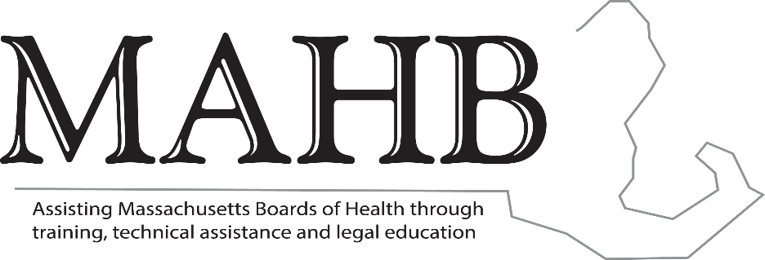
Massachusetts Association of Health Boards
Cheryl Sbarra, Esq.
Executive Director
Senior Staff Attorney
63 Shore Road, Suite 25
Winchester, MA 01890
(781)721-0183
www.mahb.org sbarra@mahb.org

MUNICIPALITES THAT BAN NATURAL AND SYNTHETIC KRATOM

- Northampton – 10.16.25
- Dracut – 4.1.25 *
- Lowell – 12.4.24, effective 1.2.25 *
- Westborough – 5.20.25
- Marlborough – 12.1.25 *
- North Attleboro – 11.14.23, effective 12.31.23 – Can only be sold in Adult-Only Retail Tobacco Stores
- Chelmsford – 3.4.25 *
- Belchertown – 12.11.24, effective 1.1.25 *
- Canton – 9.25 *
- Attleboro – effective 10.31.25
- Kingston – 10.7.25
- Bourne – effective 10.22.25
- Needham – synthetically derived Kratom revised 11.22.24

*Fines too high for a regulation enacted pursuant to G.L. c. 111, sec. 31. Fines can only be up to $1000.

